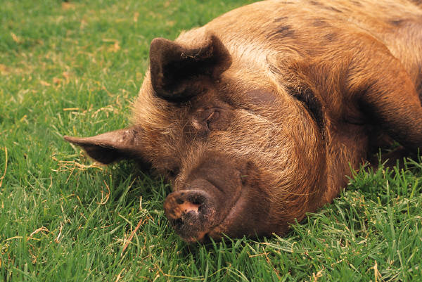
Paid Undergraduate Research Assistantship
in Food Systems (Local/Regional Meat)
Internship Application

Deadline: extended April 30, 2014
Directions: Complete and email to Jamie Picardy (jpicardy@yahoo.com)

CONTACT INFORMATION
Name:
Address:
City/State/Zip code:
Email:
Phone number:

ACADEMIC INFORMATION
Major: Grade Point Average:
Year (circle one): freshman sophomore junior senior

Please list all classes in agriculture, food studies, or environmental science that you have completed:
Type here

Please list all math and science classes in which you earned a B- or better grade:
Type here

PROFESSIONAL INFORMATION
Starting with your most recent job, please detail your previous work experiences

Employer Job Responsibilities Length of Employment

Briefly describe your preferred career for which you are preparing:
Type here

PERSONAL INFORMATION
Please describe your interests surrounding food and agriculture:
Type here

List any extra-curricular clubs or volunteering in which you regularly participate:
Type here

