Tufts ArcGIS 10.2.2 Student DVD Installation Instructions

*Revised 9/19/2014*

Notes for a quick installation: It was observed that the quickest installation occurred when no other programs were open. In addition, **the installation requires internet access**; it is suggested that multiple tabs are closed.

1. Visit the *ESRI Education Edition* website:

<http://www.esri.com/StudentEdition>. You have the DVD edition. You will be prompted to either login to your ESRI global account, or to create a username and password. Once you log in successfully, enter the number inside the CD case, which will start with “EVA”. Entering this code online first is required in order to authorize the software later.

1. Insert ArcGIS 10.2.2 disc in your computer. (If the AutoPlay does not run, use the ESRI.exe to bring up the main menu)
2. You should see a large screen with several options. If you have a previously installed version of ArcMap on your computer, you will need to uninstall. Under Uninstall Existing ArcGIS Software, click Run Utility. A process screen should appear; it could take well over 10 minutes to uninstall.

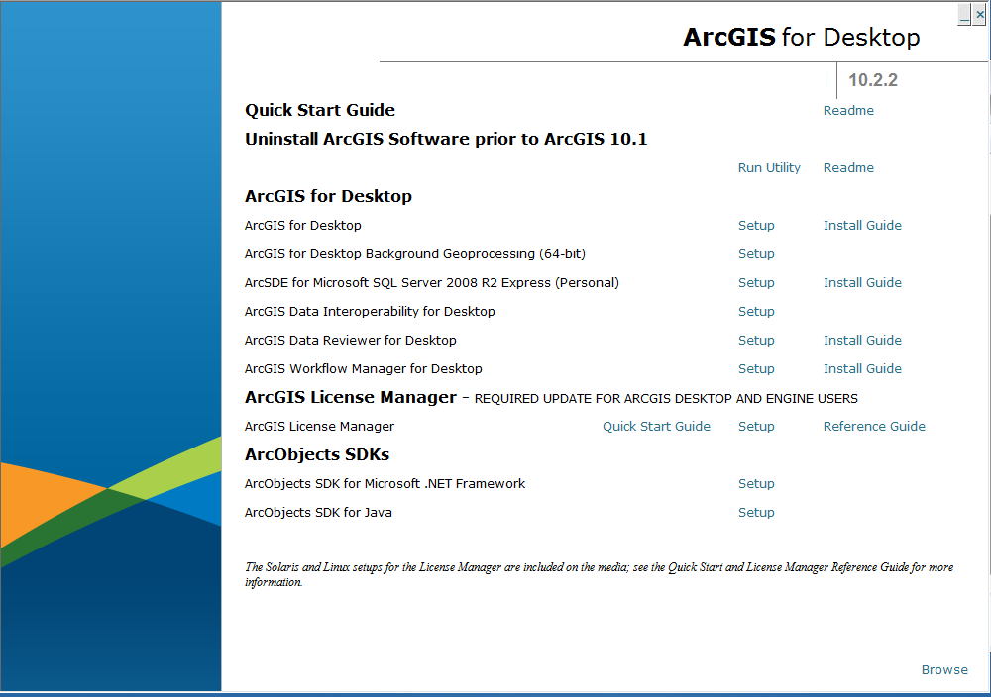

1. When the removal process is complete, select ArcGIS Desktop 🡪 Setup. A window stating that the program is preparing to install should appear.
2. Click the install button, and select **COMPLETE** install. Make sure the file path that the Arc GIS is filed to match where you would like it to save.   
   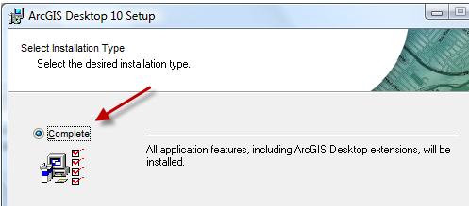
3. Select a complete installation, and follow the prompts. When the installation is complete, click “Finish” and then wait.
4. You now need to authorize your software. In ArcGIS Administrator Wizard, select **Advanced ArcInfo (Single use):**

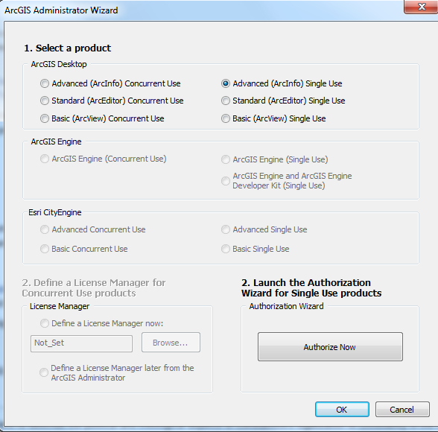

1. Now the **2. Launch the Authorization Wizard for Single Use products** activates. Click on **Authorize Now**.

Make sure “I have installed my software and need to authorize” is selected. Click next. Choose to authorize via the internet. Click next. You will then be asked to enter personal info: use *Tufts University* as an **institution**, and make sure you say you are a *student* in the **occupation** section.

1. It will ask for your authorization number. Enter the EVA code and click next.
2. The next screen is confusing – set the option for “I do not want to authorize any extensions at this time” – they have already been authorized and installed if you asked for a COMPLETE installation in Step 5 above.  
   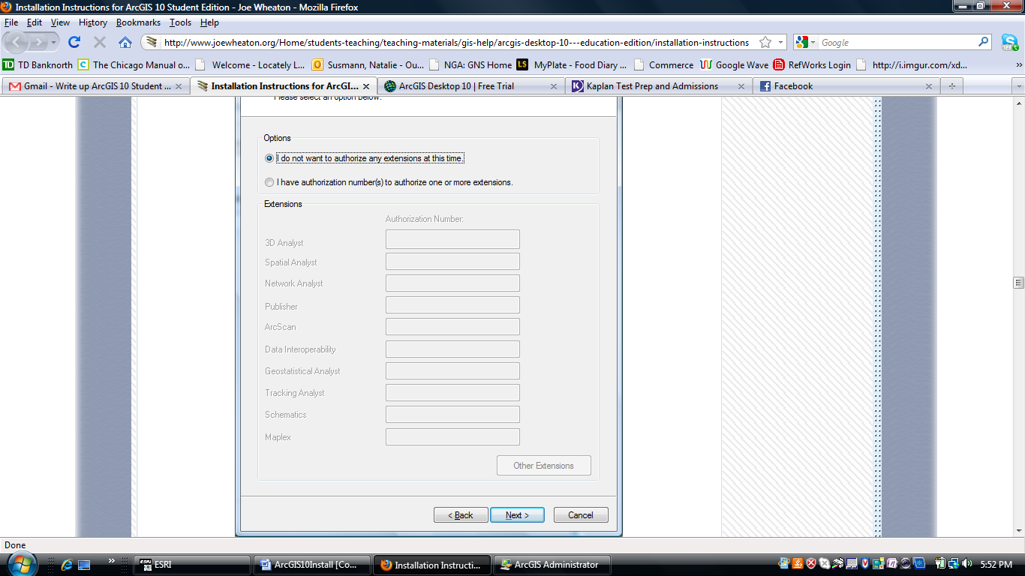
3. Click Next
4. Highlight the extensions you want to have evaluation copies of (all of them) and move them over to the *Evaluation* column:  
   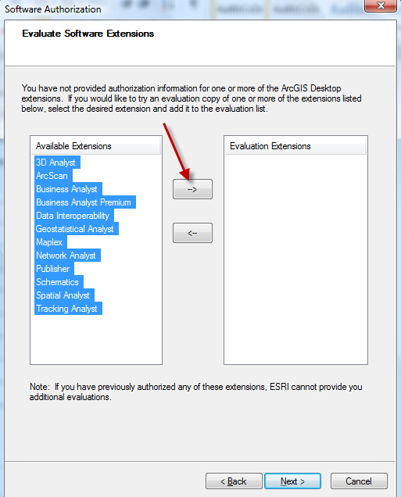
5. Make sure they are all now on the right-hand side of the screen, and click **Next**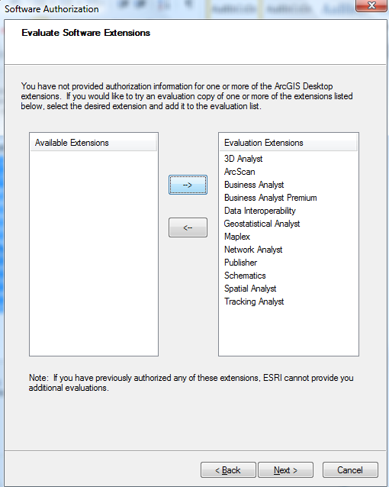
6. You should see it authorizing the software  
   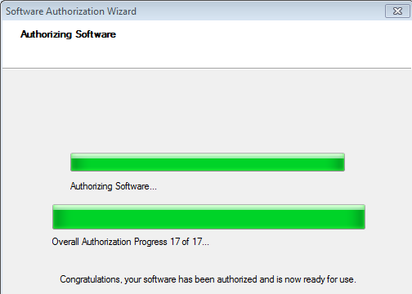
7. Open the software to make sure it works (to check *Extensions*, in ArcMap, click on **Customize – Extensions** and checkmark them)
8. Finally, we highly recommend that you need to download and install **Service Pack 1 for Desktop**. This service pack fixes many bugs in the software. Close ArcGIS if it is open before doing this.

Go to the **ArcGIS 10.2.2 Service Pack 1 for (Desktop, Engine, Server)** web page - <http://support.esri.com/en/downloads/patches-servicepacks/view/productid/189/metaid/1913>

1. Scroll down for the *Instructions* *for installing on Windows* (about halfway down the page) and follow these. In *Step 2*, choose *ArcGIS 10.2.2 SP1 for Desktop* as shown below and follow installation instructions.

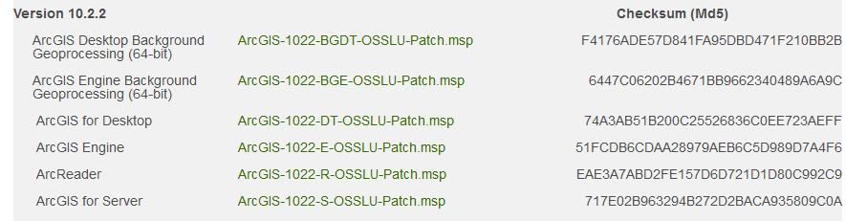

If you encounter problems, e-mail Tufts GIS Support at [**gis-support@elist.tufts.edu**](mailto:gis-support@elist.tufts.edu) and describe your problem with as much detail as you can providing error messages, etc.