Lesson 4.00 b

Multiplicative Candy Boxes II

Summary

Activity | This class is a continuation of the previous lesson. It centers on the possible amounts of candies two children, Juan and Marcia, have. Juan has a box of candy and Marcia has twice as much candy. What are the possible amounts of candies they might have?
Goals | Work with variables, function tables, algebraic representation for variables, and graphs.
Foci | Variables and Function tables  Use of symbolic notation for variables as standing for the possible amount inside a box and to represent Juan’s and Marcia’s functions;  The ratio between two multiplicative functions is constant: for any possible amount in the box, the ratio of Juan’s to Marcia’s amount is always 1:2;  Representing the situation in words, pictures, or symbols, from the point of view of Juan or Marcia (Marcia always has twice as much as Juan, Juan always has half as much as Marcia).  Graphing Marcia’s candies versus Juan’s candies.
Materials | Three boxes for holding up to 100 candies. They should be opaque so students cannot see the candies in the boxes. Plastic card file boxes work fine. You will also need a supply of small, wrapped hard candies. (There should be enough on hand so each student gets one at the end of the class.) Rubber bands can be used to keep the boxes closed. Identify the boxes with the names of the owners (Juan, Marcia).
Terms | Ratio, multiplication, division; possible amount; actual amount; known versus unknown value.

Activities

Comparing the Boxes

Part 1 [whole class]: Review the problem
Show Overhead 1 and ask the children to recall what we can say about the amounts of candies Juan and Marcia have. Ask them to state what is the ratio or relation between Juan’s and Marcia’s amounts.

Part 2 [group work]: Tabulating the problem
Distribute Handout 1 (Overhead 1) and ask the children to complete the table.
Review their answers with them. Give emphasis to work across columns (functional relation) as opposed to work on isolated column.

Part 3 [group work]: Graphing the problem
Distribute Handout 2 (Overhead 2) and ask the children to graph Marcia’s candies versus Juan’s candies.

Part 4 [whole class]: Discussing the meaning of the graph
Discuss the meaning of the graph with the children by focusing on the fact that the line represents the times two line. Ask them to predict where the times two, times four, times five lines would fall. Then ask where the line would fall if Marcia had half the amount of candies that Juan has.

Part 5 [whole class]: Homework
The students will graph the function from the previous lesson’s homework.

Overhead 1 and Handout 1
Name: _________________________________________ Date: _________
Juan and Marcia each have a box of candies.
Juan has a box of candies. Marcia has two boxes of candies.
The three boxes have exactly the same number of candies in them.

Complete the following table:

Number of candies in a box | Juan’s total candies | Marcia’s total candies
n
0
 | 1
 | 3
4
 | 5
 |  | 14

Overhead 2 and Handout 2
Name: _________________________________________ Date: _________

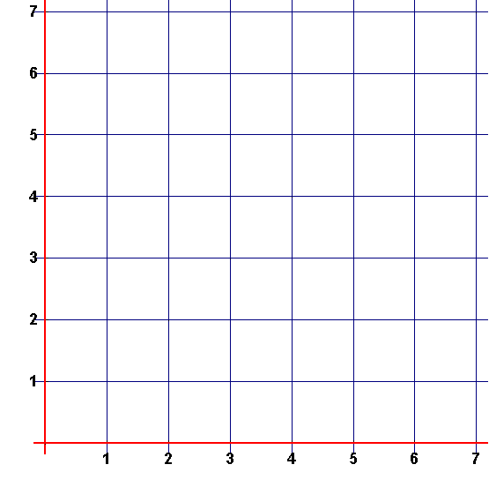
Use the table to graph Juan’s and Marcia’s amounts of candy. Pay attention to how you label your axes.

Homework, page 1
Name: ______________________________________________Date:_______________

Tony and Joy have the same birthday (January 15).
But Tony is exactly twice Joy’s age.

Complete the table for Tony’s and Joy’s ages.

Joy’s age | Tony’s age
n
0
1
2
4
7

Homework, page 2
Name: ______________________________________________Date:_______________

Use the table on page 1 to graph Tony’s and Joy’s age. Pay attention to how you label your axes.

