Lesson 4.09

Cartesian Candy Bars I

Summary

Activity | We compare ratios of various ordered pairs in a Cartesian grid. The initial discussion concerns the space as a whole; the task will focus on selected points and on the ratio of the dependent variable to the independent variable.
Goals | Focus on intensive quantities to help students realize that ratios grow as the dependent variable increases and/or the independent variable decreases, and to develop their awareness of equivalent ratios and fractions.
Materials | Overheads and Handouts.
Terms | Ratio; equivalent; equivalent ratio; fraction; equally fair; candy bars per person; amount per person
Hints | Do not connect the points representing tables in the graph space. This is not appropriate in the context we will be working with because we are dealing with a discrete quantity (number of people) that cannot be meaningfully divided into fractions. However, children should discuss how the points with the same ratio could form a straight line.

Activities

Part 1: Thinking about what the grid means
Show Overhead 1. Ask students to imagine that the graph space represents the classroom space and that there are tables at each intersection. On each table there are y candy bars; x chairs are placed around the table. There will be one child at each chair. The children at each table will share the candy bars equally between themselves.
Discuss with the whole class what the graph space and the points mean. Ask students to show where the most and the fewest candy bars are, where the most and the fewest people are. How do they explain their choices of points in the grid?
Explain how points in the graph space are identified using coordinate notation.
Distribute handouts 1 and 2 to the students.

Part 2: Expanding children’s understandings
Collect the handouts and ask a few children to show their answers to the class and to explain their choices.
Are there tables with equivalent ratios of candy bars to people (Tables A and B are equivalent if a child at Table A receives the same amount of candy as a child at Table B)? Why?
What do the tables on the x and y axes mean? What happens if there are no candy bars to share between people? If there are no chairs around a table?
Choose a few equivalent tables to discuss. In what ways are the tables the same? In what ways are they different? How many candy bars does each person get?
Introduce the notation to mean “two candy bars for three people”, or “two candy bars divided by three people.”
Note that this is different from , which stands for three candy bars for two people. Which is “better” (presuming you like candy)?
The students should realize that , , , are just as good. All cases represent 1 candy bar per person.
They should also notice that the equivalent tables (tables that are just as good) fall on a straight line.

Part 4: Homework
The students will answer questions that are similar to those dealt with in the classroom.

Overheads and Handouts

Overhead 1: Handout 1
Name: ______________________________________ Date: ____________
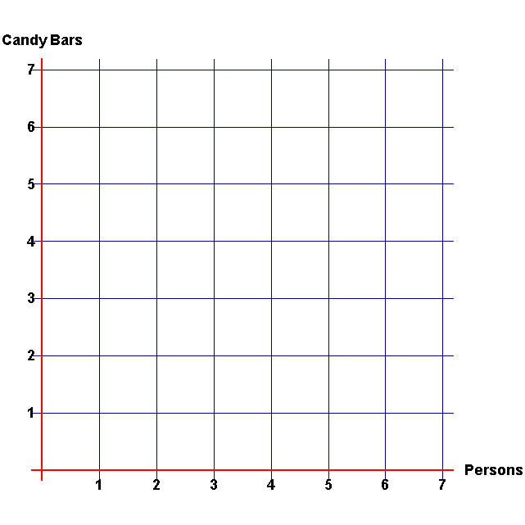
1. Show on the graph the location where one would get the most candy per person. Write the letter A at your chosen place in the diagram below. Then complete this sentence. The best place on the graph (where each person gets the most candy) is at the point ( , ).
The x coordinate goes here.
The y coordinate goes here.

2. Show on the graph the location of a table where you would have:
- 4 people sharing 6 candy bars. Write the letter B at the correct place in the diagram above. The coordinates for point B are
( , ).
6 people sharing 4 candy bars. Write the letter C the correct place in the diagram above. The coordinates for point C are ( , ).
Is one of these two locations better than the other or are they the same? Explain why.

Overhead 2: Handout 2

Name: ______________________________________ Date: ____________

- Place a star () at all the locations on the graph for which there is exactly one candy for each person at the table.
What are those points?
( , ) ( , ) ( , ) ( , ) ( , ) ( , ) ( , )

Homework
Name: ______________________________________ Date: ____________
1. Place a heart (♡) on the graph wherever there is a table for which there is exactly one candy bar for every two persons.
What are those points?
( , ) ( , ) ( , ) ( , ) ( , ) ( , ) ( , )

2. Place a diamond (◊) on the graph wherever there is a table for which there are exactly two candy bars for every three persons.
What are those points?
( , ) ( , ) ( , ) ( , ) ( , ) ( , ) ( , )

