Lesson 4.10

Cartesian Candy Bars II

Summary

Activity | Children continue the work they started in the previous lesson on sharing different amounts of candy bars among different numbers of people. They compare ratios (candy bars per person) and plot points in a Cartesian grid.
Goals | Increase students understanding of ratios and fractions in graphical, notational, and story contexts.
Materials | Overheads and Handouts.
Terms | Sharing, dividing, fractions, slope, candy bars per person
Practical Hints | Have the children work in groups of four (or less). This will be important for small group discussions.

Activities

Part 1: Sharing candies
Distribute handout 1.
Have children work in groups of four (or less).
Ask children to show how they would share the candy bars equally among those at each table, A, B, C, and D.
Which table would you sit at? Why? Convince us that you chose the best table. Are any tables the same?
Show the solutions of a few children to the class and discuss them at length.

Part 2: Representing the tables in the grid
Distribute Handout 2 and ask the children to find out the points where the tables fall.
Clarify how the tables are ordered in terms of share-size per person. Help the children adopt the convention for describing points as ordinate pairs.
Make clear that the first number corresponds to the variable in the horizontal axis (the x-axis) and the second number corresponds to the vertical axis (the y-axis). You can also explain that since the numbers have go in order, they are called ordered pairs. Each number is called a coordinate. The first coordinate is the x-value; the and second coordinate.
Consider the point (3,7).
The first (x) coordinate, 3, says that the point lies somewhere on a (projection) line going through the horizontal (x-axis) at 3.
The second (y) coordinate, 7, says that the same point lies somewhere on a (projection) line going through the vertical (y-axis) at 7.
There is only one place on the graph where these two conditions (x=3, y=7) are both true at the same time.

Part 3: Expanding children’s understandings
Are there equivalent tables, that is, tables that yield the same share even though the total number of candy bars or the total number of persons may vary? How is equivalence manifested in the Cartesian space?
Chose another ratio to discuss. How many candy bars does each person get?
Ask the students to show, approximately, where the half candy bar per person points would lie and what it would mean in this context.
Ask the students to show, approximately, where the two candy bars per person points would lie and what it would mean.
Finally ask where, approximately, the three candy bars per person points would lie and what it would mean.

Part 4: Homework
Children will represent on a graph tables expressing equivalent ratios.
Overheads and Handouts

Overhead 1: Handout 1
Name: ______________________________________ Date: ____________
Table A has 6 candy bars and 4 persons.
Table B has 5 candy bars and 2 persons.
Table C has 3 candy bars and 6 persons.
Table D has 1 candy bar and 2 persons.
1. Show how you could share the candy bars equally among those at table A.
2. Show how you could share the candy bars equally among those at table B.
3. Show how you could share the candy bars equally among those at table C.
4. Show how you could share the candy bars equally among those at table D.
5. What number is the result of 6÷4?
6. What number is the result of 5÷2?
7. What number is the result of 3÷6?
8. What number is the result of 1÷2?

Overhead 2: Handout 2
Name: ______________________________________ Date: ____________
1. Show in the graph below:
A: The table that has 6 candy bars and 4 chairs.
B: The table that has 5 candy bars and 2 chairs.
C: The table that has 3 candy bars and 6 chairs.
D: The table that has 1 candy bar and 2 chairs.
Label each the point with the corresponding letter and write the coordinates for each point. For example, the table that has 5 candy bars and 2 persons should be labeled B=(2, 5).
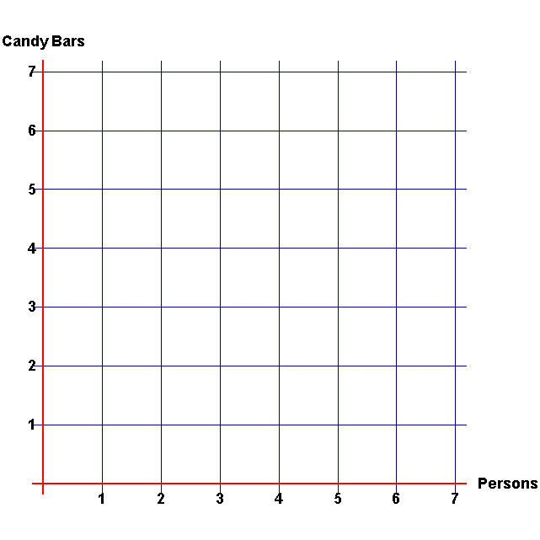

2. Show in the graph above the place of all the tables that would give one candy bar per person

3. Would the points for tables that give half candy bar per person fall above or below the points for tables that give one candy bar per person?

Overhead 3: Homework
Name: ______________________________________ Date: ____________
Show in the graph above:
1. The points that corresponds to all the tables that will give two candy bars per person
2. The points that correspond to all the tables that will give half candy bars per person
3. Write the coordinates for all the points that you marked in the graph. For example, the table that has 2 candy bars and 1 person should be labeled (1,2).
3. Are there any points that fall on a straight line?

