Lesson 4.11

The Better Paying Job

Summary

Activity | Children work on a problem about rate of pay per hour of work. They compare ratios (dollars earned per hour of work) and discuss and plot points in a Cartesian plane.
Goals | Promote students understanding of ratios and fractions in graphical, notational, and story contexts, with a focus on continuous quantities.
Materials | Overheads and Handouts.
Terms | Ratio, slope, equivalent ratios, earnings; earning vs. being paid;
Practical Hints | Have the students give their opinions about whose job pays better: Adam’s or Maggie’s. See if they can justify their views.

Activities

Part 1: Comparing earnings
Discuss Overhead 1. Explain that the graph shows the number of hours Adam and Maggie worked last week. It also shows the amount of money each person earned for the number of hours worked last week.
Ask a few children to answer and explain their answers to the questions:
Who gets paid better? Adam? Or Maggie?
How much does Adam get for the hours he works?
How much does Maggie get for the hours she works?
How many dollars does Adam get per hour of work?
How many dollars does Maggie get per hour of work?

Part 2: Expanding children’s understandings
Discuss Overhead 2 and distribute Handouts 1 and 2.
Have children work in groups of four (or less) to fill in the table for Maggie’s earnings and plot the points on the graph. Encourage them to draw the line across the points corresponding to Maggie’s earnings.

Part 3: Equivalent ratios and slopes
Discuss equivalent ratios and slopes.
Explore how the graph line relates to the multiple possible points representing the same ratio.
Use a ruler to show that the points for Maggie’s earnings all fall onto the same line. Draw the graph line across the points.

Part 4: Homework
The homework will be similar to the classroom activity: The children will compute Adam’s earnings and will plot the corresponding points in the graph space.

Overheads and Handouts

Overhead 1: Handout 1 (page 1)
Name: ________________________________________ Date: __________
Amount
Earned
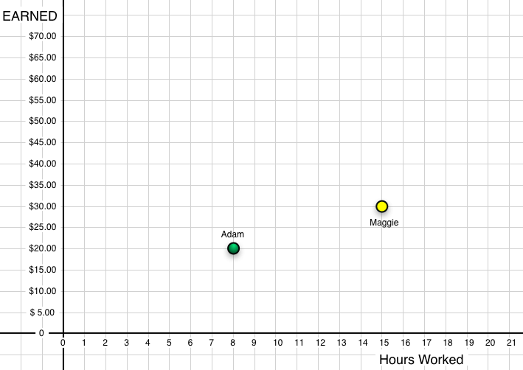

The two points in the graph above show the amount of money earned by each person (Maggie and Adam) for the number of hours they have worked last week.
Adam always gets a certain number of dollars per hour of work.
Maggie always gets another number of dollars per hour of work.

Answer the questions in the next page.

Overhead 2: Handout 1 (page 2)

- Who earned more money last week? _________________________________
Explain your answer:

- Who worked more hours last week? _________________________________
Explain your answer:

- If Adam works 15 hours, would he earn more or less money than Maggie did last week? How much more or how much less?
Explain your answer.

- If Maggie works only 8 hours, would she earn more or less money than Adam did last week? How much more or how much less?
Explain you answer

- Who gets paid better for each hour of work? Adam? Or Maggie? __________
Explain your answer:

Overhead 3: Handout 1 (page 3)

Name: ________________________________________ Date: __________

6. Show how much Maggie would earn for different amounts of hours of work.
Hours of work | Earnings (in $)
15 hours | $30.00
5 hours
10 hours
H hours
1 hour
2 hours
3 hours
hour
7. Plot the information from your table onto the graph.
8. What do you notice about the points on Maggie’s graph? Do they fall on a straight line? Why?

Homework
Name: ________________________________________ Date: __________
Amount
Earned
The two points in the graph above show the amount of money earned by each person (Maggie and Adam) for the number of hours they have worked last week.
Adam always gets a certain number of dollars per hour of work.
Maggie always gets another number of dollars per hour of work.

1. Fill in the missing values in the table below showing how much Adam would earn for different amounts of hours he works.
Hours of work | 8 hours | 4 hours | 10 hours | 1 hour |  | 3 hours |  | N hours
Earnings | $20.00 | $10.00 | $ |  | $5.00 |  | $1.25
- Plot Adam’s points in the graph above.
- What do you notice about the points on Adam’s graph? Do they fall on a straight line? Why?

