5-11— Phone Plans: Equations and Graphs

Summary

Activity | Students will compare two linear functions in the context of evaluating phone plans. One plan has two parts: a basic charge plus a charge based upon the number of minutes used. The other plan has no basic charge; it only charges according to the minutes used, however the per-minute charge is higher than in the other plan. Students are asked to determine the circumstances in which the monthly bill from each plan would be the same. They then examine the graph of the two functions and discuss how equations and inequalities relate to the graph.
Goals | To relate graphs and algebraic notation.
Terms | Function, equations, inequality, expression, solution, intersection, coordinate, rate, charge.
Hints | Focus especially on the algebraic notation, m(t)=10t and m(t)=60+5t. Focus on the use of algebraic notation for each of the functions and for the point where the two lines cross, i.e., where 10t=60+5t.

Activities

Part 1: Discussing the Problem (30 minutes).
Show Overhead 1 with the problem:
Matthew and Diana have different local telephone plans:
Matthew’s plan: He pays 10 cents per minute for all the calls he makes.
Diana’s plan: She pays 60 cents per month plus 5 cents per minute for the calls she makes.
(It doesn’t matter what time of day or which day they make their calls.)
Discuss the advantages and disadvantages of each plan with the children.
Ask them whether they think that at some point the two persons could pay the same amount of money for the same amount of minutes.
One of the big questions in this lesson is: how do we express algebraically the fact that they pay the same amount in order to obtain the amount of minutes? It may be strange for students the fact that we set up an equation equaling money in order to obtain time. It is important to insist that the point that we are looking for has the same numeric value for money and for time in both functions.
In that case, ask them to find out for which number of minutes Matthew and Diana will pay the same amount. Distribute handout 1 and guide the students to:
- Express the cost of each plan as a general rule or function, where t refers to the number of minutes they call during a month and m refers to the charges (the amount of money) that Matthew pays for t minutes. d(t) refers to the Diana’s charges. Introduce and discuss the notation,
m(t)=tx10 or m(t)=10t and
d(t)=60+(tx5) or d(t)=60+5t
Review the functional notation. Recall that m refers to Matthew’s charges, t refers to the amount of minutes and m(t) indicates that the variable m, amount of money, depends on the variable t, amount of minutes. A similar reasoning applies to Diana’s case.
- Ask the children to write an equation that sets the amount in one plan equal to the amount in the other; namely, 10t = 60 + 5t.
- Solve the equation 10t = 60 + 5t using an equation template.
- Discuss what may happen when t assumes values different from the solution. When is one plan better than the other?

Part 2: Representing the Two Options on graph [group work] (30 minutes)
Have them analyze the given graph and use algebraic notation for different parts of the graph.

Part 3: Discussion of Handout: Comparing the Two Functions [whole class] (30 minutes)
Ask a few volunteers to present and discuss their answers.

Homework: A graph

Children will solve an equation and relate the equation to the graph.

Overhead 1 and Handout 1: The Problem and the Equation
Name: __________________________________________________ Date: _______________

Matthew and Diana have different telephone plans:
Matthew’s plan: He pays 10 cents per minute for all the calls he makes.
Diana’s plan: She pays a basic rate of 60 cents per month plus 5 cents per minute for the calls she makes.
(The day and time of day do not matter.)
Last month Matthew and Diana paid exactly the same amount of money for their phone calls. How many minutes did they talk during the month?
Write an expression for Matthew’s phone charges. Write another expression for Diana’s phone charges. Then write an equation showing that their phone charges were the same and solve the equation.
Matthew’s plan
Diana’s plan

Overhead 1I and Handout II: The Problem and the Graph
Name: __________________________________________________ Date: _______________

Matthew’s plan: m(t) = 10 t Diana’s plan: d(t) = 60 + 5t
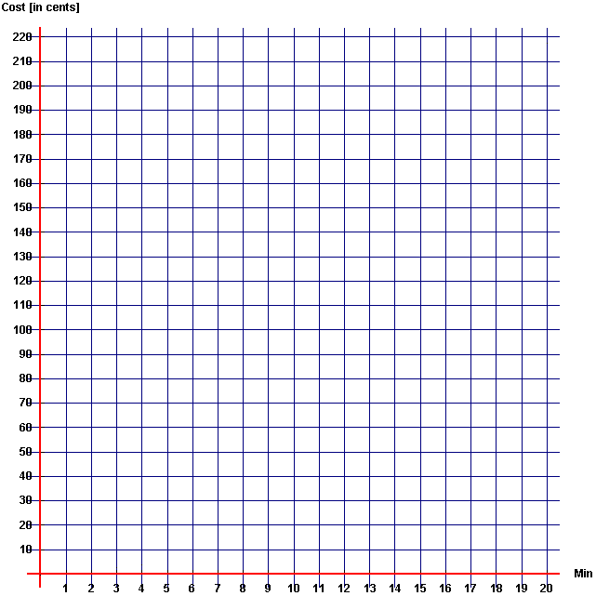

t
Label the plotted functions corresponding to Diana’s and Matthew’s phone plan.
Show the amount of minutes for which each plan charges the same amount of money.

The graphs intersect at the coordinate (t,c) in the value ( , ).

Overhead and Handout 3: Which plan would you choose?

Name: __________________________________________________ Date: _______________

Plan 1 [Matthew’s function]: m(t) = 10t
Plan 2 [Diana’s function]: d(t) = 60 + 5t
The kids in your class want to know which plan is better. What advice would you give to them?

Matthew’s plan is more expensive than Diana’s plan for people who
_____________________________________________________________

Matthew’s plan is cheaper than Diana’s plan for people who
_____________________________________________________________

The plans cost just the same if _____________________________________.

10t > 60 + 5t when t > ________ [minutes].

10t < 60 + 5t when ________ < t < ________ [minutes].

10t = 60 + 5t when t = ________ [minutes].

m(t) > d(t) when t > ________ [minutes].

m(t) < d(t) when t < ________ [minutes].

m(t) = d(t) when t = ________ [minutes].

Homework, page 1:
Name: __________________________________________________ Date: _______________

Susan and Joe shovel their neighbor’s snow in the winter.
Susan charges $0.20 per square meter.
Joe charges $5.00 to come to your house plus $0.10 per square meter.
You measured your driveway to figure out who to hire and found out that Susan and Joe would both charge you the same amount of money to clear your driveway.
Write expressions for Susan and Joe’s charges. The functions are:
s(m) = _______________
j(m) = ______________
Now write an equation to show that Susan and Joe charge the same amount of money to clear your driveway:
_____________________________________________________
Solve the equation in order to find out the amount of shoveling for which they charge exactly the same.
Susan’s plan
Joe’s plan

Homework, page 2:
Name: __________________________________________________ Date: _______________
Now plot each function below. Use the vertical axis (Cost in dollars) for representing both s(m) and j(m).
