5-12—Equations and Graphs II

Summary

Activity | Students will further compare two linear functions in the context of evaluating two plans for shoveling snow. One plan has two parts: a basic charge plus a charge based on the number of square meters cleared. The other plan has no basic charge; it only charges according to the number of square meters cleared. However the per-meter charge is higher than in the other plan. Students are asked to determine the circumstances in which the bill from each plan would be the same. They then examine the graph of the two functions and discuss how equations and inequalities relate to the graph.
Goals | To relate graphs and algebraic notation.
Terms | Function, equations, inequality, expression, solution, intersection, coordinate, rate, charge.
Hints | Focus especially on the algebraic notation, k(s)=20s and  j(s)=500+10s. Focus on the use of algebraic notation for each of the functions and for the point where the two lines cross, i.e., where 20s=500+10s.

Activities

Part 1: Discussing the Problem (30 minutes).
Show Overhead 1 with the problem:
Karen and Joe shovel their neighbor’s snow in the winter.
Karen charges 20 cents per square meter.
Joe charges $5.00 to come to your house plus 10 cents per square meter.
You measured your driveway to figure out who to hire and found out that Karen and Joe would both charge you the same amount of money to clear your driveway.
Discuss the advantages and disadvantages of each plan with the children.
Ask them whether they think that at some point the two persons could pay the same amount of money for the same amount of square meters.
One of the big questions in this lesson is: how do we express algebraically the fact that they pay the same amount in order to obtain the amount of square meters? It may be strange for students the fact that we set up an equation equaling money in order to obtain area. It is important to insist that the point that we are looking for has the same numeric value for money and for area in both functions.
In that case, ask them to find out for which number of square meters Karen and Joe will be paid the same amount. Distribute handout 1 and guide the students to:
- Express the cost of each plan as a general rule or function, where s refers to the number of square meters they shovel and k refers to the charges (the amount of money) that Karen gets for s square meters. j(s) refers to Joe’s charges. Introduce and discuss the notation,
k(s)=sx20 or k(s)=20s and
j(s)=500+(sx10) or j(s)=500+10s
Review the functional notation. Recall that k refers to Karen’s charges, s refers to the amount of money and k(s) indicates that the variable k, amount of money, depends on the variable s, amount of square meters. A similar reasoning applies to Joe’s case.
- Ask the children to write an equation that sets the amount in one plan equal to the amount in the other; namely, 20s = 500 + 10s.
- Solve the equation 20s = 500 + 10s using an equation template.
- Discuss what may happen when s assumes values different from the solution. When is one plan better than the other?

Part 2: Representing the Two Options on graph [group work] (30 minutes)
Show overhead 2 and have them analyze the given graph and develop an argument to recommend plans to their neighbors.

Part 3: Discussion of Handout: Comparing the Two Functions [whole class] (30 minutes)
Ask a few volunteers to present and discuss their answers. If there is time, use algebraic notation to represent the inequalities in different parts of the graph.

Homework: An equation and a graph

Children will work on a similar problem, will compare two linear functions (solving an equation), create tables for the two given functions, and represent the two functions graphically.

Overhead 1 and Handout 1: The Problem and the Equation
Name: __________________________________________________ Date: _______________

Karen and Joe shovel their neighbor’s driveway in the winter.
Karen charges 20 cents per square meter of snow she removes.
Joe charges $5.00 (that is, 500 cents) to come to your house plus 10 cents per square meter.
You measured your driveway to figure out who to hire. Surprisingly, you discover that Karen and Joe charge you exactly the same amount to clear your driveway.
Write expressions for Karen and Joe’s charges. The functions are:
k(s) = _______________ (s tands for the number of
j(s) = ______________ square meters shoveled)
Now write an equation to show that Karen and Joe charge the same amount of money to clear your driveway:
_____________________________________________________
Solve the equation to find out the number of square meters for which they charge exactly the same amount.
Karen’s plan
Joe’s plan

Overhead 1I and Handout II: The Problem and the Graph
Name: __________________________________________________ Date: _______________

Karen’s plan: k(s)=20s Joe’s plan: j(s)=500+10s

Label the plotted functions corresponding to Karen’s and Joe’s plan.

Your neighbors want to know which plan is better. What advice would you give to them? Explain why.

Homework, page 1:
Name: __________________________________________________ Date: _______________

Painter A charges 10 cents per square meter of wall she paints.
Painter B charges 60 cents to come to your house plus 5 cents for each square meter painted.
You measured your walls to figure out who to hire. Surprisingly, you discovered that Painters A and B would charge you the same amount to paint your walls.
Write expressions for Painter A and Painter B’s charges. The functions are:
a(s) = _______________ (s stands for the number of
b(s) = ______________ square meters painted)
Now write an equation to show that Painter A and Painter B charge the same amount of money to paint your walls:
_____________________________________________________
Solve the equation in order to find out the number of square meters for which they charge exactly the same amount.
Painter A’s plan
Painter B’s plan

Homework, page 2:
Name: __________________________________________________ Date: _______________
Show how much each painter charges for different numbers of square meters.

Painter A: Painter B:
10 cents per square meter 60 cents plus 5 cents per square meter
s [square meters] | s x 10 [cents] |  | s [square meters] | 60 + (s x 5) [cents]
0 |  |  | 0
1 |  |  | 1
2 |  |  | 2
3 |  |  | 3
4 |  |  | 4
5 |  |  | 5
10 |  |  | 10
20 |  |  | 20

Your neighbors want to know which plan is better. What advice would you give to them? Explain why.

Homework, page 3:
Name: __________________________________________________ Date: _______________
Now plot each function below.
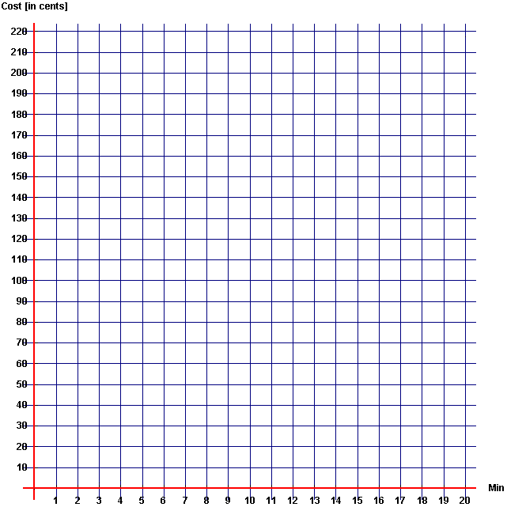
Cost in cents
Area in Square Meters

