5-13—Equations and Graphs III

Summary

Activity | Students will compare two linear functions represented in a graph. They reason about the problem using (a) the word problem and two diagrams; (b) a graph of position vs. time; (c) a table of values (d) making expressions for each position function; and (e) solving the equation algebraically.
Goals | To relate graphs and algebraic notation. To highlight a virtue of equation-solving-through-manipulation-of-algebraic-expressions (solving for x); namely, precision. (The graph has its own virtues—it highlights trends and changes over time; it also can represent piecewise functions and other functions that may not correspond to a simple algebraic expression.)
Terms | Function, equations, inequality, expression, solution, intersection, coordinate, rate, charge.
Hints | Emphasize that an equation can have non-integer solutions. And that you can’t tell for sure just where a solution lies by looking the graph of an equation.

Activities

Part 1: Discussing the Word Problem Together With Diagrams (15 minutes)
Show Overhead 1 with the problem and the diagram:
Two freight trains are racing towards each other along Cannonball Railway. They are out of control. At exactly at 9 a.m.,
- Train A is exactly 25 km north of Greensboro station and traveling north at exactly 50 kilometers per hour.
- Train B is exactly 175 km north of Greensboro station, and racing south, on the same railway track at exactly 70 kilometers per hour.
It looks like the trains are going to crash; we cannot call the conductors.
Your job is to determine exactly when they will crash if the trains keep moving along at the same speed.
You also will need to determine where they are going to crash together. If you know just where they are going to crash, you can at least tell the firemen and ambulances where they should go.
Discuss the overall situation with the children. Ask someone, perhaps several students, to make a drawing of the situation, showing what is known.
Ask the students where the trains would be after one hour (i.e., at 10 a.m.)? [A and B will be 75 km north and 105 km north of Greensboro, respectively]
Where would they be after 2 hours? [A and B will be 125 km north and 35 km north of Greensboro, respectively]
What does this information tell you? [That they either passed each other or they crashed.] We want now to get more precise information about the times and places.
Give them Handout 1 and ask them to show with labels the numerical information given in the problem (e.g. the measures, 25 km, 175km, 50 km/h, 70 km/h, and the distance between the two trains at the start and end of their journey.)

Part 2: Handout 2: Comparing the Two Functions in a Graph (15 minutes).
Show overhead 2 and give students handout 2. Allow them to use handout 1 as reference. Ask them to think about the following questions:
What does the y-axis show? What does the x-axis show?
Which train corresponds to which line? How do you know?
Do the trains crash? How do you know?
When do the trains crash?
Where along the railway line will the trains crash? How certain are you about your predictions?
Can you know with precision exactly when the crash will occur? Can you know with precision where it will occur?
What do the lines mean to the right of the crash point?

Part 3: Handout 3: Filling in a Table of Values (15 minutes)
Allow students to keep handouts 1 and 2. Give students handout 3 and have them try to fill in some of the values in the table. More advanced students will try to fill out values on the half-hour and possibly on the quarter hour.
Make sure to discuss the results at length.

Part 4: Handout 4: Filling in a Table of Values (15 minutes)
Show handout 4 and spend some time exploring with the whole class mathematical expressions for representing function a and function b. Make sure to consider the following things:
What units are used for t? [hours, t means the number of hours passed since 9a.m.]
What units are used for a(t)? [km, the number of km north of Greensboro]
What are the functions?
a(t) = 25 + 50 x  t [this should read 25 plus 50 times t]
b(t) = 175 - 70 x  t [this should read 175 minus 70 times t]
There is a lot to discuss about the difference between: 25 + 50t and 175 - 70t. Why do we add in one of them and in the other we take away? This issue might require a whole lot of the discussion. It might be useful to have a table for both of them to SEE with numbers how the two trains behave differently.

Part 4: Solving the Equation (Still handout 4) (15 minutes)
What does it mean to solve the following equation for t?
25 + 50 x  t = 175 - 70 x  t
What would we have learned if we know the value of t that makes the equation true?

Part 5: Discussion: Comparing the Two Functions [whole class] (15 minutes)
Ask a few volunteers to present and discuss their answers.
Go over the solution 150/120 and show how it can be expressed as 5/4 or 1 and 1/4.
What does this mean? [The trains will crash in 1 and 1/4 hours, that is, at 10:15 a.m..]
There are many issues about fractions that will undoubtedly arise. Given them your attention.
How can we find out where the trains will crash?
[e.g. Substitute the elapsed time into 25 + 50 x  t.
This yields 25 + 50 x  1 and 1/4 or (25 + 50 + 50/4) km]. Remember that this answer is the exact location, north of Greensboro station.

Homework:

Students are asked to solve the train crash problem on their own. We do not provide a table, graph, or equation template.

Overhead 1 and Handout I: A Train Crash
Name: __________________________________________________ Date: _______________

Two freight trains are racing towards each other along Cannonball Railway. They are out of control. At exactly 9 a.m.,
- Train A is exactly 25 km north of Greensboro station and traveling north at exactly 50 kilometers per hour.
- Train B is exactly 175 km north of Greensboro station and racing south, on the same railway track at exactly 70 kilometers per hour.
It looks like the trains are going to crash; we cannot call the conductors.
Place the numbers that you know about in the problem below. Estimate WHEN and WHERE the trains will crash.

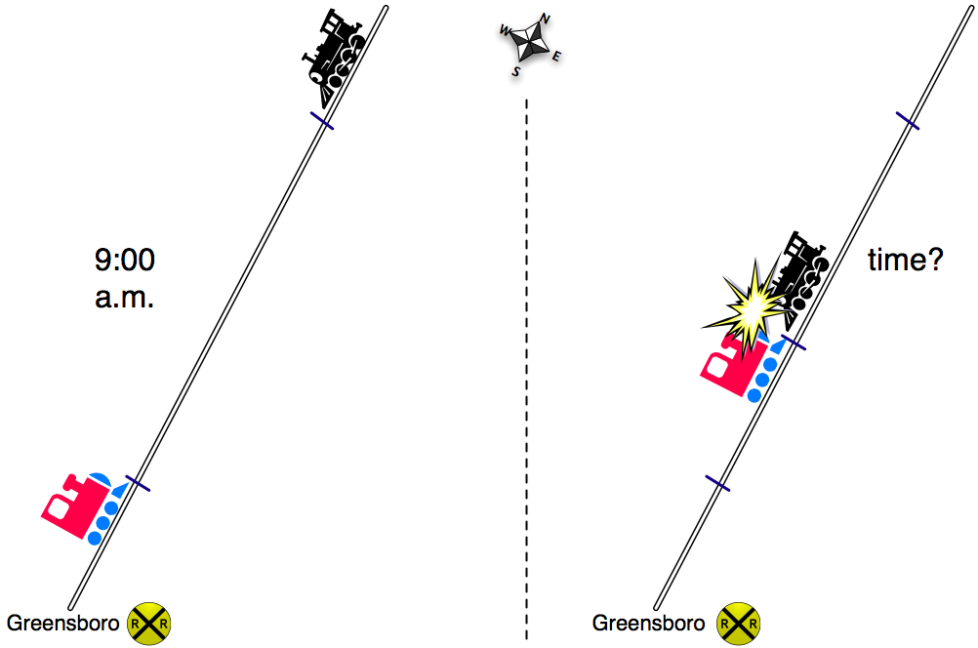

Overhead 2 and Handout 2: Reasoning from graphs
Name: __________________________________________________ Date: _______________
Two freight trains are racing towards each other along Cannonball Railway. They are out of control. At exactly 9 a.m.,
- Train A is exactly 25 km north of Greensboro station and traveling north at exactly 50 kilometers per hour.
- Train B is exactly 175 km north of Greensboro station and racing south, on the same railway track at exactly 70 kilometers per hour.
Estimate WHEN and WHERE the trains crash.
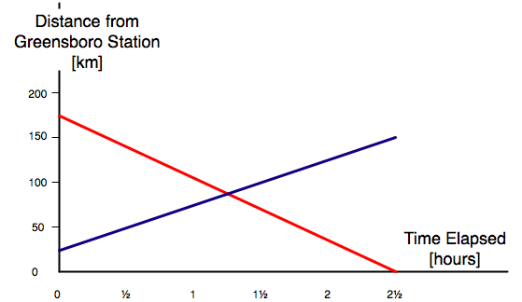

My Claim | My evidence
The time when the
trains crash is:

The place where
the trains crash is:

Overhead 3 and Handout 3: Filling in a table
Name: __________________________________________________ Date: _______________
Two freight trains are racing towards each other along Cannonball Railway. They are out of control. At exactly 9 a.m.:
- Train A is exactly 25 km north of Greensboro station and traveling north at exactly 50 kilometers per hour.
- Train B is exactly 175 km north of Greensboro station and racing south, on the same railway track at exactly 70 kilometers per hour.
Complete the following table based on the given information.

Time | Time elapsed [hours] | Position Train A: Km north of Greensboro | Position Train B: Km north of Greensboro |  | Distance between the trains.
9:00 a.m. | 0 hours | 25 | 175 |  | 175-25= 150
 | hour
9:30 a.m. | hour
10:00 a.m. | 1 hour | 25 + 50 = | 175 -
10:30 a.m. | 1 hours
11:00 a.m. | 2 hours

Overhead 3 and Handout 3: Solving the Equation
Name: __________________________________________________ Date: _______________
Two freight trains are racing towards each other along Cannonball Railway. They are out of control. Exactly at 9 a.m.
- Train A is just exactly 25 km north of Greensboro station and traveling north at exactly 50 kilometers per hour.
- Train B is exactly 175 km north of Greensboro station and racing south, on the same railway track at exactly 70 kilometers per hour.
It looks like the trains are going to crash; we cannot call the conductors.
Write expressions for Train A and Train B’s distances from Greensboro. The functions are:
Train A’s position [km north of Greensboro], a(t) = _______________
Train B’s position [km north of Greensboro], b(t) = ______________
Now write an equation to show that Train A and Train B will meet at some point on
the railway line: __________________________________________
Solve the equation in order to find out when and where the trains will crash.
Train B’s distance north of Greensboro
Train A’s distance north of Greensboro

Homework: Reviewing the Train Crash Problem.
Name: __________________________________________________ Date: _______________

Two freight trains are racing towards each other along Cannonball Railway. They are out of control. Exactly at 9 a.m.
- Train A is just exactly 25 km north of Greensboro station and traveling north at exactly 50 kilometers per hour.
- Train B is exactly 175 km north of Greensboro station and racing south, on the same railway track at exactly 70 kilometers per hour.
It looks like the trains are going to crash; we cannot call the conductors.

Write expressions for Train A and Train B’s distances from Greensboro. The functions are:
Train A’s position [km north of Greensboro], a(t) = _______________
Train B’s position [km north of Greensboro], b(t) = ______________

Show when and where the trains will crash. You can use a picture, a graph, a table, or an equation (that you solve). You can also use words to explain.

