Lesson 4-13
Graphing Halves and Doubles

Summary

Activity | Children work on a problem about distance and time and compare two rates: half a meter per second and two meters per second.
Goals | To further promote students understanding of ratios and fractions in graphical, notational, and story contexts, with a focus on continuous quantities.
Materials | Overheads and Handouts.
Terms | Ratio, slope, equivalent ratios, speed, ordered pairs, as fast as, at a steady pace, at a steady rate, faster, more quickly, more slowly, less quickly, less slowly.
Practical Hints | Have the students give their opinions about who walks faster. See if they can justify their views. Ask them to compare ratios and slopes. Represent in writing the ratios and the ordered pairs.
Notes about the math | There are several different ways to represent multiplication of quantities. Both are correct. But you must be careful not to be inconsistent in their use.  For the following discussion, presume that we are discussing a problem in which Shaquille travels for n seconds at 2 meters per second. The problem is to express how far Shaquille travels after a certain number of seconds. You can think of the speed as a function, say, f(n) := 2n. [We are using the special equals sign, :=, to show that it is a definition.]  Method 1: Showing the units  Let’s assume that n = 7s  We adults know that the answer will be 14 meters. The question is, “How can we show this?” That is, how do we start with an input of 7sec and get an output of 14 meters.  7s x 2m does not yield 14m  Nor does 7s x 2 yield 14m  Keeping track of the units requires that we conceive of the multiplication operation as  7s x  The tricky part of this expression is the intensive quantity, , which is read as “two meters per second”, “two meters for each second”, or even “two meters for every one second”. The same quantity is correctly written as:  2  2  However, regardless of format, it does not mean that the distance traveled was two meters and the time taken was one second, as students will often assert. The expression does not reveal the distance or the duration of travel. It only reveals the speed.  See (Schwartz 1976-1996) for a clarification of what this means. The article is available online at http://gseweb.harvard.edu/%7Efaculty/schwartz/semantic.htm  The part of the multiplication can be thought of as an exchange function whereby meters are exchanged for seconds.  So the multiplication  x  involves two processes: (a) it doubles the input number and (b) it exchanges meters for seconds. These need to be carefully distinguished  Method 2: Suppressing the units  Let’s assume now that n = 7. We suppress the unit of measure [seconds] here.  Likewise, we can represent the speed as 2.  And the output of 7 x 2 is 14.  The notation is much simpler than the case above. But it is also more mysterious because it glosses over the fact that (7) seconds have been transformed, so to speak, into (14) meters.  In the present lesson students will be multiplying while keeping track of the units. Make sure you are comfortable with the above distinctions before teaching this lesson.  Method 3: Showing only one of the units  There is a third way of conceiving multiplication in problems involving quantities. It is a bit of a compromise between the two methods shown above: distance is explicitly tracked but time is not.  The speed, two meters per second, tells us that 2 meters are traversed each second.  The distance can be thought of as 2m times the number of seconds.  2m x 7 yields 14m.  This representation only keeps explicit track of a single unit, meters. It is less burdensome than Method 1, but it glosses over the exchange function aspect of multiplication (Schwartz, op.cit., refers to the exchange function as the referent-transforming character of multiplication to contrast it with addition, which combines like units.)

Activities

Part 1: Generating data on a table [work in pairs]

Distribute Overhead 1. Ask children to work in pairs and develop data tables.
If necessary, use the tables in Overhead 2 to discuss children’s work.

Part 2: Plotting data [work in pairs]
Distribute Handout 2. Ask students to work in pairs and draw the graphs for the data in the tables.

Part 3: Discussing students’ work and focusing on ratios and ordered pairs [whole class]
Discuss the students’ work and explore comparisons between the two lines at the same time and at the same distance.
Focus on ratios and the writing of ordered pairs.

Part 4: Homework
The homework will be similar to the classroom activity but will refer to triples and thirds.

Overhead1: Presenting data tables.

Name: _______________________________________

Shaquille walks for a while at 2 meters per second.
Jane walks for a while at 1 meter for every 2 seconds.
Fill in the tables showing how far Shaquille and Jane walk after 1 through 10 seconds.
Shaquille Jane
Time (seconds) | Distance (meters) |  | Time (seconds) | Distance (meters)
1s | 1s x = 2m |  | 2s | 1m
 |  |  | 1s
 |  |  | 4s
 |  |  | 10s
 |  |  | 5s
 |  |  | 8s
 |  |  | 9s
 |  |  | 3s
 |  |  | 6s
 |  |  | 7s

Overhead 2: The data tables
Shaquille walks for a while at 2 meters per second.
Jane walks for a while at 1 meter for every two seconds.
Fill in the tables showing how far Shaquille and Jane walk after 1 through 10 seconds.

Shaquille Jane
Time (seconds) | Distance (meters) |  | Time (seconds) | Distance (meters)
1s | 1s x = 2m |  | 2s | 2s x = 1m
2s | 2s x = 4m |  | 1s | 1s x = m
3s | 3s x = 6m |  | 4s | 4s x = 2 m
4s | 4s x = 8m |  | 10s | 10s x = 5m
5s | 5s x = 10m |  | 5s | 5s x = 2 m
6s | 6s x = 12m |  | 8s | 8s x = 4m
7s | 7s x = 14m |  | 9s | 9s x = 4 m
8s | 8s x = 16m |  | 3s | 3s x = 1 m
9s | 9s x = 18m |  | 6s | 6s x = 3 m
10s | 10s x = 20m |  | 7s | 7s x = 3 m

Overhead 3: Graphing and comparing graphs.

Name: _______________________________________

Use the data in your tables to show in the graph space below how many meters Shaquille and Jane walk at each moment from 1 through 10 seconds.

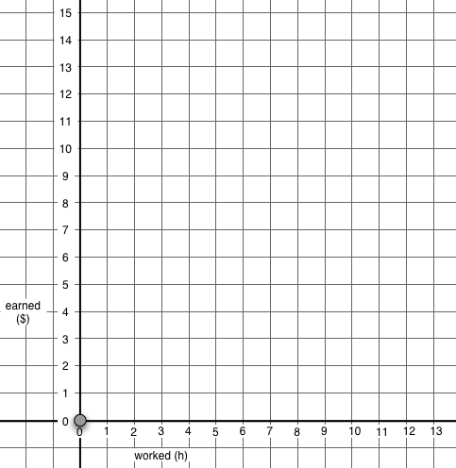

Time

(Seconds)
Walked distance (Meters)

Overhead 4: Homework (page 1)
Name: _______________________________________________________
On Sunday Shaquille walked for a while at 3 meters per second.
Jane walked for a while at 1 meter for every 3 seconds.
Make a table to show how much Shaquille and Jane walked from 1 through 10 seconds.

Shaquille Jane
Time (seconds) | Distance (meters) |  | Time (seconds) | Distance (meters)
1s | 1s x = 3m |  | 1s | 1s x = m

Overhead 5: Homework (page 2)

Name: _______________________________________

Use the data in your tables to show in the graph space below how many meters Shaquille and Jane walked on Sunday from 1 through 10 seconds.

Time

(Seconds)
Walked distance (Meters)

Schwartz, J. L. (1976-1996). Semantic aspects of quantity. Unpublished paper, Cambridge, Harvard University (73 pp.). Cambridge, MA, Harvard University, Department of Education: 40 pp.

