5-14—Elapsed Time

5-14—Elapsed Time 1
Summary 1
Activities 2
Part 1: Elapsed Time: Fractional Parts of Hours [40 min uses Handout I] 2
Discuss Elapsed Time With the Class [15 min.] 2
Distribute & Later Discuss Handout 1 [25 min.] 4
Part II. Using Elapsed Time in a Formula [40 min, uses Handout 2] 4
Recall the Formulas for the Trains (10 min.) 4
Explain, handout 2, and discuss (calculating position from elapsed time—25 min.) 4
Part III. Homework [10 min, uses Handout 3—Homework] 5
Overheads and Handouts 6
Overhead I 6
Handout 1, part 1: Time elapsed 7
Handout 1, part 1I: Time elapsed 8
Overhead 2: Formulas For Obtaining Position From Elapsed Time 9
Handout 2: Using Time Elapsed to Find Position of Train 10
Handout 3 (Homework): Position of Train B 11

Summary

Activity | A variant of the train crash problem is used to address questions about elapsed time. The task is to determine where a train is based, given a certain time.
Goals | Work with non-integral values of elapsed time (e.g. 3 hours, 1.25 hours). Plug such values into algebraic expressions, obtaining answers in (non-integral values of) position.
Terms | Elapsed time or 'time gone by' (vs. time or time of day); position; equation, expression, solution, intersection, coordinate, rate, quarter-hour, half-hour.
Hints | Make certain that students appreciate the kind of units being considered at each moment in a computation. They also should be able to nimbly move between the world of algebraic expressions to the world of the trains.

Activities
This class has three parts. In Part I, we discuss time intervals: (a) on analogue clock-faces; (b) as digital expressions (hours and minutes); (c) as hours and minutes elapsed; (d) and as fractions (mixed or not) of hours. Students work on handouts involving multiple ways to express elapsed time.
In Part II, we deal with the multiplication of (fractional values of) elapsed time by speed, giving results in km. The handout they work on has them inserting various time intervals into the formulas for positions of train A (see problem from previous lesson.
For homework (Part III), they do problems similar to the ones in Parts I and II. (Train B is used for the homework).

Part 1: Elapsed Time: Fractional Parts of Hours [40 min uses Handout I]

Discuss Elapsed Time With the Class [15 min.]
During last lesson, several students were puzzled about fractional (and decimal expressions of elapsed time). This introduction will address those issues. However, it cannot fully 'solve' all of the matters that might arise; e.g. we will not consider decimal expressions of time.
Go over several intervals to make sure that students can move among the diverse representational forms.
This is the template (see Overhead 1) that you may wish to have multiple copies of.
Start Time | End Time | Elapsed Time
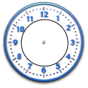

The examples below show some items you may wish to discuss using Overhead 1. But in the lesson, elicit times and values from students; don't provide all the values.
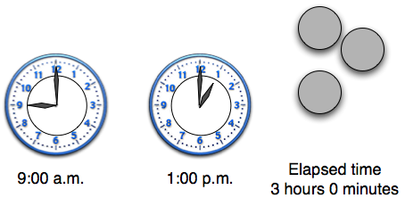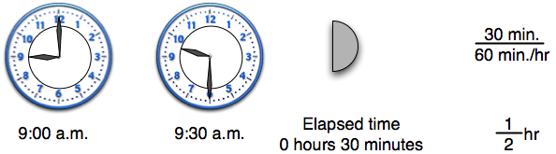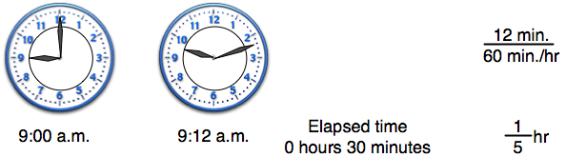

Distribute & Later Discuss Handout 1 [25 min.]
Display Handout I and go over the Instructions. Students are to fill in the table using times of their own.
When they are done, collect the handouts and discuss various issues that arose: things kids were unsure of, how to get from hours, minutes to fractional values, etc.

Part II. Using Elapsed Time in a Formula [40 min, uses Handout 2]

Recall the Formulas for the Trains (10 min.)
Remind students of the train problem from Lesson 5-13. Today we're going to focus on the formulas that were used in the example.
Train A a(h) = 25 + 50h
Train B b(h) = 175 – 70h
Here are some questions to consider discussing with students.
- What units are associated with the 25, h, 50, and a(h)
- When you know the value of a(h) what does it tell you?
- How do you figure out where a train is?

Explain, handout 2, and discuss (calculating position from elapsed time—25 min.)

Go over the new, horizontal diagram of the trains so that the students know that it refers to the same trains as in 5-13. However, this week we assume they do not crash.
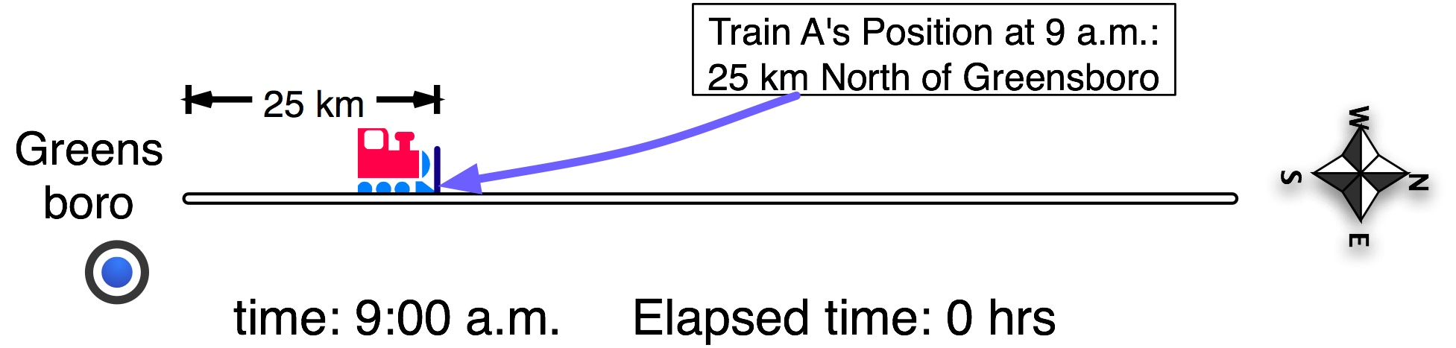

Before handing out the worksheet/handout, go through the first two examples, namely, the cases where the elapsed times are 1 and 1 and ½ hours.

The first case is relatively straightforward.
The second involves breaking up the multiplication into two parts (first by one, then by one half). It therefore makes use of the distributive law.

Elapsed [hours, minutes] | Elapsed  [hrs] | Position  25 + 50h | Position [km] | Position [km]
1h  0 min | 1 h | 25 + 50 x (1) | 25+(50 x 1) | 25+(50)=
1h 30 min | 1$\frac{1}{2}$ h | 25 + 50 x (1$\frac{1}{2}$) | 25+(50 x 1)+(50 x $\frac{1}{2}$)

Discuss the results kids got in their tables. Make sure they understand what the answer in the last column means.

Part III. Homework [10 min, uses Handout 3—Homework]
Exactly like Handout 2. However, this we are considering the path of Train B.

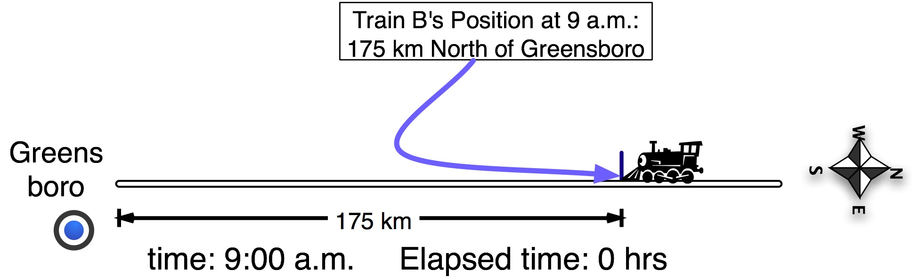

Overheads and Handouts

Overhead I

Start Time | End Time | Elapsed Time

Handout 1, part 1: Time elapsed
Name: __________________________________________________ Date: _______________

Start Time | End Time | Elapsed [hours, minutes] | Elapsed  [hrs]
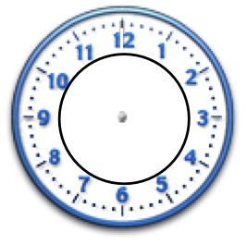  10:15 a.m. | 11:30 a.m | 1h 15 min | 1$\frac{\text{15}}{\text{60}}$ h  1$\frac{1}{4}$ h  $\frac{5}{4}$ h
 | 11:30 a.m |  | $\frac{1}{4}$ h
 |  |  | h
 |  |  | h

Handout 1, part 1I: Time elapsed
Name: __________________________________________________ Date: _______________

Start Time | End Time | Elapsed [hours, minutes] | Elapsed  [hrs]
10:15 a.m. | 11:30 a.m

Overhead 2: Formulas For Obtaining Position From Elapsed Time

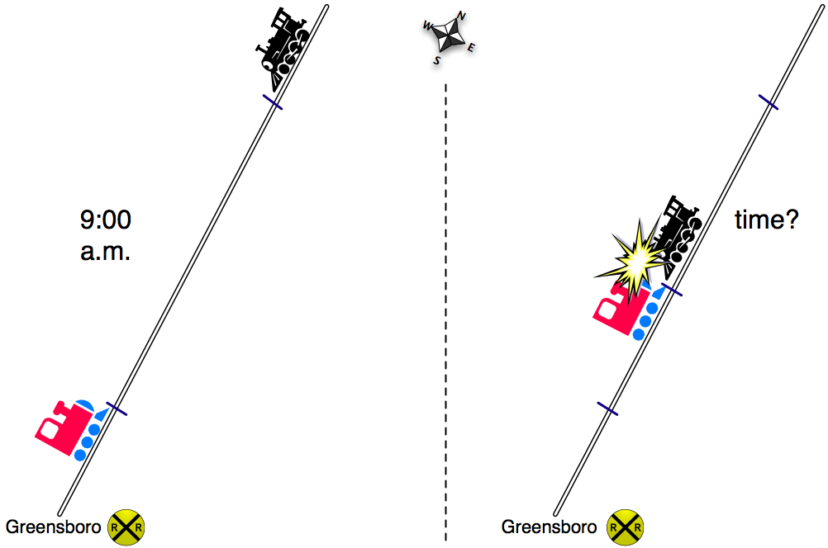

Formula For Train A a(h) = 25 + 50h

Formula for Train B b(h) = 175 – 70h

Handout 2: Using Time Elapsed to Find Position of Train
Name: _____________________________________ Date: _______________

a(h) = 25 + 50h
Elapsed  time [hrs,min] | Elaps-  ed time  [hrs] | Position  25 + 50h | Position [km] | Position [km]
1h  0 min | 1 h | 25 + 50x(1) | 25+(50x1) | 25+(50)=
1h 30 min | 1$\frac{1}{2}$ h | 25 + 50x(1$\frac{1}{2}$) | 25+(50 x 1)+ (50 x $\frac{1}{2}$)
2h | 2 h | 25 + 50x(2)
2h 30 min | 2$\frac{1}{2}$ h
3 | h | 25 + 50x( )
3h 30 min
4h

Handout 3 (Homework): Position of Train B
Name: _________________________________________ Date: ___________

b(h) = 175 - 70h
Elapsed time [hours, minutes] | Elaps-  ed time  [hrs] | Position  175 -70h | Position [km] | Position [km]
0h 30 min | $\frac{1}{2}$ h | 175 - 70 x ($\frac{1}{2}$) | 175 - (70 x $\frac{1}{2}$) | 175-35=
1h | 1h | 175 - 70 x ( )
1h 30 min | 1$\frac{1}{2}$ h | 175 - 70 x (1$\frac{1}{2}$) | 175-(70 x 1)-(70 x $\frac{1}{2}$)
2h | 2 h | 175- 70 x (2)
2h 30 min | 2$\frac{1}{2}$ h | 175 + 70 x ( )
3 h | 3 h

