Lesson 4-14

Graphing Thirds and Triples

Summary

Activity | Children work on a problem about distance and time and compare two rates: one third of a meter per second and three meters per second.
Goals | To further promote students understanding of ratios and fractions in graphical, notational, and story contexts, with a focus on continuous quantities.
Materials | Overheads and Handouts.
Terms | Ratio, slope, equivalent ratios, speed, ordered pairs, as fast as, at a steady pace, at a steady rate, faster, more quickly, more slowly, less quickly, less slowly.
Practical Hints | Have the students give their opinions about who walks faster. See if they can justify their views. Ask them to compare ratios and slopes. Represent in writing the ratios and the ordered pairs.

Activities

Part 1: Generating data on a table [whole class]
Show, discuss, and complete the tables in Overhead 1. This is based on the problem that the students solves as homework for last lesson (4.13 Graphing Doubles & Halves)

Part 2: Plotting data [work in pairs]
Distribute the Handout (Overhead 2). Ask students to work in pairs and draw the graphs for the data in the tables.

Part 3: Discussing students’ work and focusing on ratios and ordered pairs [whole class]
Discuss the students’ work and explore comparisons between the two lines at the same time and at the same distance.
Focus on ratios and the writing of ordered pairs.

Part 4: Homework
The homework will be similar to the classroom activity but will refer to fourths.

Overhead1: The data.
Carlos walked for a while at a constant speed of 3 meters per second.
Marina walked for a while at a constant speed of 1 meter for every 3 seconds, or 1/3 meter per second.
Show below how much Carlos and Marina walked by various moments from 1 through 10 seconds.
Carlos Marina
Elapsed time (seconds) | Distance (meters) | Distance (meters)
1s | 1s x = 3m | 1s x =
2s | 2s x = 6m | 2s x =
3s | 3s x = 9m | 3s x =
4s | 4s x = 12m | 4s x =
5s | 5s x = 15m | 5s x =
6s | 6s x = 18m | 6s x =
7s | 7s x = 21m | 7s x =
8s | 8s x = 24m | 8s x =
9s | 9s x = 27m | 9s x =
10s | 10s x = 30m | 10s x =

Overhead 2: Graphing and comparing graphs.
Name: _______________________________________
Use the data in the table to show in the graph space below how many meters Carlos and Marina walk during the interval from 1 through 10 seconds.

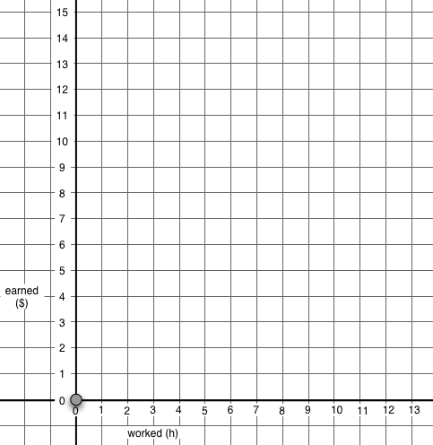

Time

(Seconds)
Distance Walked
(Meters)

Overhead 3: Homework page 1
Name: _______________________________________________________
Carlos walked for a while at 4 meters for every second.
Marina walked for a while at 1 meter for every 4 seconds.
Make a table to show how much Carlos and Marina walked at each moment from 1 through 10 seconds.

Overhead 4: Homework page 2
Name: _______________________________________

Use the data in your tables to show in the graph space below how many meters Carlos and Marina walk from 1 through 10 seconds.

Time

(Seconds)
Distance walked (Meters)

