5-16—Varying Rates of Change

Summary

Activity | Students will compare three functions, two of which are nonlinear, that tell the story of three cousins who all save $1,000 in one year. One saves a lot the first day and less and less each day as time goes on; one saves very little the first day and more and more each day throughout the year; the last sister saves the same amount each day. Students will be asked to predict the shape of the graph for each function and, later, to look at and describe graphs of all three cousins’ savings.
Goals | To develop skills with varying rates of change (even when we may not be able to write a formula). To understand the difference between cumulative amounts (total savings) and daily. To understand the basic graph types (graphicles) that vary in rates of change (see note below).
Terms | Function, rate, change, cumulative, slope, increasing, decreasing, slower, faster, ratio of x-variation to y-variation, slope of the secant line, slope of the tangent line.
Hints | Emphasize that we can describe a lot about a graph without knowing exact coordinates or formulas.
Note | This lesson was inspired by Judah L. Schwartz and his notions about elementary graph shapes. Here we introduce seven elementary graph shapes which we shall call 'graphicles' (a term we made up here). It is useful to think of any graph as made up of these basic shapes. The following section is written to give teachers a sense of the underlying mathematical ideas.

Background

This section covers some of the mathematical ideas that went into the present lesson. It is written for adults, particularly teachers, with a grounding in mathematics. Pay attention to how we describe different graphs of functions over time. You might want to think of the examples in terms of graphs showing how much money a person has over a certain interval of time.

The simplest case of a function over time is one in which there is no change at all. This is conveyed by a graph that is parallel to the x-axis (Table 1).

Table 1: A constant function shows no change over time.
graphicle zero
derivatives | f'(x) | f''(x)
 | 0 | 0
description  Amount or  intensity | no change; does not increase or decrease
example  Money | The person always has the same amount of money; she neither saves nor spends. The bank balance remains constant.

Elementary Graphs Related to Today's Lesson

Table 2 shows three graphicles representing increase over time..

Students are already familiar with Graphicle 1, which displays a function that increases steadily over time. Graphicle 1 tells the story of a person who saves the same amount each day. Graphicle 2 tells the story of a person who saves less and less each day. Graphicle 3 conveys the story of a person who saves more and more each day. In today's lesson, each graphicle corresponds to one of the cousins in the story: Patty, Elizabeth, and Carly. See the lesson’s story problem for details.

[Advanced note: The first derivative, f'(x), is positive for each case because the slope of the graph is upward-as-you-go-right. The second derivative, f''(x) captures the changes in the increase, as time passes.]

Table 2: Graphicles Showing Increase Over Time (Saving)
graphicle | 1   |  | 2   |  | 3  
derivatives | f'(x) | f''(x) | f'(x) | f''(x) | f'(x) | f''(x)
 | + | 0 | + | - | + | +
description  Amount or  intensity | increases | steadily | increases | by less & less | increases | by more and more
example  Money | Patty saves the same amount of money each day |  | Elizabeth starts saving lots of money each day, but saves less and less each day; |  | Carly starts saving just a little money each day, but saves more and more each day.
Note | Constant increase |  | The total amount is always increasing; the amount saved on a given day is smaller and smaller as time passes |  | The total amount is always increasing; the amount saved on a given day becomes larger and larger as time passes

Elementary Graphs For Today's Homework

The homework will deal with stories in which amounts decrease over time. Students must consider Graphicles 4-6 for these cases. .

Graphicle 4 tells the story of the brother, Jake, who spends the same amount each day. Jake's savings decrease by the same amount each day.

Graphicle 5 tells the story of Martin, who spends more and more each day. Note: At the end of each day, he has less money (accumulated) than the day before. Also, on each day he spends more money than the day before.

Graphicle 6 tells the story of Peter, who spends less and less each day. At the end of each day, he also has less money (accumulated) than the day before. However, on each day he spends less money than the day before.

Table 3: Graphicles for Decrease Over Time (Spending)
graphicle | 4   |  | 5   |  | 6  
derivatives | f'(x) | f''(x) | f'(x) | f''(x) | f'(x) | f''(x)
 | - | 0 | - | + | - | -
description  Amount or  intensity | decreases | steadily | decreases | by more and more | decreases | by less & less
example  Money | Jake spends the same amount of money each day |  | Martin starts spending just a little money each day, but spends more and more each day; |  | Peter starts spending a lot of money each day, but spends less and less as time passes.
Note | Jake's total is constantly decreasing. |  | Martin's total amount is always decreasing; the amount he spends on a given day is grreater and greater as time passes |  | Peter's total amount is always decreasing; the amount he spends on a given day is less and less as time passes

Additional Thoughts: Derivatives

The first derivative of a function at a point is the slope of the tangent line to the graph of the function at that point. By observing the slope of the derivative, we can tell how the function is changing at that instant. All of the points along the Graphicles 1 to 3 have a positive slope or derivative. However, the derivative (slope of the tangent) of Graphicle 2 becomes less steep as time proceeds. If you were to plot the derivative of Graphicle 2 over time, that graph (of the derivative) would also have a slope. It's slope, that is the second derivative of Graphicle 2 would be negative.

For more information, see: Eric W. Weisstein, "Tangent Line". From MathWorld--A Wolfram Web Resource. http://mathworld.wolfram.com/TangentLine.html. You may also want to read up on secants, which deal with what happens as two points on a line get closer and closer. [See: Eric W. Weisstein, "Secant Line". From MathWorld--A Wolfram Web Resource. http://mathworld.wolfram.com/SecantLine.html.]

Activities

Part 1: Discussing the Word Problem
Show Overhead 1 with the problem:

The Three Cousins Story
Elizabeth Excited, Patty Planner, and Carly Catch-up are all cousins. Next year, they would like to send their grandmother on a big vacation for her birthday, but the trip will cost $3,000. Elizabeth, Patty, and Carly decide that they have one year to raise $1,000 each.
Elizabeth starts saving a lot of money on the very first day and realizes that she would like to have some money for herself too. So, each day, she puts less money into her bank account than the day before.
Patty figures out exactly how much money she will need to save each day to reach $1,000 in one year and she puts the same amount of money into her account each day.
Carly begins by saving very little but each day she puts more money into her account than the day before.

All three girls are successful in saving exactly $1,000 at the end of the year.
Discuss the overall situation with the children. Ask someone, perhaps several students, to explain the situation, describing what is known.
Ask the students what they think a graph of each cousin might look like.
Distribute Handout 1 and obtain graphs from each of the students.
Choose various graphs from the students and then discuss them. Here are some questions to consider:
- Who has the most money at the beginning of the year?
- Who has the most money at the end of the year?
- Who has the most money at mid-year? Who has the least?
- Who starts off saving the most money each day? Who starts off saving the least?
- Who ends up saving the most money each day?
- Is there a day in which the two of the cousins have the same amount?
- Is there a day on which two cousins save the same amount?

Part 2: Handout 2: Comparing the Two Functions in a Graph
Show overhead 2 and give students handout 2. Allow them to use handout 1 as reference. Ask them to think about the following questions:
Which cousin corresponds to which line? How do you know?
How would you describe in words Elizabeth’s graph? Patty’s? Carly’s?
Can you know who saves more money on a particular day? How?

Part 3: Group Discussion
Show table with 8 different types of graphs. Which one shows increasing slower and slower? Decreasing slower and slower? Increasing faster and faster? Etc.

Homework:

Children will be asked to solve a similar problem but, this time, the story refers to the amounts of money spent by three children over time.

Overhead 1 and Handout I: Saving Strategies
Name: __________________________________________________ Date: _______________

The Three Cousins Story
Elizabeth Excited, Patty Planner, and Carly Catch-up are all cousins. Next year, they would like to send their grandmother on a big vacation for her birthday, but the trip will cost $3,000. Elizabeth, Patty, and Carly decide that they have one year to raise $1,000 each.
Elizabeth starts saving a lot of money on the very first day and realizes that she would like to have some money for herself, too, so each day, she puts less money into her bank account than the day before.
Patty figures out exactly how much money she will need to save each day to reach $1,000 in one year and she puts the same amount of money into her account each day.
Carly begins by saving very little but she realizes that she will not save enough money in time, so each day she puts more money into her account than the day before.

All three girls saved exactly $1,000 at the end of the year.
Draw graphs showing how much money Elizabeth, Patty and Carly had during the year.
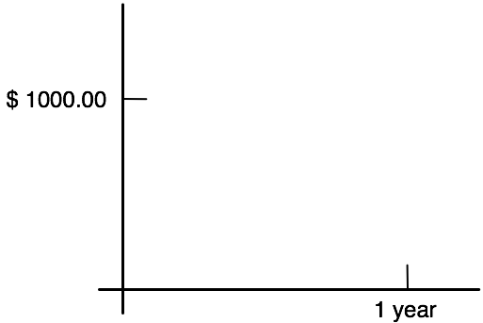

Overhead 2 and Handout 2: Reasoning from graphs
Name: __________________________________________________ Date: _______________

Look at the graphs below.

Which graph represents Elizabeth’s savings? ____________________
Which graph represents Patty’s savings? _______________________
Which graph represents Carly’s savings? _______________________
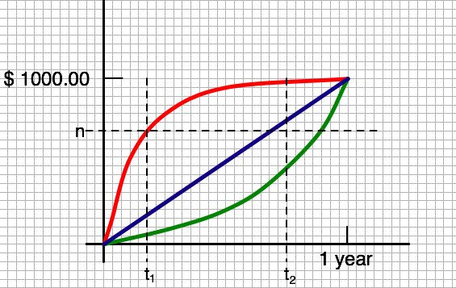

Who had the most money on day t₁? __________________________________
Who saved more money on day t₁? (Just that day) _______________________
Who had the most money on day t₂? __________________________________
Who saved more money on day t₂? (Just that day) _______________________

How long, approximately, does it take each girl to save n dollars? (Use a fraction such as ¼ year, ½ year, etc.
Elizabeth_______________________________________________________
Patty__________________________________________________________

Carly__________________________________________________________

Homework: Reasoning from graphs (page 1)
Name: _______________________________________ Date: __________

The three brothers, Jake, Martin, and Peter each bring $1,000 to spend on their 100 day vacation.
Peter spends a lot of money on the first day of the trip, but then realizes that he might run out! So, each day, he spends less than the day before.
Jake figures out exactly how much he can spend every day to have enough money for the entire ten days of the trip. He spends the same amount each day.
Martin wants to make sure that he doesn’t run out of money so he is careful at the beginning of his trip and doesn’t spend a lot on the first day, but each day he spends more than the day before.
At the end of the trip, all three boys had spent all of their money.
Draw graphs showing how much money Peter, Jake and Martin had during the 100 day vacation.

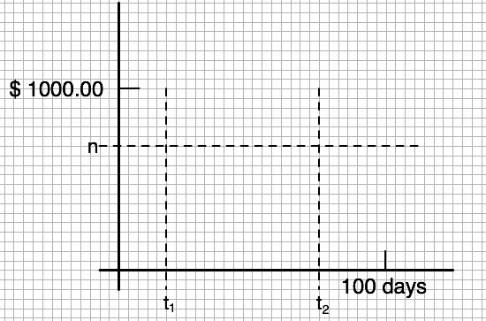
k

Homework: Reasoning from graphs (page 2)
Name: _______________________________________ Date: __________

Who had the most money on day t₁? __________________________________
Who spent more money on day t₁? (Just that day) _______________________
Who had the most money on day t₂? __________________________________
Who spent more money on day t₂? (Just that day) _______________________

How long, approximately, does it take each boy to reach k dollars?

Peter_________________________________________________________

Jake__________________________________________________________

Martin_________________________________________________________

