Lesson 4.16: Varying Velocity

Summary

Activity | Children are asked to tell a story about a trip depicted through a graph.
Goals | Explore how speed and velocity are conventionally represented through graphs according to slope. Introduce velocity as speed with direction. Deal with the facts that (a) a totally horizontal segment conveys absence of movement, (b) a left-to-right downward segment on the graph indicates that the distance from the person to the house decreases, even though the person is still walking (the cumulative distance nonetheless increases)
Terms | Speed, velocity, ordered pairs, as fast as, at a steady pace, at a steady rate, faster, more quickly, more slowly, less quickly, less slowly. Increasing, decreasing, and constant segments. Distance from [name of a person] to her/his house. Elapsed time.

Activities

Part 1: Writing a story about a graph [Small group work]
Show Overhead 1 and distribute the corresponding Handout 1.
Ask the children to work in pairs and write a story about what is shown on the graph.

Part 2: Discussing children’s stories [Whole class]
Select a few stories to discuss.
Explore comparisons between different segment slopes.
Some ideas that you may want to discuss with your students:
- Where did Kevin start his walk? Did he start at his house?
- Did he end up at his house?
- Did he ever go to his house?
- What is the maximum distance at which he was from his house?
- What is happening from E to F? Is Kevin still walking? Why is the line going down? What happens with the time in this interval? What happens to the distance in this interval? (the time increases but the distance decreases)
- When did Kevin go the fastest? When did he walk the most meters per hour? How do you know?
- Explain what is happening from A to B. And from D to E. What is varying? What is constant?
Why does the steepness of a line tell you?

Part 3: Homework
The homework will be similar to the classroom activity.

Overhead1 and Handout 1 (page 1): The graph.
Name: _______________________________________
The graph below shows how Kevin walked yesterday. Write a story about how Kevin walked.
A
B
C
D
E
F

Seconds
Meters
Distance between Kevin and his house
(Meters)

Time elapsed during his walk

(Seconds)

Handout 1 (page 2): The story.
Name: _______________________________________
Below, write a story about Kevin’s walk.
You can describe where Kevin went , how far he was from his house, when he was and where he was at that time, how fast he walked, where he walked faster and, where he started his walk.
What else can you describe?

Homework (page 1): The graph.
Name: _______________________________________
The graph below shows how Lisa walked yesterday. Write a story about how Lisa walked.
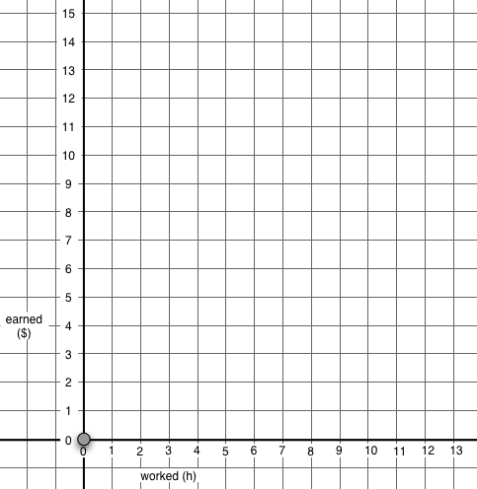
A
B
C
D
E

Seconds
Meters

Time elapsed during her walk

(Seconds)
Distance between Lisa and her house
(Meters)

Homework (page 2): The story.
Name: _______________________________________
Below, write a story telling how Lisa walked.
You can describe where Lisa went, how far she was from her house, when she was and where she was at that time, how fast she walked, where she walked faster and, where she started her walk.
What else can you describe?

