Lesson 4.17

Assessment III:

Summary

Activity | This is a written assessment where children will work with verbal comparisons between quantities, equations, and true and false equations and statements and with graphs.
Goals | To evaluate children’s learning about graphs and about algebraic notation for measurements and about how they deal with argumentation on true and false statements.
Materials | Written questions.
Terms | Equals, divided by, times, three times as much, two times as much, half, one third.  Speed, velocity, ordered pairs, as fast as, at a steady pace, at a steady rate, faster, more quickly, more slowly, less quickly, less slowly.

Name: _________________________________________ Date: _________
The graph below shows how Aline walked yesterday.

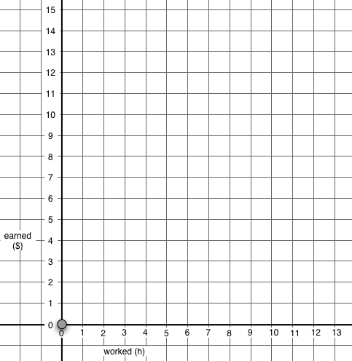
A
B
C
D
E

Time elapsed during her walk

(hours)
Miles
Distance from Alina’s House
(in Miles)

Answer the questions about this graph on the next pages.
Name: _______________________________________

1. Write a story talking about Alina’s trip.
You can describe where Alina went, how far she was from her house at the end of her trip, when she was at each point, where she was at each time, how fast she walked, where she walked faster and, where she started her walk.
What else can you describe?

2. How many hours did her trip last? ________________

3. How many miles did she walk altogether on her trip? _______________

4. How many miles does she still have to walk to get to her house? _______

Name: _______________________________________
5. Which statements about Alina’s trip are True or False?
Circle your answer.

 | True or | False? | Explain
Alina walked fastest from A to B | True | False
Alina walked fastest from D to E | True | False
Alina walked slowest from C to D | True | False
Alina walked slowest from D to E | True | False

6. Jason has three times as much money as Sally. How much money does Sally have? [More than one answer could be true.]
- Sally has 3 dollars.
- Sally has 50 cents.
- Sally has one third of the amount Jason has.
- Sally has three times the amount Jason has.
- None of the above answers is correct.
Explain your answer:

7. The amount of money Ramon has is equal to one third of the amount of money Mary has. How much money does Ramon have? [More than one answer could be true.]
- Ramon has 3 dollars.
- Ramon has 1 dollar.
- Ramon has three dollars less than Mary.
- Ramon has three times the amount Mary has.
- None of the above answers is correct.
Explain your answer.
Name: _________________________________________ Date: _________

8. The distance from Marina’s home to her school is exactly twice the distance from Tony’s home to his school.

True? False? or ‘You can’t tell ? [Circle your answer]

Marina is ten years old | True | False | You can’t tell.
Tony is five years old. | True | False | You can’t tell.
Marina’s home is very far from the school | True | False | You can’t tell.
The distance from Tony’s home to the school is half the distance from Marina’s home to the school. | True | False | You can’t tell.
Marina walks twice as much to get to her school as Tony does. | True | False | You can’t tell.
Tony’s home is closer to his school than Marina’s. | True | False | You can’t tell.

Name: _________________________________________ Date: _________
9. Karina and Jimmy collect baseball cards. Jimmy has three times as many cards as Karina has.
K means how many cards Karina has.
J means how many cards Jimmy has.
For each of the following equalities, circle an answer to indicate whether the equality is true or false.
 | True or | False? | Explain
K = 3 x J | True | False
J = 3 x K | True | False
J = K | True | False
K = × J | True | False
K = J ÷ 3 | True | False
J = | True | False

