5-17 — Basic Function Shapes

Summary

Activity | In this lesson, the students will (a) discuss, represent, and solve a verbal problem involving the choice between two functions; (b) choose, among 8 basic graphs (7 distinct shapes), the one that matches specific situations; and (c) write stories to match a specific graph shape.
Goals | Identify the basic function shapes that match specific situations.
Terms | Function, pattern, “grows by”, “changes by … each time”, increases/decreases, faster/slower, steady rate.

Activities

Part 1: Representing the Two Options on a Table [whole class: 25 minutes]
Show the problem (Overhead 1) and ask children to read and discuss it.
Your grandmother offers to give you, for the whole year, one of 2 deals:
- Deal A: 5 cents every day
- Deal B:
  - She gives 1 cent on day 1,
  - She gives 2 cents on day 2,
  - She gives 3 cents on day 3, and so forth.
Which deal would you accept, Deal A or Deal B?
Show that the deal you chose is better.
What would the increase of your total amount of money look like for each deal?
- Which deal would you choose?
- Is one deal better than the other? Always?
- When is deal 1 better than deal 2?
- When is deal 2 better than deal 1?
- Will the two deals ever give you the same amount of money?
Ask a few children to predict on the overhead the shape of the graph for each deal. Discuss their suggestions with the whole class.

Part 2: Matching the Deals to Graphs [whole class and group work: 25 minutes]
Show Overheads 2a and b and discuss the meaning of each shape.
Distribute Handout 1a and b and ask the children to choose the graph that corresponds to each deal and to explain their choices.
Ask a few volunteers to present and discuss their answers.

Part 3: Making Up Stories to Match a Graph [group work and whole class: 25 min]
Show Overhead 3 and distribute Handout 2a and b. Ask the children to write different context stories that will match the same graph.
Ask a few volunteers to present and discuss their stories.

Part 4: Homework (Overhead 4)
They will solve a problem similar to the one they discussed in class.

Overhead 1: The Problem
Your grandmother offers to give you, for the whole year:
- Deal A: 5 cents every day
- Deal B:
  - She gives 1 cent on day 1,
  - She gives 2 cents on day 2,
  - She gives 3 cents on day 3, and so forth.
Which deal would you accept, Deal A or Deal B? Why?

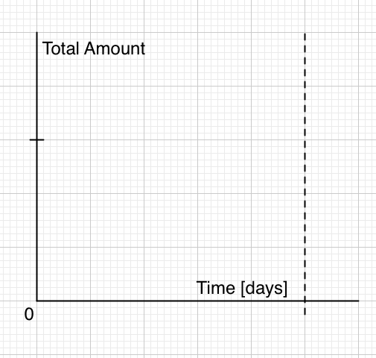

Part 2: Overhead 2a: 8 graphs (7 basic shapes) (20 minutes).
Go over each graph below, discussing its meaning in the contexts of saved amounts, growth, and swimming pools (water height or depth): Which graphs show increases, decreases, no change? Which one increases/decreases faster and faster? Slower and slower?

Graph 1  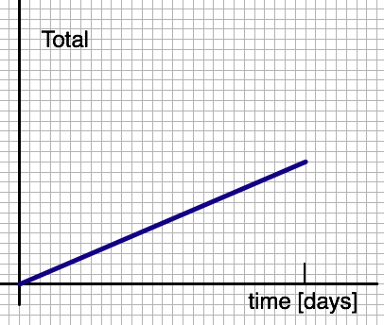 | Graph 2  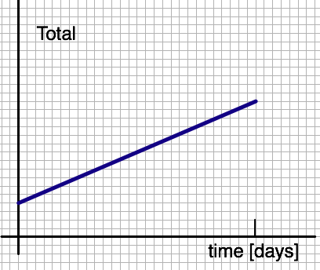 | Graph 3  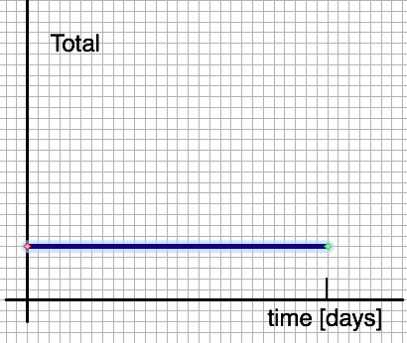
Graph 4  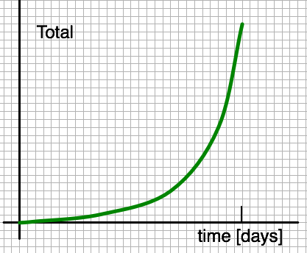 | Graph 5  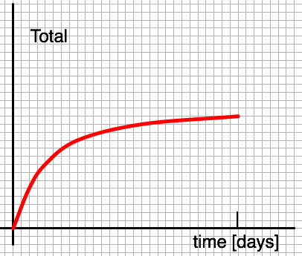 | Graph 6  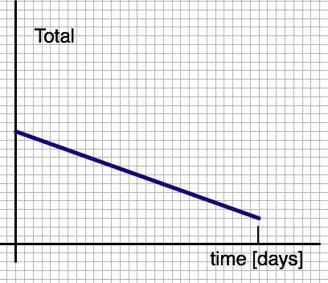
Graph 7  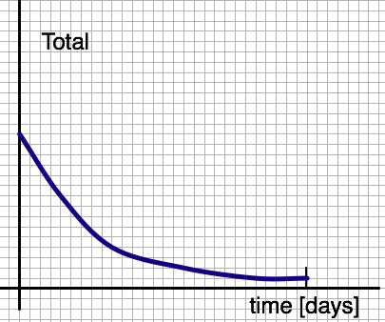 | Graph 8  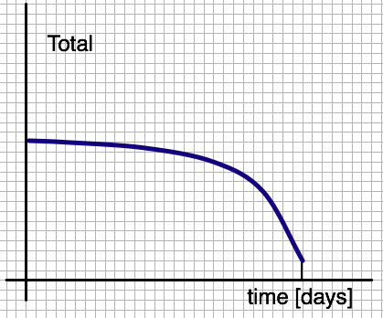

Part 2: Overhead 2b: 8 graphs (7 basic shapes) (20 minutes).

Here are the same graphs but with labels that clarify the meanings.
1-Increases steadily | 2-Increases steadily; doesn't start at zero | 3-No change
4-Increases faster & faster | 5-Increases slower & slower | 6-Decreases steadily
7-Decreases slower & slower | 8-Decreases faster & faster

Handout 1a: Finding the Graph for Each Deal
Name: __________________________________________________ Date: _______________

Look carefully at graphs 1-8 and answer the questions on the next page.

Graph 1 | Graph 2 | Graph 3
Graph 4 | Graph 5 | Graph 6
Graph 7 | Graph 8 | Box 9  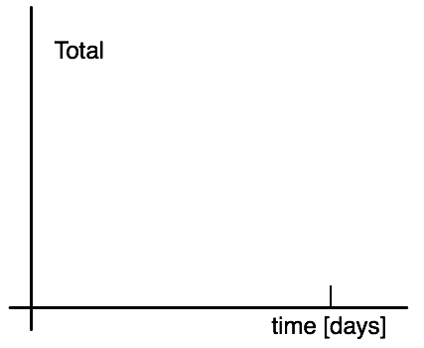

Handout 1b: Finding the Graph for Each Deal
Name: __________________________________________________ Date: _______________

Deal A is like Graph _______
Explain why: ____________________________________________________
_____________________________________________________________
_____________________________________________________________
_____________________________________________________________
_____________________________________________________________

Deal B is like Graph _______
Explain why: ____________________________________________________
_____________________________________________________________
_____________________________________________________________
_____________________________________________________________
_____________________________________________________________

In box 9, draw graphs for both Deal A and Deal B.

Overhead 3 and Handout 2a: Writing a Story to Match a Graph
Name: __________________________________________________ Date: _______________

Look carefully at the graph below and answer the questions on the next page.

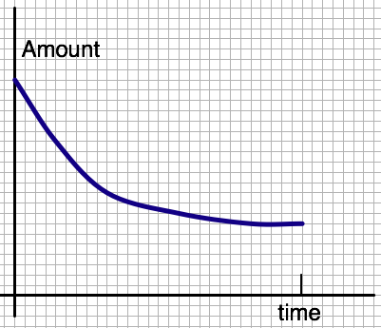

Handout 2b: Writing a Story to Match a Graph
Name: __________________________________________________ Date: _______________
1. Imagine that the graph shows the amount of money in your bank account over the last year. Write a story corresponding to the graph.

2. Imagine that the graph shows the level of water in a swimming pool over one week. Write a story corresponding to the graph.

3. Imagine that the graph above shows the number of traffic accidents in Boston between 1950 and 2000. Describe what the graph shows.

Homework 1
Name: __________________________________________________ Date: _______________

Your grandfather offers to give you, for one month…
- Deal K: 5 dollars on each day.
- Deal L:
  - 1 dollar on day 1,
  - 2 dollars on day 2,
  - 3 dollars on day 3, and so forth.
Which deal would you accept, Deal K or Deal L? _____ Explain why:

Look at the graphs on the next page:

Deal K is like Graph _______
Explain: _______________________________________________________
_____________________________________________________________
_____________________________________________________________
_____________________________________________________________
_____________________________________________________________
_____________________________________________________________
_____________________________________________________________
_____________________________________________________________

Deal L is like Graph _______
Explain: _______________________________________________________
_____________________________________________________________
_____________________________________________________________
_____________________________________________________________
_____________________________________________________________
_____________________________________________________________
_____________________________________________________________
_____________________________________________________________

In box 9, draw graphs for both Deal A and Deal B.

Homework 2: Representing the Problem
Name: __________________________________________________ Date: _______________

Graph 1 | Graph 2 | Graph 3
Graph 4 | Graph 5 | Graph 6
Graph 7 | Graph 8 | Graph 9

