Lesson 4.18
Graphing A Story About A Trip

Summary

Activity | A trip is described in miles, hours, and miles/hr. Students produce a graph from the description. They then produce a table from the graph.
Goals | Explore how speed and velocity are conventionally represented through graphs according to slope. Introduce velocity as speed with direction. Deal with absence of movement and change in direction.
Terms & expressions | “how long…?”, “how far…?”, “how fast…?”, “how far away…?”, Clock Time, Elapsed Time

Activities

Part 1: Building a graph from a story [Small group work]
Show Overhead 1 and distribute the corresponding Handout 1.
Ask the children to draw a graph that corresponds to the story about Marcus’ trip. They may work in pairs.

Part 2: Discussing children’s stories [Whole class]
Select a two, possibly three, graphs to discuss. Select them according to the variety of interpretations of the story.
Have the designers of one graph (one with some errors) explain how the graph corresponds to each part of the story. Go through the explanation with great care, making sure that other students are grasping what the designers tried to do. Encourage the other students to express their doubts and reservations. When possible, have those students speak directly to the designers. Give the designers an opportunity to defend their reasoning, and to alter their graph if need be.
During the discussion it may be helpful to refer explicitly to the parts of the story, a, b, c, d, e…. Note that, sometimes, the letters correspond to a point on the graph; other times, they refer to segment(s) of the graph. When placing letters onto the overhead, make sure to distinguish these different cases.

Part 3: Homework
The homework will be similar to the classroom activity.

Overhead1 and Handout 1 (page 1): The story.
Name: _______________________________________
Last Sunday Marcus took a walk along the Mystic River.
His trip:
- He started at 8:30 a.m., already one mile away from his house.
- He went 6 miles at 3 miles per hour.
- He then stopped for 2 hours to fish.
- After fishing, he walked 2 more miles in one hour.
- Then he walked back to his house, along the same path, at 3 miles per hour.
Make a graph of his trip on the next page.
After making your graph, fill in the table below showing where he was between zero and 8 hours. Use your graph to help you fill in the values.

Clock Time | Elapsed Time  (in hours) | Distance from the house  (in miles)
8:30 a.m. | 0
 | 1
 | 2
 | 3
 | 4
 | 5
 | 6
 | 7
 | 8
How many hours did Marcus’ trip last (from start to finish)? ____________
What time was it when his trip ended? _____________
How many miles did he walk altogether on his trip? __________________
Name: _______________________________________
Marcus’ trip:

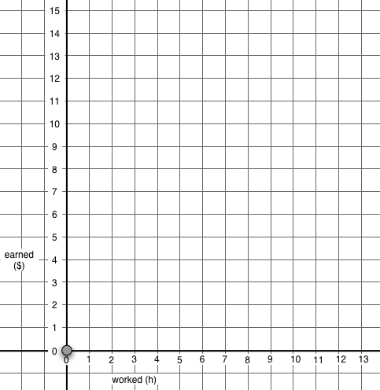

Elapsed Time (in hours)
Miles
Distance from Marcus’ House
(in Miles)

Homework (page 1): The story.
Name: _______________________________________
Last Sunday Susanna walked along the Charles River.
- She started at 6:15 a.m., already 3 miles away from her house.
- She went 4 miles at 2 miles per hour and then
- 3 more miles at one mile per hour.
- She then stopped for 2 hours to rest.
- Then she walked back to her house, along the same path, at 2 miles per hour.
Make a graph of her trip on the next page.
After making your graph, fill in the table below showing where she was between zero and 12 hours. Use your graph to help you fill in the values.
Clock Time | Elapsed Time  (in hours) | Distance from her house  (in miles)
6:15 a.m. | 0
 | 1
 | 2
 | 3
 | 4
 | 5
 | 6
 | 7
 | 8
 | 9
 | 10
 | 11
 | 12
How many hours did her trip last? ________________
What time was it when she arrived back at her home? _____________
How many miles did she walk altogether on her trip? _________________
Name: _______________________________________
Susanna’s trip:

Miles
Distance from
Susanna’s House
(in miles)

Elapsed Time (in hours)

