Name: _________________________________________ Date: _________
The graph below shows how Aline walked yesterday.

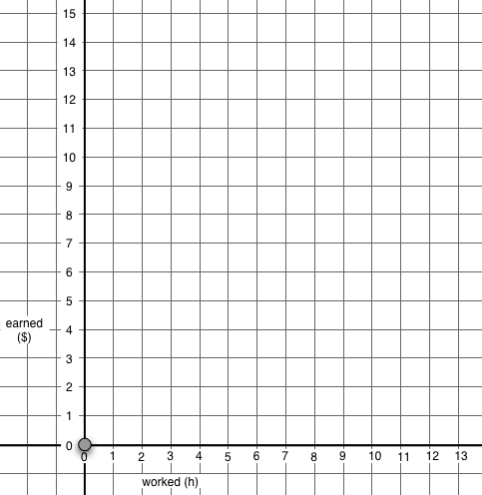
A
B
C
D
E

Hours
Miles
Distance from Alina’s House
(in Miles)

Answer the questions about this graph on the next pages.
Name: _______________________________________

1. Write a story talking about Alina’s trip.

2. How many hours did her trip last? ________________

3. How many miles did she walk altogether on her trip? _______________

4. How many miles does she still have to walk to get to her house? _______

Name: _______________________________________
5. Which statements about Alina’s trip are True or False?

 | True or | False? | Explain
Alina walked fastest from A to B | True | False
Alina walked fastest from D to E | True | False
Alina walked slowest from C to D | True | False
Alina walked slowest from D to E | True | False

6. Jason has three times as much money as Sally. How much money does Sally have? [More than one answer could be true.]
- Sally has 3 dollars.
- Sally has 50 cents.
- Sally has one third of the amount Jason has.
- Sally has three times the amount Jason has.
- None of the above answers is correct.
Explain your answer:

7. The amount of money Ramon has is equal to one third of the amount of money Mary has. How much money does Ramon have? [More than one answer could be true.]
- Ramon has 3 dollars.
- Ramon has 1 dollar.
- Ramon has three dollars less than Mary.
- Ramon has three times the amount Mary has.
- None of the above answers is correct.
Explain your answer.
Name: _________________________________________ Date: _________

8. The distance from Marina’s home to her school is exactly twice the distance from Tony’s home to his school.

True? False? or ‘You can’t tell ? [Circle your answer ]

Marina is ten years old | True | False | You can’t tell.
Tony is five years old. | True | False | You can’t tell.
Marina’s home is very far from the school | True | False | You can’t tell.
The distance from Tony’s home to the school is half the distance from Marina’s home to the school. | True | False | You can’t tell.
Marina walks twice as much to get to her school as Tony does. | True | False | You can’t tell.
Tony’s home is closer to his school than Marina’s. | True | False | You can’t tell.

Name: _________________________________________ Date: _________
9. Karina and Jimmy collect baseball cards. Jimmy has three times as many cards as Karina has.
K means how many cards Karina has.
J means how many cards Jimmy has.
 | True or | False? | Explain
K = 3 x J | True | False
J = 3 x K | True | False
J = K | True | False
K = × J | True | False
K = J ÷ 3 | True | False
J = | True | False

