Lesson 4.22
The Wallet Problem III

Summary

Activity | Students will continue working with the wallet problem. They will be shown a graph for Mike’s amounts and asked to (a) determine whether it represents Robin’s or Mike’s money and (b) to predict where the line for Mike would fall. Later they will plot Mike’s amounts and will discuss why the lines cross.
Goals | To think about contexts for equations. An equation can be thought of as a special condition under which two functions share the same value(s). In order for students to appreciate this notion, they need to think of the amounts themselves as functions. Think of the wallet as an input value and the person's total amount as the output value
Practical Hints | The discussion will eventually lead to the algebraic notation for the equality 8 + W = 3W.

Activities

Part 1: Graphing the Wallet Problem [Whole class]
Show Overhead 1, page 2: A graph representing Mike’s amounts.
Consider the problem and ask the children to:
- Determine whether it represents Robin’s or Mike’s money and
- Predict where the line for Robin would fall.

Part 2: Graphing the Wallet Problem [Small groups]
Distribute Handout 1 and ask the children to plot Robin’s amounts.

Part 2: Discussing children’s results [Whole class]
Discuss with the children the meaning of the graph?
What does it show?
Why do the lines cross?
When/where does Robin have more money than Mike?
When/where does Mike have more money than Robin?
When there are 5 dollars in Mike’s wallet, what is the difference between Mike’s and Robin’s amounts. Show the difference on the graph (Repeat the question for other amounts).

Part 4: Homework
Students will work on a similar problem.

Overhead 1: The Graph
Name: _________________________________________ Date: _________
Mike has $8 in his hand and the rest of his money is in his wallet.
Robin has, altogether, exactly three times as much money as Mike has in his wallet.

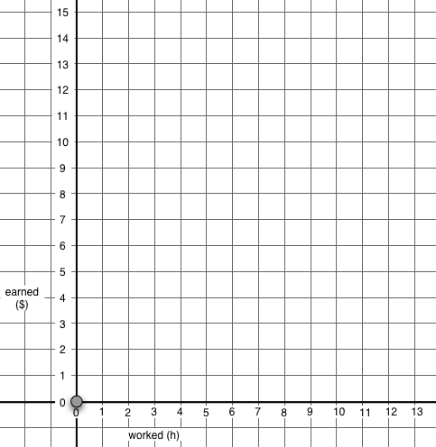
Total amount
($)
Amount
In wallet
($)

Handout 1, page 1: The Table
Name: _________________________________________ Date: _________

Mike has $8 in his hand and the rest of his money is in his wallet.
Robin has, altogether, exactly three times as much money as Mike has in his wallet.

In Mike’s Wallet | Mike (in wallet and hand) | Robin
$ 0.50 | $ 8.50 | $ 1.50
$ 1.00 | $ 9.00 | $ 3.00
$ 2.00 | $ 10.00 | $ 6.00
$ 2.50 | $ 10.50 | $ 7.50
$ 3.00 | $ 11.00 | $ 9.00
$ 4.00 | $ 12.00 | $ 12.00
$ 5.00 | $ 13.00 | $ 15.00
$ 6.00 | $ 14.00 | $ 18.00
$ 7.00 | $ 15.00 | $ 21.00
$ 8.00 | $ 16.00 | $ 24.00
N | N + 8 | N x 3

Handout 1, page 2: The Graph
Name: _________________________________________ Date: _________
Mike has $8 in his hand and the rest of his money is in his wallet.
Robin has, altogether, exactly three times as much money as Mike has in his wallet.
Total amount
($)
Amount
In wallet
($)

Homework
Name: _________________________________________ Date: _________
Roger has $100 in his hand and the rest of his money is in his wallet.
Marina has, altogether, exactly five times as much money as Roger has in his wallet.

In Roger’s Wallet | Roger (in wallet and hand) | Marina
$ 10.00
$ 15.00
$ 20.00
$ 25.00
$ 30.00
$ 35.00
N

Do you know how much money Roger and Marina each have?

Do you know who has more money?

Could Roger ever have the same amount of money as Marina?
________________________________________________________________

