Lesson 4.23
Equations & Inequalities
Expressed In Algebraic Notation: I

Summary

Activity | Students will work with equations and inequalities—first simple ones, next comparisons of two functions. The Wallet Problem will provide the background context.
Goals | Have students reason about statements such as:  W = 7.5 W > 8 W<2 4 < W ≤ 7  W + 8 = 11 W + 8 > 13 W+8 < 7 4 < W ≤ 7  W x 3 = 6 W x 3 > 14 W x 3 < 4
Practical Hints | Three representations are used: (1) the algebraic notation (2) number lines and (3) explanations that draw upon particular contexts.

Activities

Part 1: Focusing on the Number Lines [Whole class]
Show Overhead 1, 2, 3, etc. and discuss the following statements, considering the x- and the y-axis:
W = 7.5 W > 8 W<2 4 < W ≤ 7
W + 8 = 11 W + 8 > 13 W+8 < 7 4 < W ≤ 7
W x 3 = 6 W x 3 > 14 W x 3 < 4

Part 2: Representing comparative statements [Small groups]
Ask the students to complete the comparative examples. Each example should have a diagram on a number line, an explanation, and a symbolic expression.

Part 2: Discussing children’s results [Whole class]
Go over the children’s examples.

Part 4: Homework
Students will work on a similar problem.

Overhead 1: The Cartesian Space
Mike has $8 in his hand and the rest of his money is in his wallet.

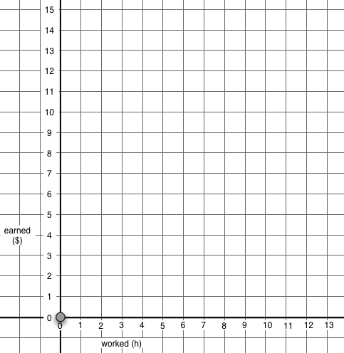
Total amount
($)
Amount
In wallet
($)
W+8
W

Overhead 2: The Cartesian Space
Name: _________________________________________ Date: _________
Mike has $8 in his hand and the rest of his money is in his wallet.

Total amount
($)
Amount
In wallet
($)
W+8
W

Overhead 3: The Cartesian Space
Name: _________________________________________ Date: _________
Mike has $8 in his hand and the rest of his money is in his wallet.

Total amount
($)
Amount
In wallet
($)
W+8
W

Overhead 4: The Cartesian Space
Name: _________________________________________ Date: _________
Robin has, altogether, exactly three times as much money as Mike has in his wallet.
Total amount
($)
Amount
In wallet
($)
W x 3
W

Overhead 5: The Cartesian Space
Name: _________________________________________ Date: _________
Robin has, altogether, exactly three times as much money as Mike has in his wallet.
Total amount
($)
Amount
In wallet
($)
W x 3
W

Overhead 6: The Cartesian Space
Name: _________________________________________ Date: _________
Robin has, altogether, exactly three times as much money as Mike has in his wallet.
Total amount
($)
Amount
In wallet
($)
W x 3
W

Handout 1: Number lines, explanations, and algebraic expressions

Name: _________________________________________ Date: _________

Show on the line and write the explanation or the algebraic expression:

Explanation: There are $3.00 in the wallet.

Algebraic expression: w = 3

Explanation: There are $6.50 or more in the wallet.

Algebraic expression: _____________

Explanation: There is __________________________________

Algebraic expression: w < $3.75 and w > $2.00

Explanation: There is __________________________________

Algebraic expression: $ 1.25 < w and w < $4.50

Homework: Number lines, explanations, and algebraic expressions
Name: _________________________________________ Date: _________

Show on the line and write the explanation or the algebraic expression:

Explanation: There are $5.00 in the wallet.

Algebraic expression: w = 5

Explanation: There are $3.50 or more in the wallet.

Algebraic expression: _______________

Explanation: There is __________________________________

Algebraic expression: w < $4.25 and w > $3.00

Explanation: There is at least $0.50 in the wallet and _________________

Algebraic expression: $ 0.50 < w and w < $2.75

