Lesson 4.24
Intervals II

Summary

Activity | Students reason about graphs showing growth over time. Compare heights of children and heights of two animals at different time intervals.
Goals | Focus on intervals, e.g., what happened  4 ≤ a ≤ 7 [a in years]  45 ≤ h ≤ 55 [h in inches]
Practical Hints | Pay attention to the shape curves suggested by children. See whether they draw continuous graphs. Do all children realize that growth will taper off? Will any represent shrinkage?

Activities

Part 1: Graphing One’s Height Over Time
Draw growth over one’s lifetime (without numbering the x and y axes).
What would a straight line mean?… etc.

Part 2: Ask students to show their own expected growth on numbered axes.
Don’t suggest how to draw the graphs.
Some questions to ask:
What will a person’s height look like when shown over their lifetime?
Does one always grow taller?
Are there periods when people grow more quickly?
Distinguish between linear, decreasing, and increasing rates of growth. What are the arguments in favor of each?

Part 3: Discuss Several Examples from Students. Then overlay two or more graphs.
Go over the children’s examples. Use different colors for different kids.
Assume that the information is correct. What does it imply?
Eventually ask students to tell what happens in a particular interval:
4 ≤ a ≤ 7 [a in years].
Ask a student to state her age when she went through an interval such as…
45 ≤ h ≤ 55 [h in inches]

Part 4: Homework
Students will work on a similar problem.

Overhead 1: Growing Over A Lifetime

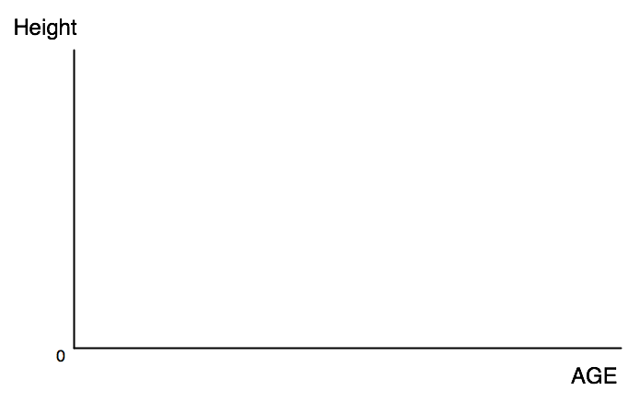

Handout 1
Name: _________________________________________ Date: _____

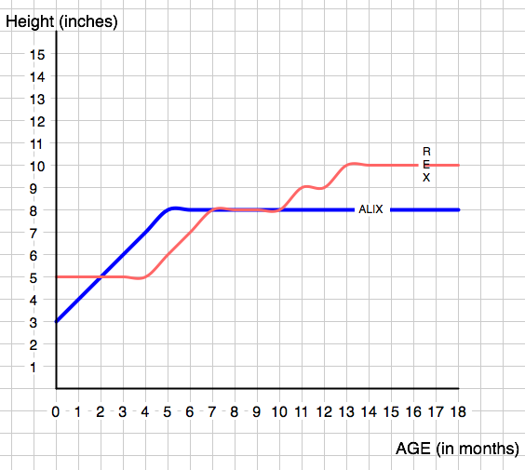
How tall was Alix when she was born? ______________________________
How tall was Rex when he was born? _______________________________
Was there ever a age when Rex and Alix were the some height? ________
Was there ever an age when Rex and Alix grew just as fast? ___________
Tell what happend in the interval, 6 ≤ Age ≤ 8 ______________________
_____________________________________________________________
_____________________________________________________________

Homework 1
Name: _________________________________________ Date: _____

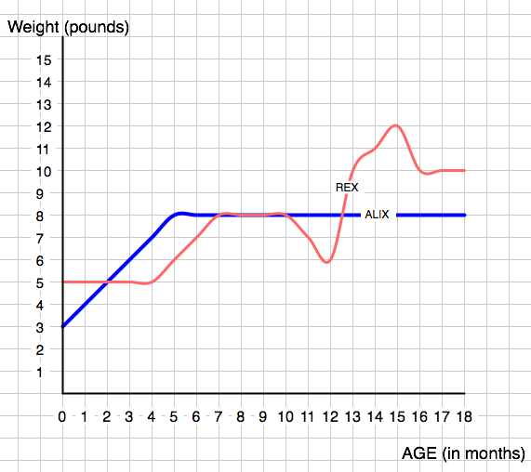
How heavy was Alix when she was born? __________________________
How heavy was Rex when he was born? ___________________________
Was there ever a age when Rex and Alix were the some weight? _______
Was there ever an age when Rex and Alix grew just as fast? __________
Tell what happened to Alix in the interval, 9 ≤ Age ≤ 12 ______________
_____________________________________________________________
Tell what happened to Rex in the interval, 9 ≤ Age ≤ 12 ______________
_____________________________________________________________

