Lesson 4.26
The Evaluation Problem

Summary

Activity | Students will be once again given the problem that was part of the assessment. They will be given one graph and asked to draw the second graph.
Goals | To review the basics of algebraic notation and graphing
Practical Hints | Ask students who can identify and draw the graphs to help the other children.

Activities

Part 1: The Problem [Small group work]
Show Overheads 1 and 2, in sequence, and distribute the corresponding Handouts 1 and 2.

Part 2: Discussing children’s results [Whole class]
Following children’s suggestions, discuss:
If there are N dollars in the Piggy Bank, how can you represent Jason’s and Kimberley’s amounts?
Which features of the graph shows that the line given in the handout is Kimberley’s line? (Starts at zero; goes up by 3s, etc.). Why is it that that line can’t be Jason’s line?
Where should Jason’s line start? Where does it crosses Kimberley’s line?
Show on the graph where Jason has more. Where Kimberley has more. Where they have the same amount of dollars.

Part 4: Homework
Students will be asked to write a story about two graphs.

Overhead1 and Handout 1: Revision.
Name: _________________________________________ Date: _________
Fill in the table with amounts that could be true. Remember that:
Jason has $6 in his pocket. The rest of Jason’s money is in Jason’s piggy bank.
Kimberley has 3 times the amount of money that is in Jason’s piggy bank.
In Jason’s Piggy Bank | Jason (in pocket and in piggy bank) | Kimberley
$ 1.00 | $ 7.00
$ 2.00 | $ 8.00
$ 3.00 | $ 9.00
$ 4.00 | $ 10.00
$ 5.00 | $ 11.00
$ 10.00

N

If you know how much money is in Jason’s Piggy Bank, what do you have to do to find out how much money Kimberley has?

Could Jason ever have the same amount of money as Kimberley? Explain.

Who has more money? (Circle your answer)
- Jason
- Kimberley
- It depends…
2. Explain your answer ________________________________________
__________________________________________________________________________________________________________________

Overhead1I and Handout I1: Revision.
Name: _________________________________________ Date: _________
Jason has $6 in his pocket. The rest of Jason’s money is in Jason’s piggy bank.
Kim has 3 times the amount of money that is in Jason’s piggy bank
Total Amount ($)
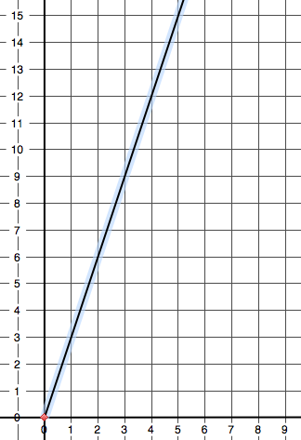  Amount in Jason’s Piggy Bank ($) | 1. Whose amounts are shown on the graph?  (a) Jason’s (b) Kim’s  2. Explain: _____________________  __________________________________  __________________________________  3. Draw the line for the other child’s amounts.  4. Make a circle around the part of the graph  that shows Jason having more money than Kim.  5. How much money has to be in the piggy bank  for Jason to have more money than Kim? __________________________________  __________________________________  6. Make a square around the part of the graph  that shows Kim having more money than Jason.  7. How much money has to be in the piggy bank  for Kim to have more money than Jason? __________________________________  __________________________________  8. Draw an arrow to show on the graph where  Jason and Kim have the same total amount of money.

Homework, page 1
Name: _________________________________________ Date: _________

Total amount of money
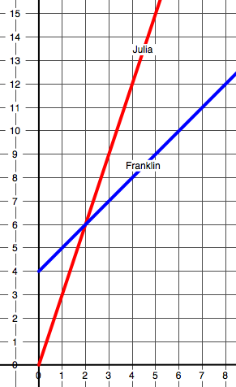 | Write a story about the graphs on the left.
Money in Franklin’s wallet

Homework, page 2
Name: _________________________________________ Date: _________

Make a table to show Julia’s amounts and Franklin’s amounts for each amount of money in Franklin’s wallet.

