Lesson 4.27
A Running Race: I

Summary

Activity | Compare a race between two students: one who runs at a constant pace, the other who tires out as the race proceeds.
Goals | Have students make comparisons in speed along various time and distance intervals of the race.

Activities

Part 1: Discussing the Race
Some initial questions to ponder:
- Who was in the race?
- Who won? How do you know?
- At one minute, who was ahead? How do you know?
- At one minute, who was running faster? How do you know?

Part 2: What happened in particular intervals [individual work].
Ask the students to complete the examples.

Part 2: Discussing children’s results [Whole class]
Go over the children’s examples.

Part 4: Homework
Students will work on a similar problem.

Overhead 1: A Race Between José and Ashley

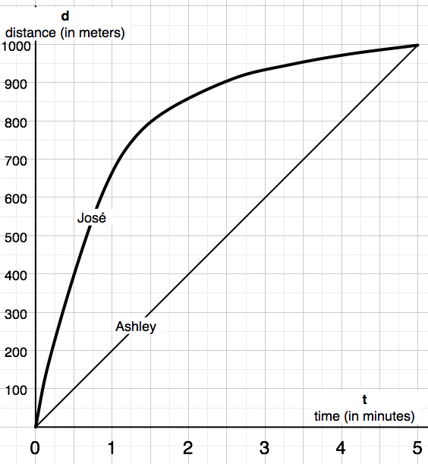

Handout 1: Figuring Out What Happened in the Race
Name: _________________________________________ Date: _________

1. Jose and Ashley were farthest away from each other at t = _________

2. How far apart were they at that time?
Jose and Ashley were ______ meters apart at ___ minutes into the race.

3. Describe what happened in the following time intervals:

0 ≤ t ≤ 1 [minutes] : ____________________________________
____________________________________________________
____________________________________________________
____________________________________________________

4 ≤ t ≤ 5 [minutes] : ____________________________________
____________________________________________________
____________________________________________________
____________________________________________________

Homework
Name: _____________________________________ Date: _________
1. When did Ashley catch up to Jose? At t = ______ and d = _________

2. How did the race end? Explain. _______________________________
_________________________________________________________
_________________________________________________________

3. Describe what happened in the time interval, 3 ≤ t ≤ 4 [minutes]
_________________________________________________________
_________________________________________________________
_________________________________________________________

4. Jose and Ashley were 300 meters apart when t = _________________
Was there any other time they were 300 meters apart?_______________

5. When was Jose ahead of Ashley? At _____ < t < ______ [minutes]

6. Ashley reached the 800 meter mark ________ minutes after Jose.

