Lesson 4.28
Running Race II

Summary

Activity | Compare a race between two students: one who runs at a constant pace and one who invigorates as the race proceeds.
Goals | Have students make comparisons in speed along various time and distance intervals of the race.
Hint | Have multiple overheads of the race so that projection lines can be drawn on them for different scenarios.

Activities

Part 1: Discussing the Race
Some initial fractions
questions to ponder:
- Who was in the race?
- Who won? How do you know?
- At one minute, who was ahead? How do you know?
- At one minute, who was running faster? How do you know?
- Distance = speed x time
  - We know (from Race 1) that Ashley consistently runs .
  - d = × t minutes
  - this could be introduced, but merits a special lesson.

Part 2: What happened in particular intervals [individual work].
Ask the students to complete the examples.

Part 2: Discussing children’s results [Whole class]
Go over the children’s examples.

Part 4: Homework
Students will work on a similar problem.

Overhead 1: Jane races against Ashley.

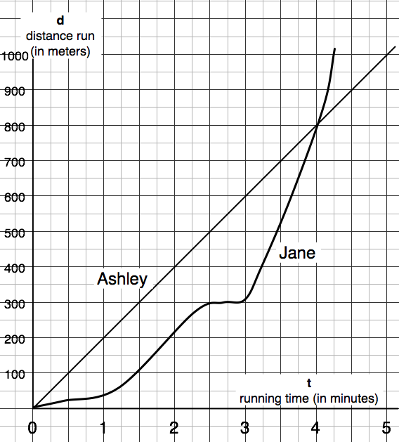

Handout: Figuring Out What Happened in the Race
Name: _________________________________________ Date: _________

- Who ran at a steady pace throughout the race? _________
  - What was that person’s speed? __________per ____
- Who stopped running during the race? ______
  - For how long did she stop running? ________ ]
- When were Jane and Ashley running just about as fast?

At ___________≤ t ≤ ___________ [minutes]

Homework: Figuring Out What Happened in the Race
Name: _________________________________________ Date: _________

1. When did Ashley fall behind Jane? At t = ______ and d = _________

2. When did Ashley arrive at the half-way mark in the race? t= _______
When did Jane arrive at the half-way mark in the race? t= ________

3. What were the two intervals of time when Ashley was running faster than Jane?
Interval 1: ___________≤ t ≤ ___________ [minutes]

Interval 2: ___________≤ t ≤ ___________ [minutes]

