Lesson 4.30
Swimming Pools

Summary

Activity | Compare how two swimming pools fill up with water over several hours.
Goals | Have students make comparisons in rate of flow along various time and distance intervals of the race.

Activities

Part 1: Discussing the Rates
Some initial questions to ponder:
- Look at the graphs? What pools are we comparing?
- Did they start filling at the same time?
- What is the maximum height (or depth) of each pool?
- Which pool filled up first? How do you know?
- At one minute, which pool was more full? How much higher was the water level in that pool? How do you know?
- At one minute, which pool was filling more quickly? How do you know?
Collectively, make a table showing the increase in height per time…

Part 2: What happened in particular intervals [individual work].
Ask the students to complete the examples.

Part 3: Discussing children’s results [Whole class]
Go over the children’s examples.

Part 4: Homework
Students will work on a similar problem.

Overhead 1: Two Swimming Pools Filling Up With Water

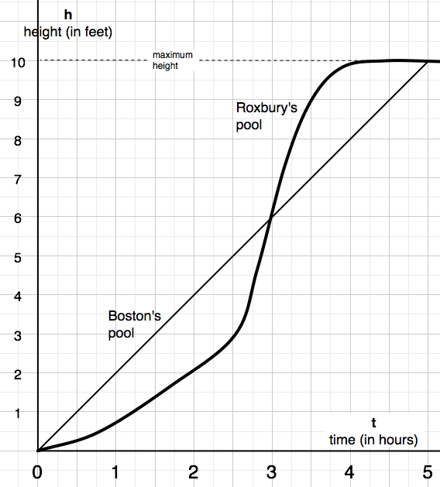

Handout 1: Comparing How Two Pools Filled Up
Name: _________________________________________ Date: _________
Use the graphs on the next page to fill in the tables.

Boston’s Pool
Time period  [hours] | Begin height  h₁  [feet] | End height  h₂  [feet] | Change in height  h₂- h₁  [feet]
0 ≤ t < 1 | 0
1 ≤ t < 2
2 ≤ t < 3
3 ≤ t < 4
4 ≤ t < 5

Roxbury’s Pool
Time period  [hours] | Begin height  h₁  [feet] | End height  h₂  [feet] | Change in height  h₂- h₁  [feet]
0 ≤ t < 1 | 0
1 ≤ t < 2
2 ≤ t < 3
3 ≤ t < 4
4 ≤ t < 5

Handout 2: Comparing How Two Pools Filled Up
Name: _________________________________________ Date: _________

1. When was Roxbury’s pool filling up the fastest?
Between ______ and ______ hours.
______ ≤ t < ______ [hours]

2. When was Roxbury’s pool filling up the slowest?
Between ______ and ______ hours.
______ ≤ t < ______ [hours]

3. During what period was Roxbury’s pool filling up faster than Boston’s pool?
Between ______ and ______ hours.
______ ≤ t < ______ [hours]

Homework: Water in the Pools
Name: _________________________________________ Date: _________

1. At what time did Boston’s pool become full? At t = _______ [hours]

2. At what time was Roxbury’s pool filled? At t = _______ [hours]

3. During what time was the water in Roxbury’s pool at a lower level than the water in Boston’s pool? ______ < t < ___________ [hours]

4. Draw a graph of another pool, from Quincy (maximum height 10 ft).
It started off empty.
After 2 hours it was half filled.
At five hours it was filled.

5. When was the water height of the Quincy pool (that you showed) the same as the water height in the Roxbury pool? ___________________

