4-32 — Comparing Functions
This lesson was implemented over two days
Day 1: Comparing two functions
Day 2: Choosing a graph to match verbal descriptions

Summary

Activity | In the first class, the students will discuss, represent, and solve a verbal problem involving the choice between two functions. In the second one they will be asked to choose, among 8 basic graph shapes, the one that matches specific situations.
Goals | Use tables, graphs, and algebraic notation to solve a problem.
Terms | Function, pattern, “grows by”, “changes by … each time”, increases/decreases, faster/slower, steady rate.

Activities

Part 1: Discussing 8 graph shapes (20 minutes).
Go over each graph below, discussing its meaning… Which graphs show increases, decreases, no change? Which one increases faster and faster? Slower and slower?
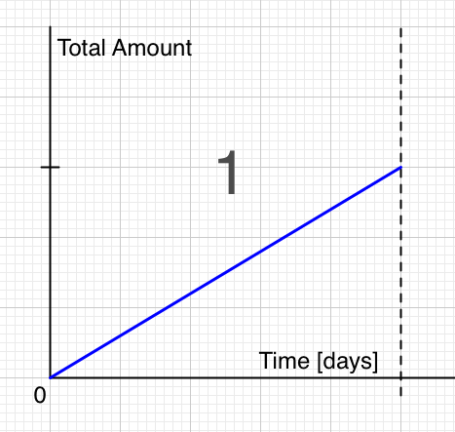 | 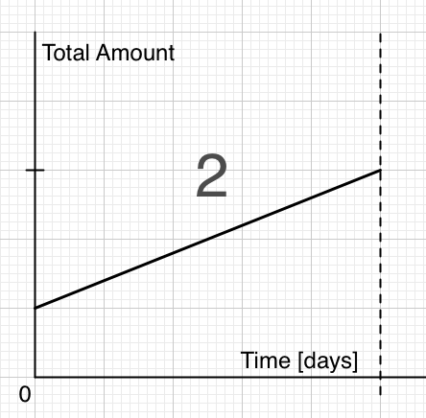 | 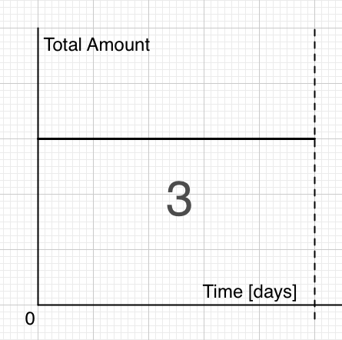
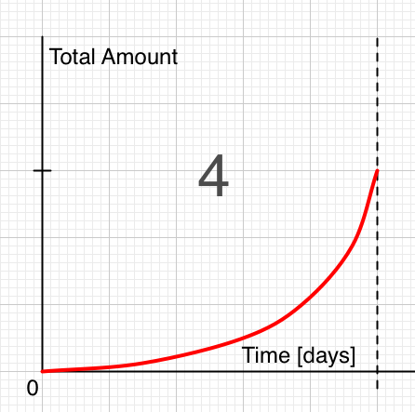 | 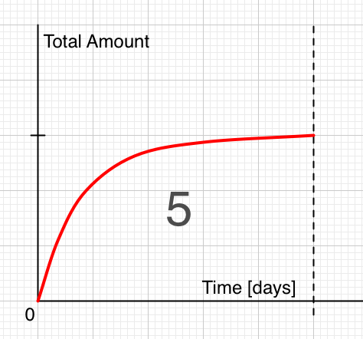 | 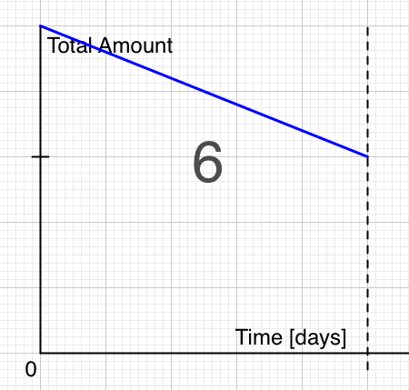
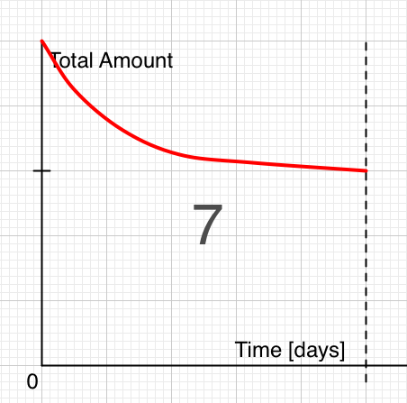 | 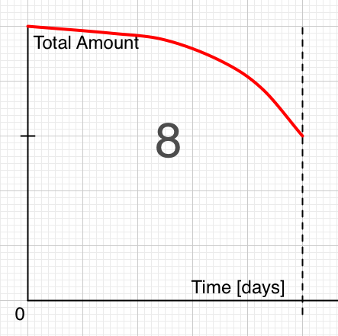

Part 2: Representing the Two Options on a Table [group work]
Show the problem (Overhead 1) and ask children to read it.
Ask the children to state what they would prefer.
Ask the children to show on the board which deal is better.
Your grandmother offers to give you, for the whole year:
- Deal A: 5 cents every day
- Deal B:
  - She gives 1 cent on day 1,
  - She gives 2 cents on day 2,
  - She gives 3 cents on day 3, and so forth.
Which deal would you accept, Deal A or Deal B?
Show that the deal you chose is better.
What would a graph of each of the deals look like?

Part 3: Representing the Two Options in a Table [group work]
Distribute the Handout (Overhead 2) and ask children to complete the two tables, to state and to justify, in writing, what they would prefer.

Part 3: Discussion of Handout: Comparing the Two Functions [whole class]
Ask a few volunteers to present and discuss their answers. Ask questions such as:
Is one option better than the other? Always?
When is option 1 better than option 2?
When is option 2 better than option 1?
Are there days when the two options will give you the same amount of money?

Part 4: Homework (Overhead 4)
They will solve a problem similar to the one they discussed in class.

Overhead 1: The Problem

Your grandmother offers to give you, for the whole year:

- Deal A: 5 cents every day

- Deal B:
  - She gives 1 cent on day 1,
  - She gives 2 cents on day 2,
  - She gives 3 cents on day 3, and so forth.

Which deal would you accept, Deal A or Deal B?
Show that the deal you chose is better.
What would a graph of each of the deals look like?

Overhead 2 and Handout 1: Representing the Problem
Name: __________________________________________________ Date: _______________

Your grandmother offers you two deals for a whole year.
- Deal A:
  - She will give you 5 cents on each day for a year, or
- Deal B:
  - She will give you 1 cent on day 1,
      - 2 cents on day 2,
      - 3 cents on day 3, and so forth.
Which deal would you accept, Deal A or B?
DEAL A DEAL B
Day | ΔA change | A |  | Day | ΔB change | B
1 | +$.05 | $.05 |  | 1 | +$.01 | $.01
2 | +$.05 | $.10 |  | 2 | +$.02 | $.03
3 | +$.05 | $.15 |  | 3 | +$.03 | $.06
4 | +$.05 | $.20 |  | 4 | +$.04 | $.10
5 | +$.05 | $.25 |  | 5 | +$.05 | $.15
6 | +$.05 | $.30 |  | 6 | +$.06 | $.21
7 | +$.05 | $.35 |  | 7 | +$.07
8 | +$.05 | $.40 |  | 8 | +$.08
9 | +$.05 | $.45 |  | 9 | +$.09
10 | +$.05 |  |  | 10 | +$.10
11 | +$.05 |  |  | 11 | +$.11
12 | +$.05 |  |  | 12 | +$.12

True or false?
- The total amount for Deal A increases at a steady rate (True, False)
- The total amount for Deal B increases at a steady rate. (True, False)

Which Deal is better at the end of one year? Explain. _________________________________________________
_________________________________________________
_________________________________________________

Overhead 3

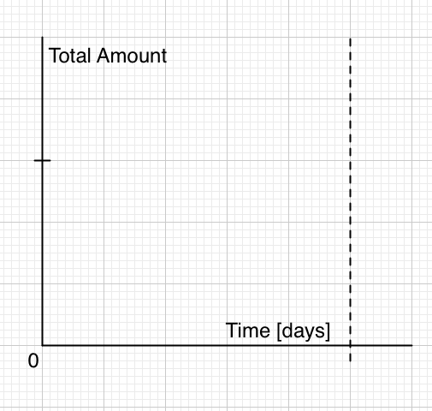

Overhead 4 and Handout 2: Representing the Problem
Name: __________________________________________________ Date: _______________

Look carefully at the graphs in boxes 1-8.
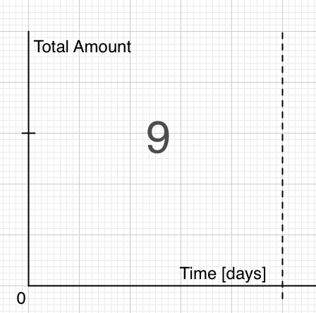
Deal A is like Graph _______ Deal B is like Graph _______
In box 9, draw graphs for both Deal A and Deal B.

Homework 1
Name: __________________________________________________ Date: _______________

Your grandfather offers to give you, for one month…
- Deal K: 5 dollars on each day.
- Deal L:
  - 1 dollar on day 1,
  - 2 dollars on day 2,
  - 3 dollars on day 3, and so forth.
Which deal would you accept, Deal K or Deal L? _____
DEAL K DEAL L
Day | ΔK change | K |  | Day | ΔL change | L
1 | +$5 | $5 |  | 1 | +$1 | $1
2 | +$5 | $10 |  | 2 | +$2 | $3
3 | +$5 | $15 |  | 3 | +$3 | $6
4 | +$5 | $20 |  | 4 | +$4 | $10
5 | +$5 | $25 |  | 5 | +$5 | $15
6 | +$5 | $30 |  | 6 | +$6
7 | +$5 | $35 |  | 7 | +$7
8 | +$5 | $40 |  | 8 | +$8
9 | +$5 | $45 |  | 9 | +$9
10 | +$5 |  |  | 10 | +$9
11 | +$5 |  |  | 11 | +$9
12 | +$5 |  |  | 12 | +$9

True or false?
- The total amount for Deal K increases at a steady rate (True, False)
- The total amount for Deal L increases at a steady rate. (True, False)

Which Deal is better at the end of one month? Explain. ________________________________________________________
________________________________________________________
________________________________________________________
________________________________________________________

Homework 2: Representing the Problem
Name: __________________________________________________ Date: _______________

Look carefully at the graphs in boxes 1-8.
Deal K is like Graph _______ Deal L is like Graph _______
In box 9, draw graphs for both Deal K and Deal L.

