4-33 — Phone Plans

Summary

Activity | Students compare two phone plans, one of which has a lower rate, but a monthly basic charge, the other has a higher rate but no basic charge.
Goals | Use tables, graphs, and algebraic notation to solve a problem.
Terms | Function, pattern, “grows by”, “changes by … each time”
Hints | Pay special attention to how students move from one representational form to another. Focus on the use of algebrai notation for each of the function and for the point where the two lines cross.

Activities

Part 1: Discussing the Problem (20 minutes).
Show Overhead 1:
Your mother is comparing two telephone offers:
Offer #1: You pay $0.10 per minute for all the calls you make.
Offer #2: You pay $0.60 per month plus $0.05 per minute for the calls
you make.
(It doesn’t matter what time of day or which day you make your calls.)
Discuss the advantages and disadvantages of each plan with the children.
Ask them to express the cost of each plan as a general rule, where t refers to the number of minutes they call during a month. Discuss the notation for each of the two functions and ask the children to discuss the equation t x 10 = 60 + (t x 5).

Part 2: Representing the Two Options on tables and algebraic notation [group work]
Have them complete a table for each plan.

Part 3: Discussion of Handout: Comparing the Two Functions [whole class]
Ask a few volunteers to present and discuss their answers. Discuss how they found the number of cents for 20 and for 35 minutes. Ask them whether there will be a point where the plans will cost the same per month. Ask questions such as:
Is one option better than the other? Always? When is option 1 better than option 2? When is option 2 better than option 1? Are there times when the two options will give you the same amount of money?
Have them make up advice to give others: What sort of advice would you give your mother? Why? What sort of advice would you give to the student in another class? Make sure your advice will be useful to all of the students.

Part 4: Homework (Overhead 4)
They will graph the two functions and answer questions related to the problem.
The following class will explore the same graph in more depth.

Overhead 1: The Problem

Your mother asked you to compare plans she received from two telephone companies:

Plan #1: You pay $0.10 per minute for all the calls you make.
Plan #2: You pay $0.60 per month plus $0.05 per minute for the calls you make.

(It doesn’t matter what time of day or which day you make your calls.)

Overhead 2: Representing the Problem: tables and algebraic notation
Name: __________________________________________________ Date: _______________
Show how much each plan charges for different numbers of minutes.

Plan 1: 10¢ per minute Plan 2: 5¢ per minute plus 60¢
t [minutes] | t x 10 [cents] |  | t [minutes] | 60 + (t x 5) [cents]
0 |  |  | 0
1 |  |  | 1
2 |  |  | 2
3 |  |  | 3
4 |  |  | 4
5 |  |  | 5
6 |  |  | 6
7 |  |  | 7
8 |  |  | 8
9 |  |  | 9
10 |  |  | 10
11 |  |  | 11
12 |  |  | 12
13 |  |  | 13
14 |  |  | 14
20 |  |  | 20
35 |  |  | 35

Overhead 3 and Handout 1: Representing the Problem: tables and algebraic notation
Name: __________________________________________________ Date: _______________
Show how much each plan charges for different numbers of minutes.

Plan 1: 10¢ per minute Plan 2: 5¢ per minute plus 60¢
t [minutes] | t x 10 [cents] |  | t [minutes] | 60 + (t x 5) [cents]
0 | 0 x 10 = 0 |  | 0 | 60 + (0 x 5) = 60
1 | 1 x 10 = 10 |  | 1 | 60 + (1 x 5) = 65
2 | 2 x 10 = 20 |  | 2 | 60 + (2 x 5) = 70
3 | 3 x 10 = 30 |  | 3
4 | 4 x 10 = 40 |  | 4 | 60 + (4 x 5) = 80
5 | 5 x 10 = 50 |  | 5
6 | 6 x 10 = 60 |  | 6
7 | 7 x 10 = 70 |  | 7 | 60 + (7 x 5) = 95
8 | 8 x 10 = 80 |  | 8 | 60 + (8 x 5) = 100
9 | 9 x 10 = 90 |  | 9
10 |  |  | 10
11 |  |  | 11
12 |  |  | 12
13 |  |  | 13
14 |  |  | 14
20 |  |  | 20
35 |  |  | 35

Homework 1: Representing the Problem: tables and algebraic notation
Name: __________________________________________________ Date: _______________
Show how much each plan charges for different numbers of minutes.

Plan 1: 10¢ per minute Plan 2: 5¢ per minute plus 60¢
t [minutes] | t x 10 [cents] |  | t [minutes] | 60 + (t x 5) [cents]
0 | 0 x 10 = 0 |  | 0 | 60 + (0 x 5) = 60
1 | 1 x 10 = 10 |  | 1 | 60 + (1 x 5) = 65
2 | 2 x 10 = 20 |  | 2 | 60 + (2 x 5) = 70
3 | 3 x 10 = 30 |  | 3
4 | 4 x 10 = 40 |  | 4 | 60 + (4 x 5) = 80
5 | 5 x 10 = 50 |  | 5
6 | 6 x 10 = 60 |  | 6
7 | 7 x 10 = 70 |  | 7 | 60 + (7 x 5) = 95
8 | 8 x 10 = 80 |  | 8 | 60 + (8 x 5) = 100
9 | 9 x 10 = 90 |  | 9
10 |  |  | 10
11 |  |  | 11
12 |  |  | 12
13 |  |  | 13
14 |  |  | 14
20 |  |  | 20
35 |  |  | 35

Homework 2: Representing the Problem: Graphs
Name: __________________________________________________ Date: _______________

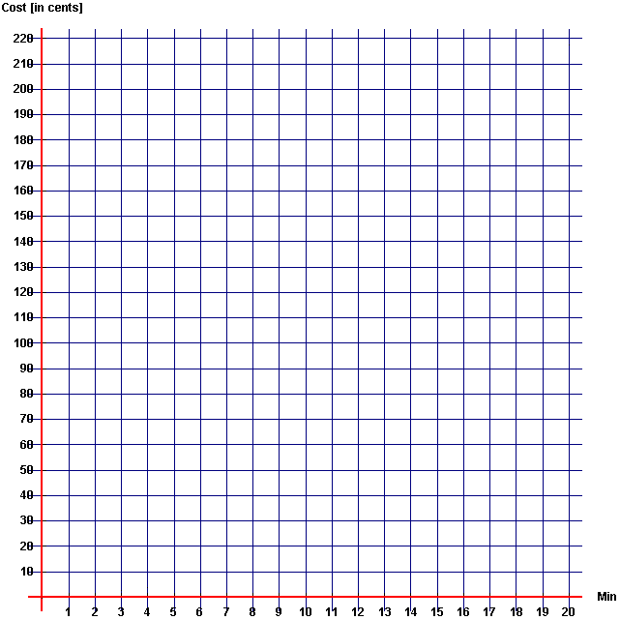
Use the data from the table to make a graph for each telephone plan. Label each graph.

t

Homework 3: Which plan would you choose?

Name: __________________________________________________ Date: _______________

What do the graphs show?

What advice would you give to someone (for instance, your mother) about the two plans? Explain.

Could Plan #1 and Plan #2 ever cost the same amount per month? When?

If t x 10 is Plan #1 and
60 + (t x 5) is plan #2,
What does this mean: t x 10 = 60 + (t x 5) ?

