35 —Three Heights Problem

Summary

Activity | In this class we will explore: (a) How the children deal with comparisons, (b) How they draw inferences from comparisons, and (c) How they represent comparisons between three unknown amounts.
Goals | Review work with addition (and subtraction) as functions, not simply operations on particular numbers.
Materials | Overheads.
Terms | Differences, representing variables.

Activities

Reasoning about Relative Heights

Part 1: The Problem (whole class)
Present the Heights Problem in Overhead 1 to whole class,
Enact the heights in the class by comparing three children.

Part 2: Drawing the Heights (group work and whole class)
Distribute Handout 1 and ask children to diagram the 3 heights.
Choose one or two diagrams to discuss.
Attribute some possible values for one of the characters in the problem and ask the children to determine the height of the others.

Part 3: Table of Possible Values (whole class and group work)
Show Overhead 3 and, together with the children, fill out the first row of the Table of Possible Answers.
Distribute Handout 2 and give special attention to how the children fill out the last three lines where one of the heights is represented by letters.
Children present, discuss, and explain their answers to the whole class.

Part 3: Discussion on Possible Graphs (whole class)
Show Overhead 4, ask the children to choose which graph represents the three heights, and to explain and defend their choices.

Overheads and Handouts

Overhead 1: The Heights Problem

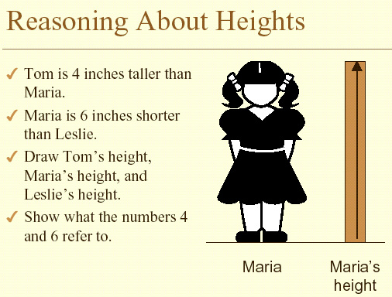

Overhead 2 and Handout 1: Showing the Heights

Name: ______________________________________________Date:_______________

Tom is 4 inches taller than Maria.
Maria is 6 inches shorter than Leslie.

Draw: Tom’s height
Maria’s height
Leslie’s height
Show what the numbers 4 and 6 refer to in your drawing.

Overhead 3 and Handout 2: Relationships Between Heights.

Name: ______________________________________________Date:_______________

Tom is 4 inches taller than Maria.
Maria is 6 inches shorter than Leslie.
Fill out the table.

Tom’s height is:  [in inches] | Maria’s height is:  [in inches] | Leslie’s height is:  [in inches]
34
 | 37
 |  | 37
 | N
Z
 |  | P

- Do you know who is the tallest of the three children? Or, does it depend on Maria’s height? ____________________
_______________________________________________
_______________________________________________

- Is Maria ever the same height as Tom? _______________
_______________________________________________
_______________________________________________

- Is it true that Tom is always taller than Leslie? ________
_______________________________________________
_______________________________________________

Overhead 4: Choosing a Graph
Tom is 4 inches taller than Maria.
Maria is 6 inches shorter than Leslie.
Which of the following graphs represent Leslie’s height and Tom’s height in relation to Maria’s height?

