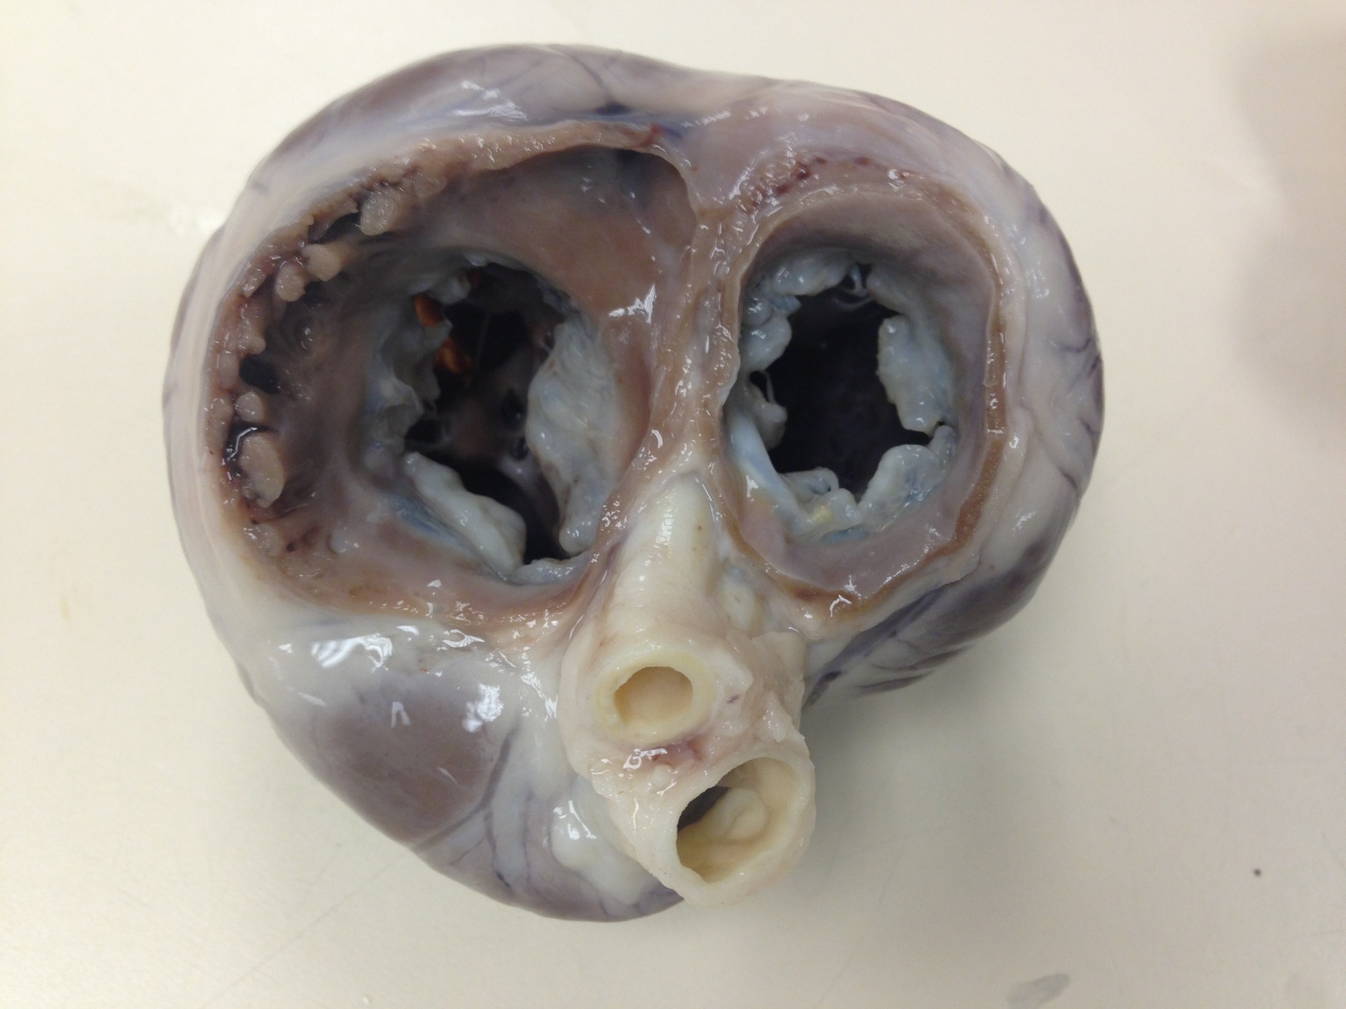

Chronic valvular disease (CVD) [aka endocardiosis, degenerative mitral valve disease (DMVD), myxomatous mitral valve disease (MMVD)] in an 11 year old Cavalier King Charles Spaniel. The dog lived for 2.5 years after the diagnosis of congestive heart failure and had developed severe pulmonary hypertension. There is both left and right atrial enlargement, marked thickening and degeneration of the mitral and tricuspid valves, and the pulmonary artery is larger than the aorta. Both ventricles are dilated, and there is concentric hypertrophy of the right ventricle.

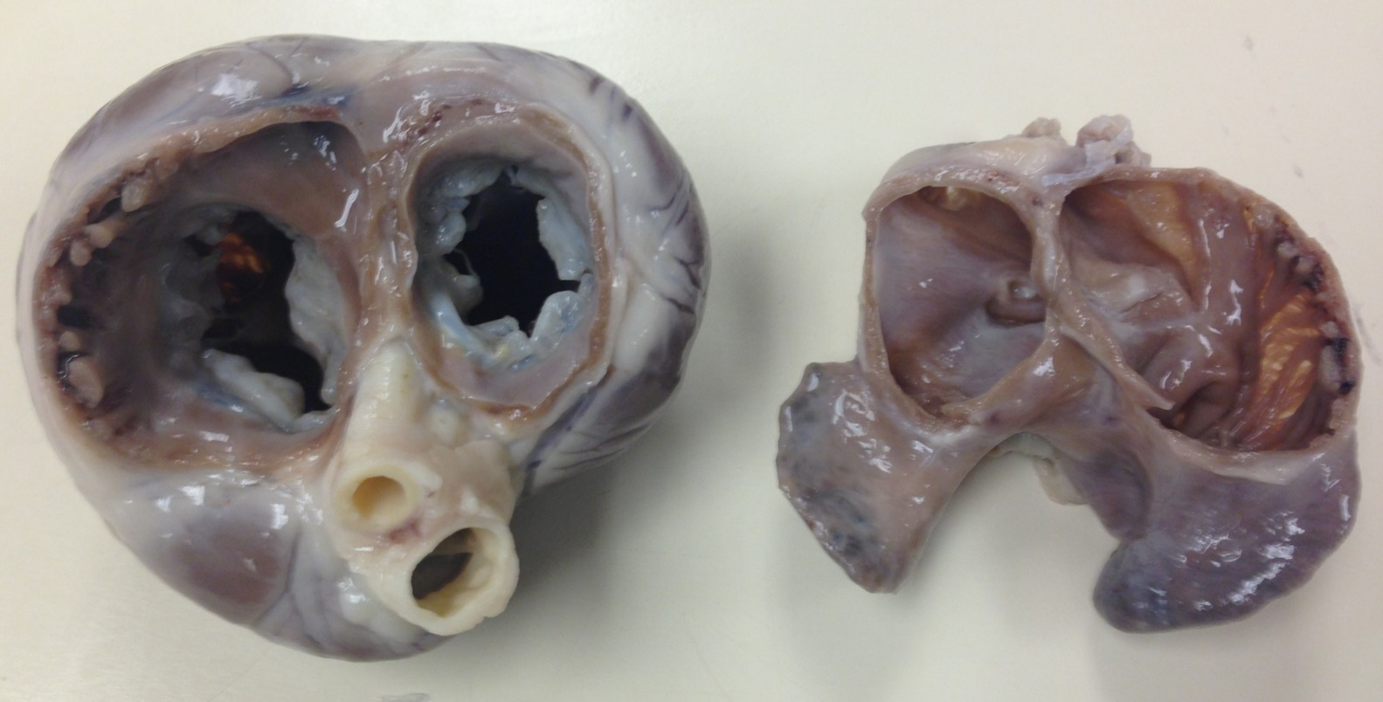

LV

PA

LA

RA

RV

Ao