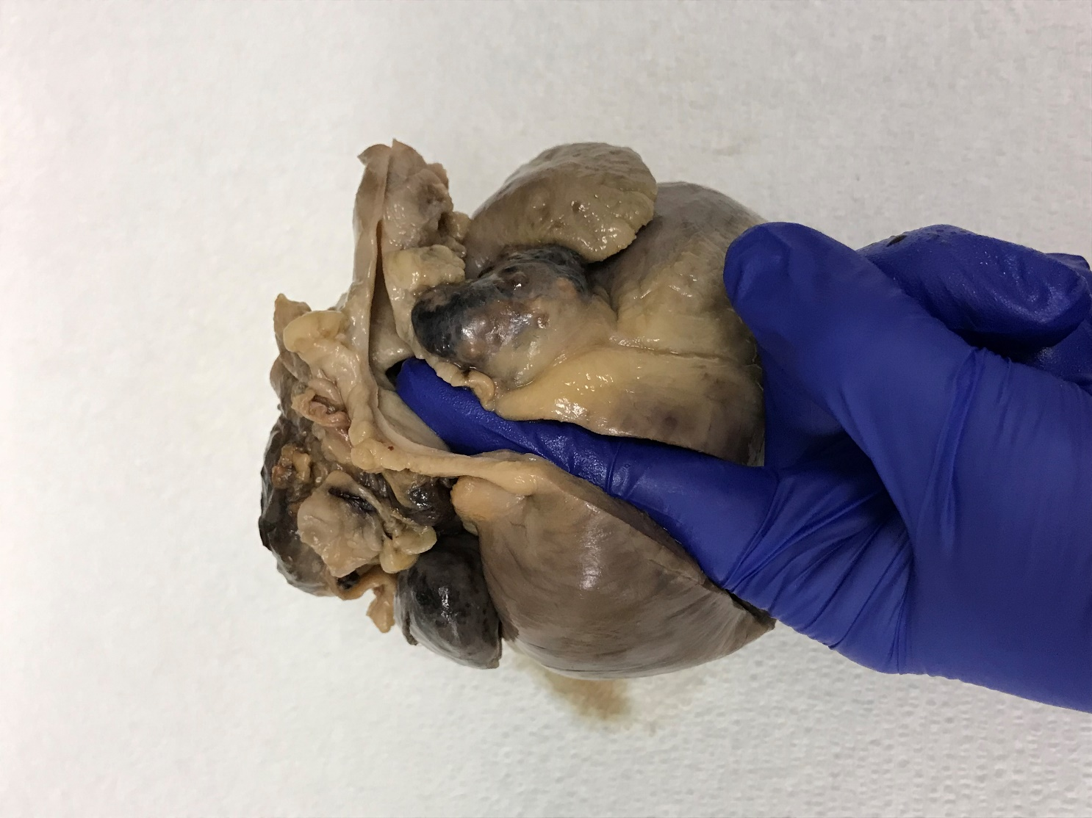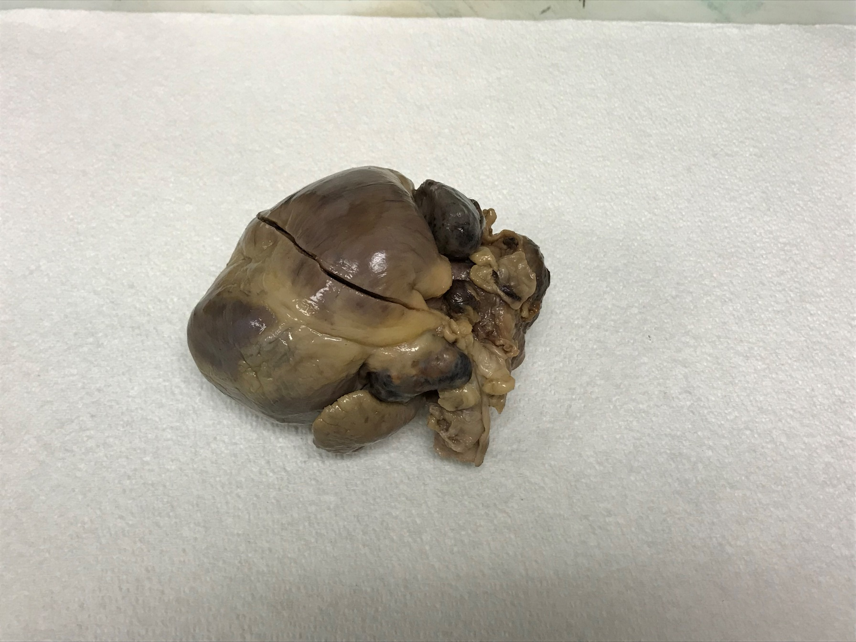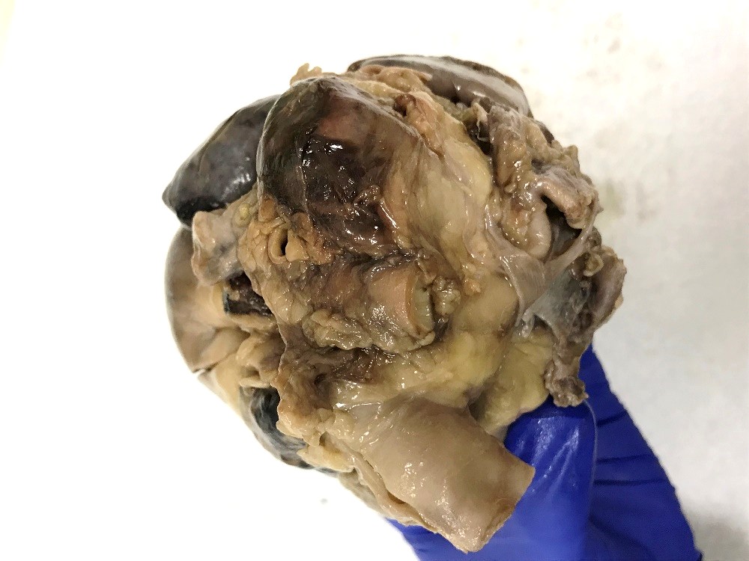

* Can you explain the clinical findings based on what you see here?
* What kind of tumor is most likely?
* What treatment options would have been available for this dog?

A 10-year-old CM bulldog presented for abdominal distension and dyspnea. He was found to have marked ascites and pleural effusion.

On necropsy, a large heart base tumor is present surrounding the aorta and pulmonary artery.

The right heart has been incised from the tip of the right atrium to the pulmonary artery to expose the dilated right atrium and ventricle.

The right ventricular outflow tract is compressed by the mass, and you can appreciate the narrowing by putting your finger in the RVOT across the pulmonic valve.

Aorta