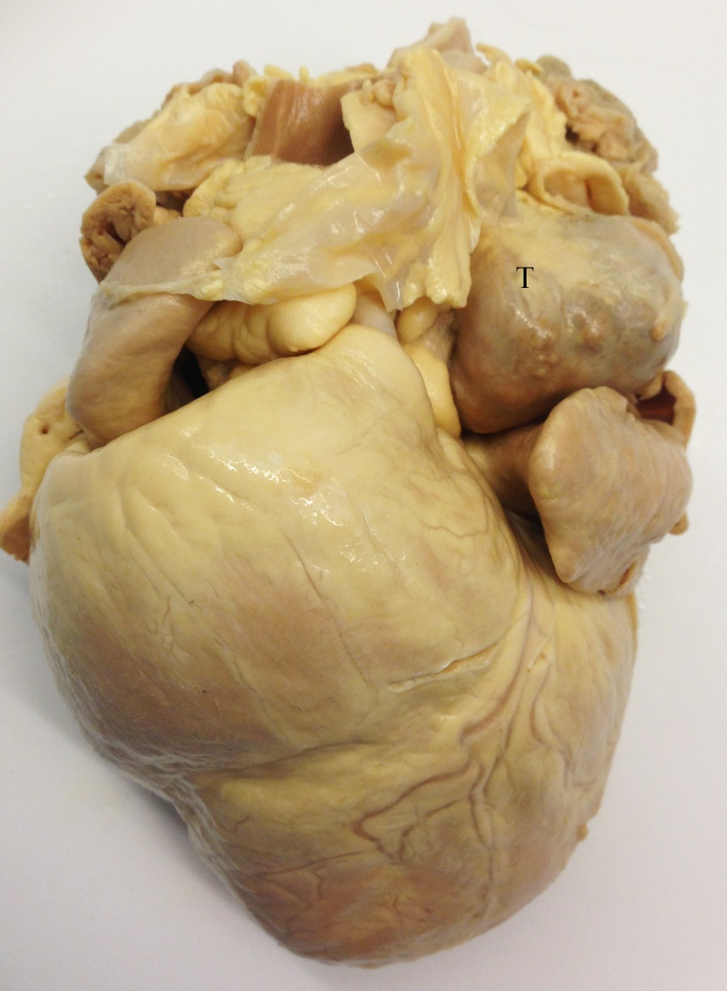

This is an example of a heart base tumor (T). These tumors are common in brachycephalic breeds, especially Boxers, bulldogs, and Boston terriers. They are typically chemodectomas, and usually originate in the region of the aortic root. These tumors are often benign, but can cause pericardial effusion or compression of surrounding structures.

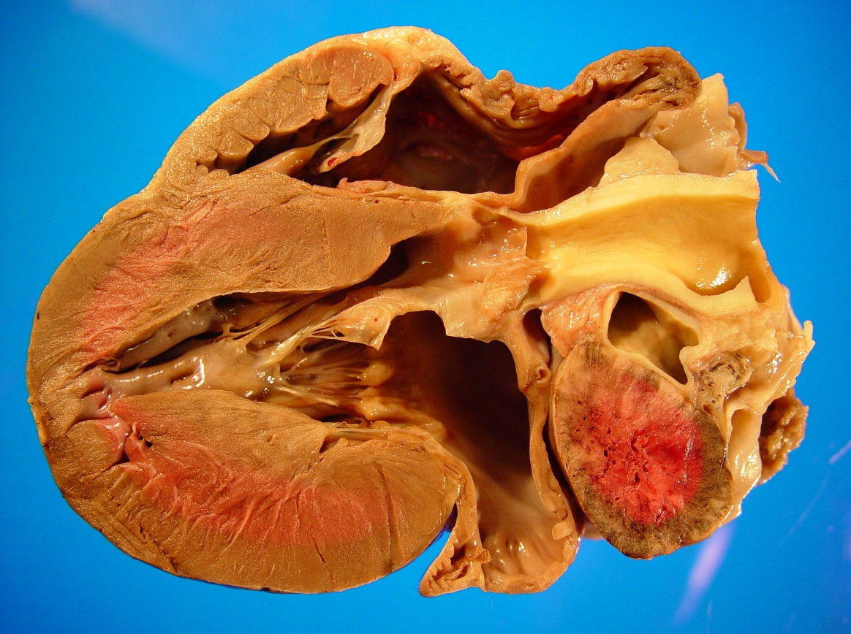

T