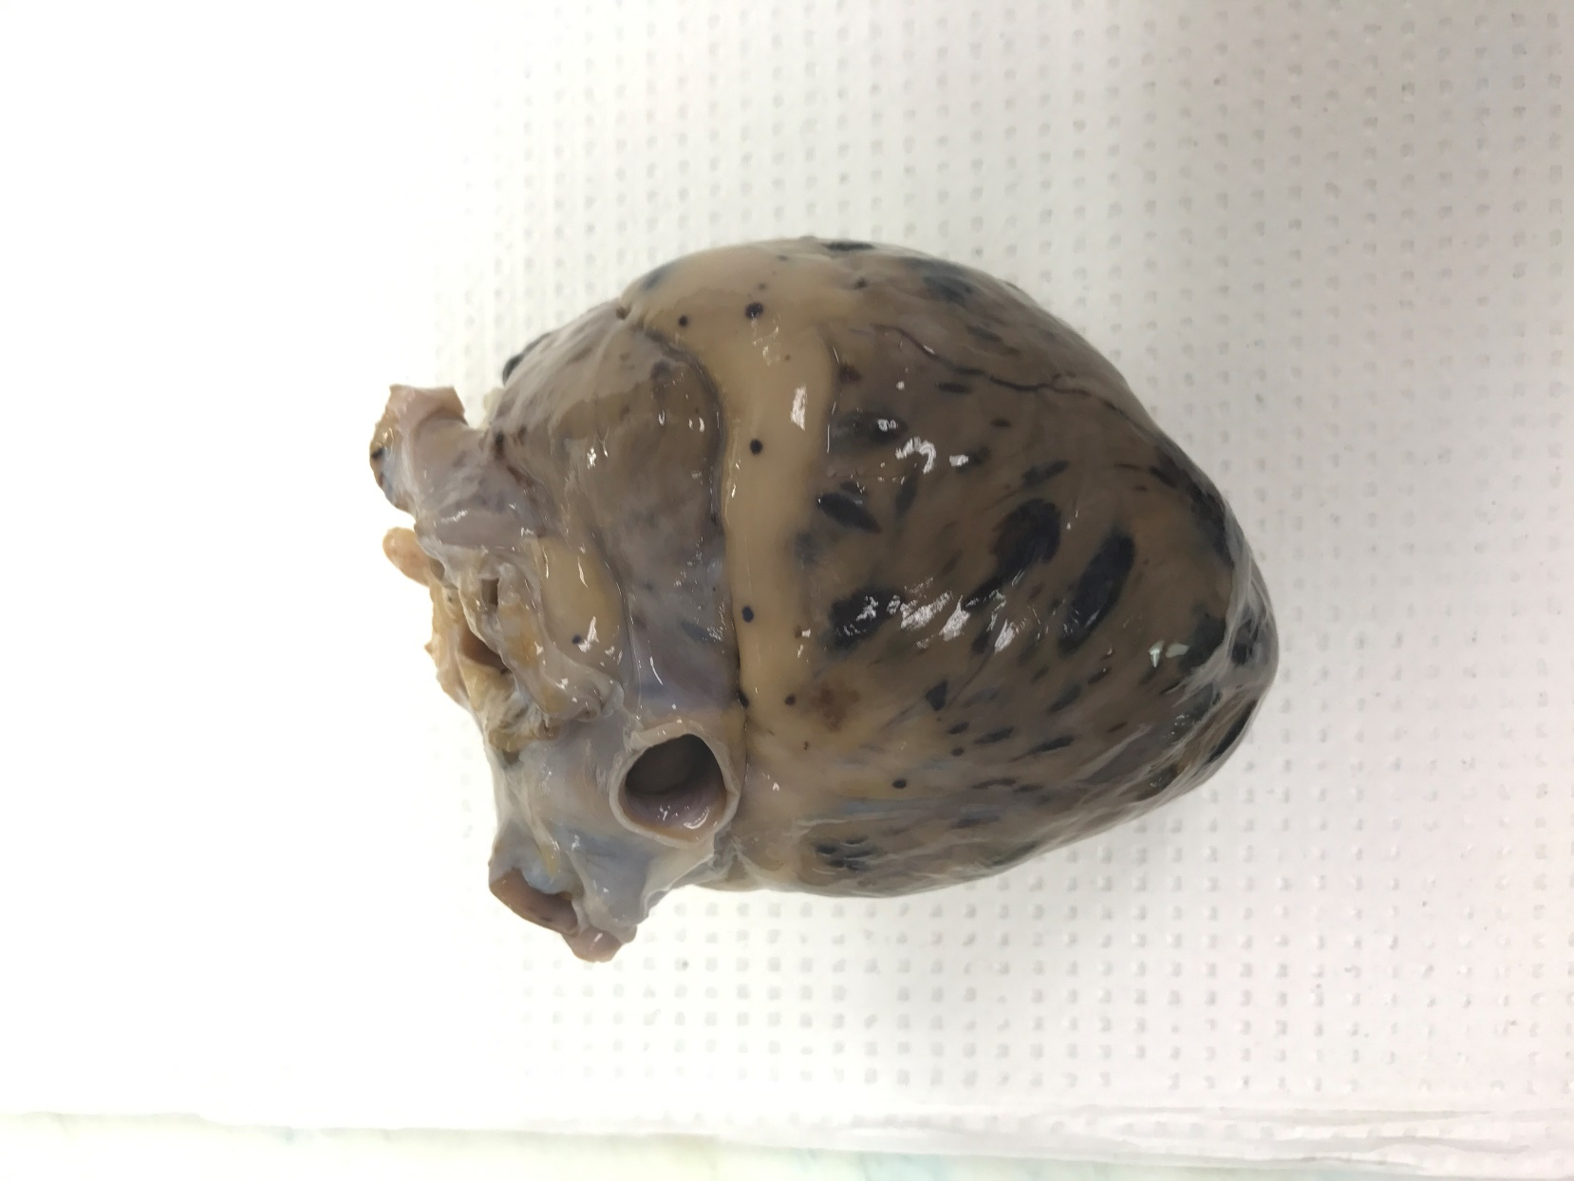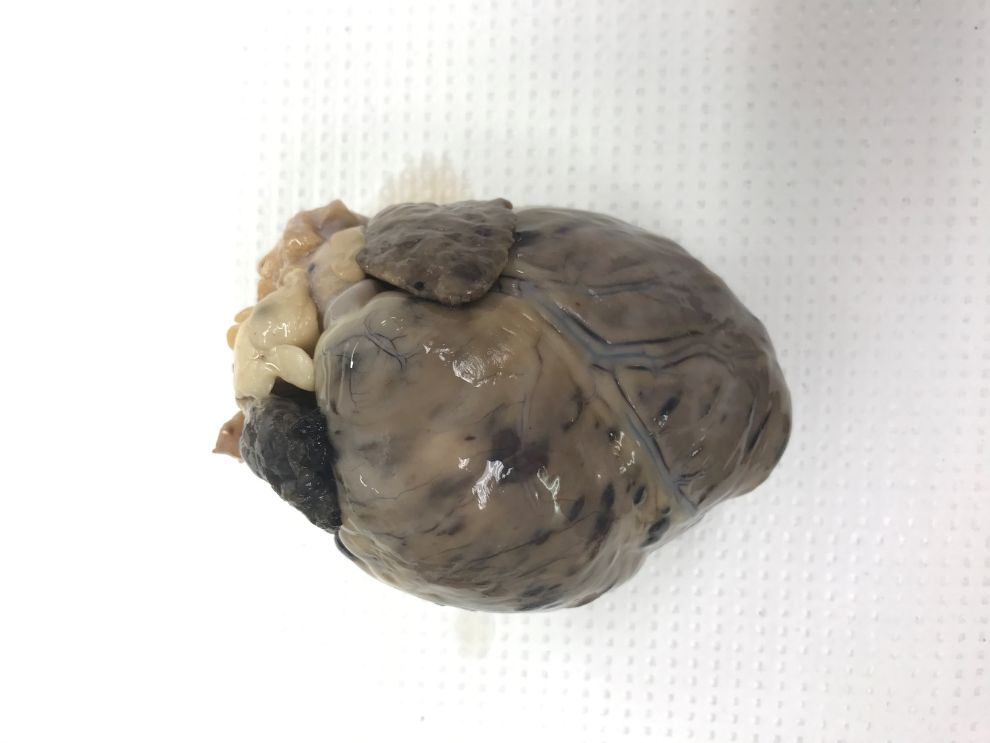

Golden retrievers and German Shepherd dogs are predisposed hemangiosarcoma, but it also occurs in other older large breed dogs and sometimes in small breed dogs.

Hemangiosarcomas are extremely aggressive, malignant tumors of endothelium. Prognosis is grave, with survival of days to weeks without treatment or 3-6 months with a combination of surgical intervention and chemotherapy.

Common sites for the visceral form include: right auricle, spleen, liver, kidney, and retroperitoneum. Sometimes it is not clear which is the primary lesion. Widespread metastasis to the lung, body cavities and brain is also common.

Clinical signs are typically acute weakness or collapse, often associated with an episode of vomiting. Signs usually result from acute hemorrhage into the pericardium, causing cardiac tamponade and reduced cardiac output.

From the cranial aspect you can see the large, dark red mass on the right atrial appendage and extending into the right atrium. Multiple metastatic lesions are present throughout the myocardial wall.

**RAA**