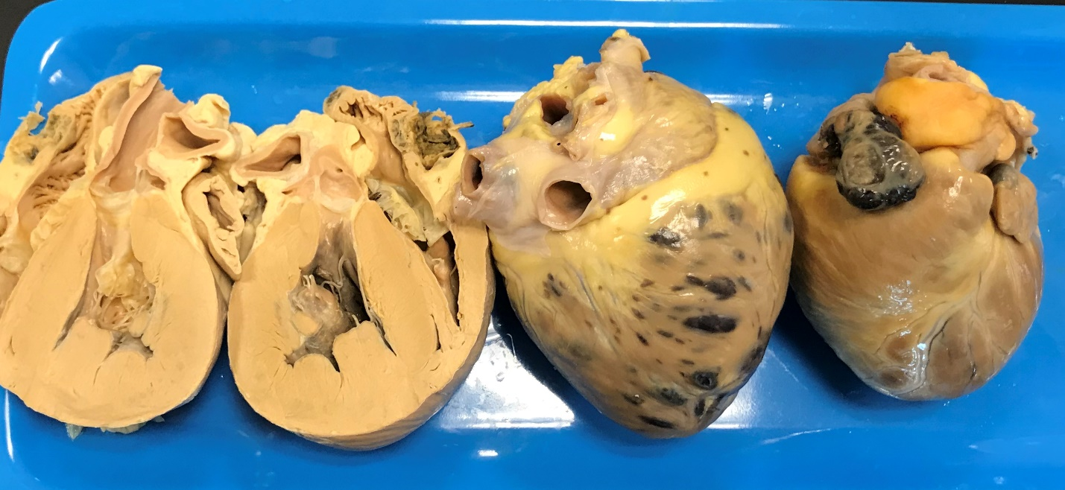

Hemangiosarcomas are extremely aggressive, malignant tumors, and they have often metastasized at the time of diagnosis even if there is no gross metastatic disease visible.

Dogs often present with weakness or collapse (sometimes in shock) resulting from hemorrhage into the pericardial space and cardiac tamponade.

Prognosis is grave, but pericardiocentesis often results in immediate improvement of clinical signs, and dogs can feel quite well for a variable amount of time at home (typically until bleeding occurs again or sometimes because of signs related to metastatic disease.)

Several manifestations of cardiac hemangiosarcoma:

* Invading the right atrial wall
* Right atrial appendage and throughout the myocardium
* Visible on right atrial appendage only
* How might the femoral pulses feel with pericardial effusion?
* What ECG finding may be present with pericardial effusion?
* What might you expect to see on point-of-care blood work when an animal presents for collapse resulting from pericardial effusion?