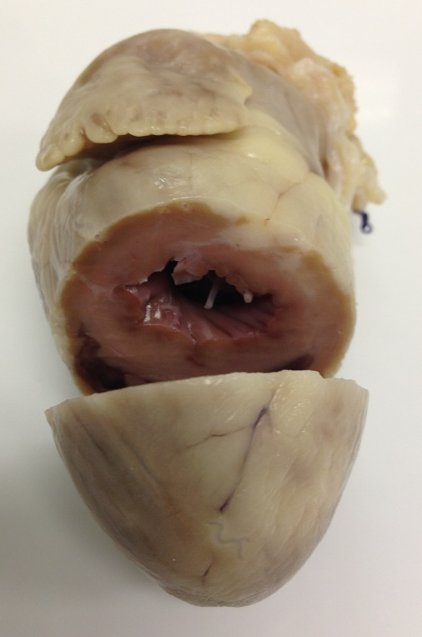

This cat had severe HCM with secondary marked left atrial dilation. He presented for aortic thromboembolism (ATE) to the hind limbs from a thrombus that had formed in the enlarged left atrium.

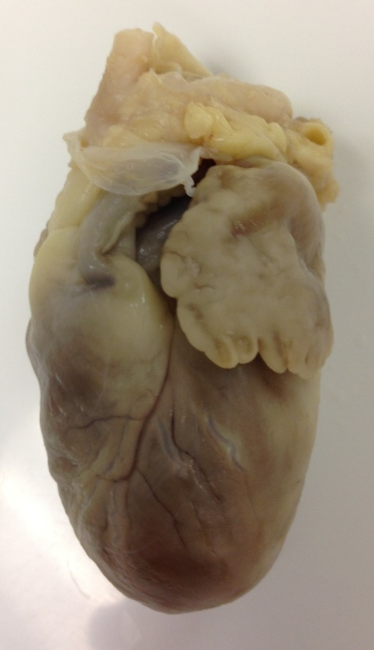

L

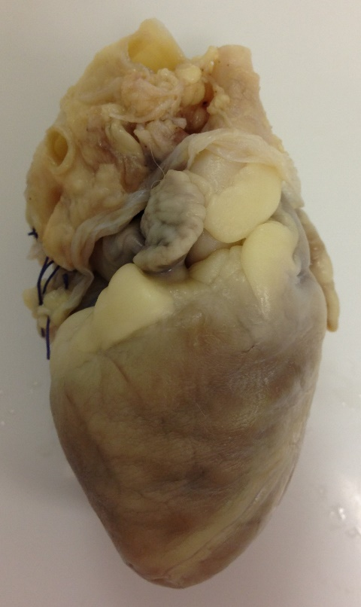

R

Note the dramatic enlargement of the left atrial appendage in comparison to the right.

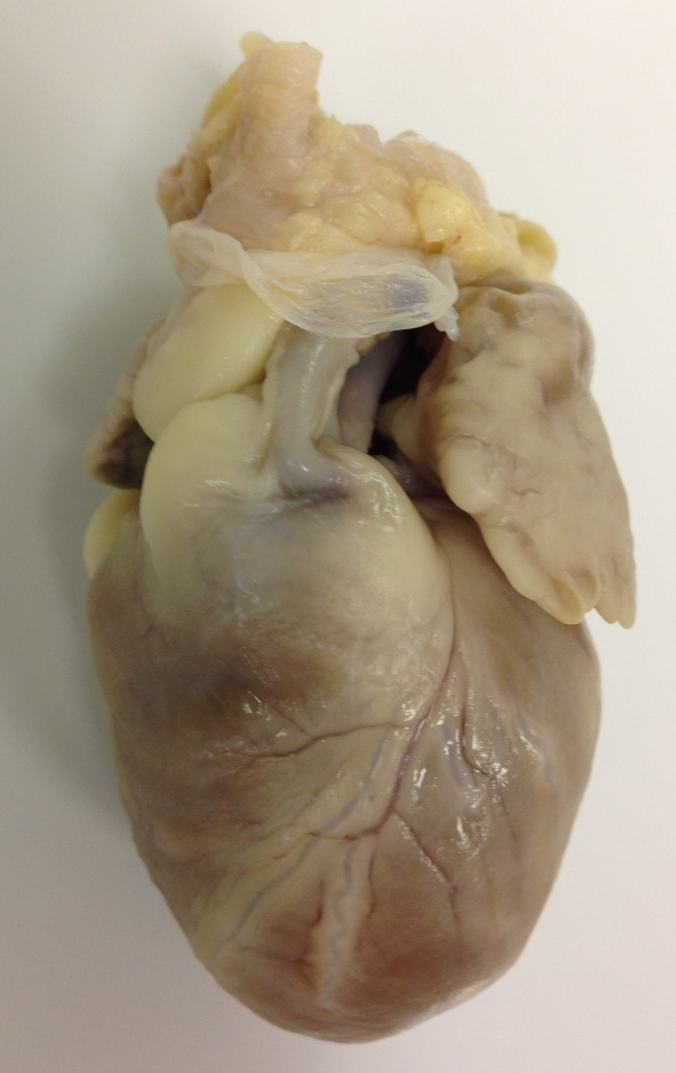

L

R