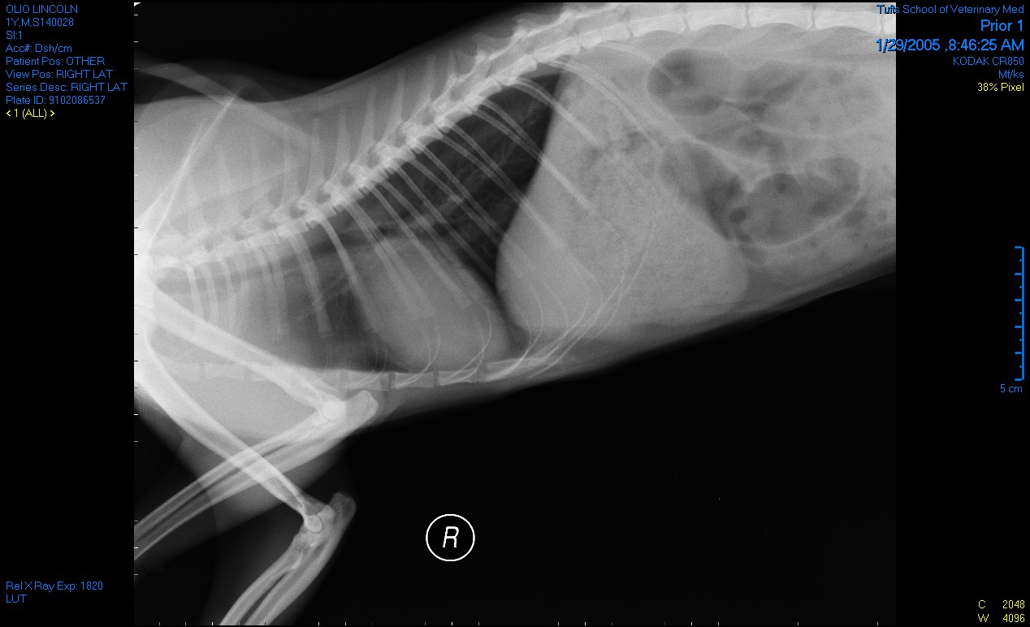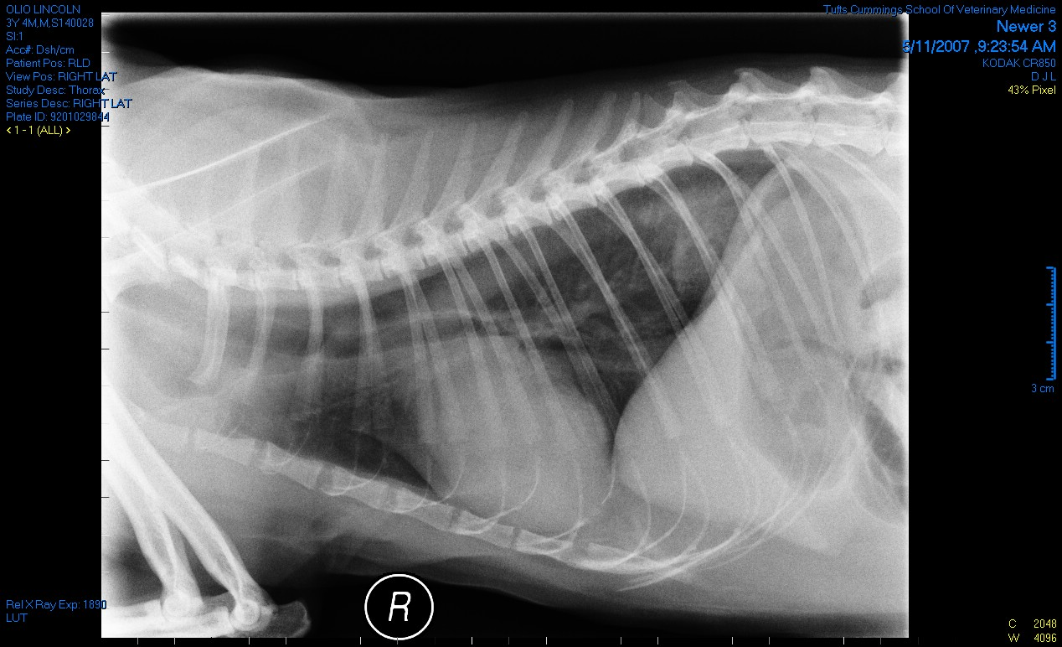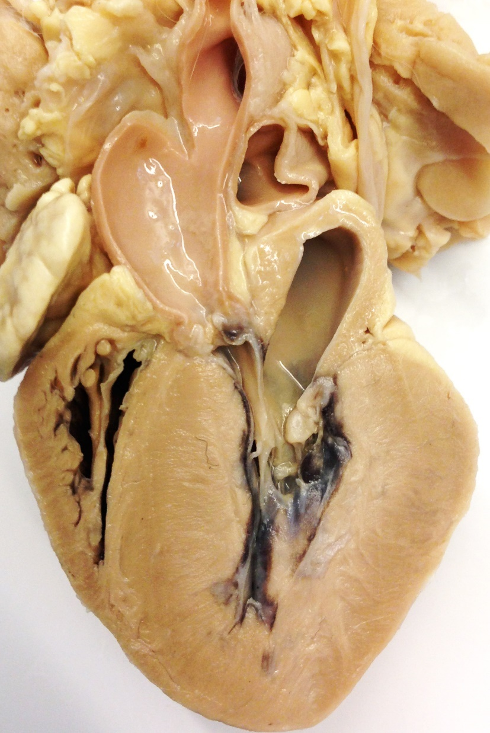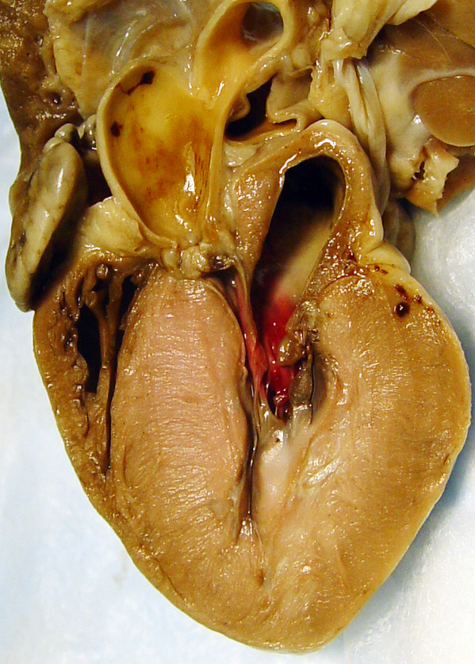

A cat with severe aortic stenosis and hypoplasia of the aortic root. Note the marked secondary LV concentric hypertrophy. Balloon dilation was attempted, but was unsuccessful do to the size of the patient, and ultimately he developed left-sided congestive heart failure.

The radiographs below show progressive cardiomegaly from when the cat was 2 years old (left) to when the cat was 4 years old (right).