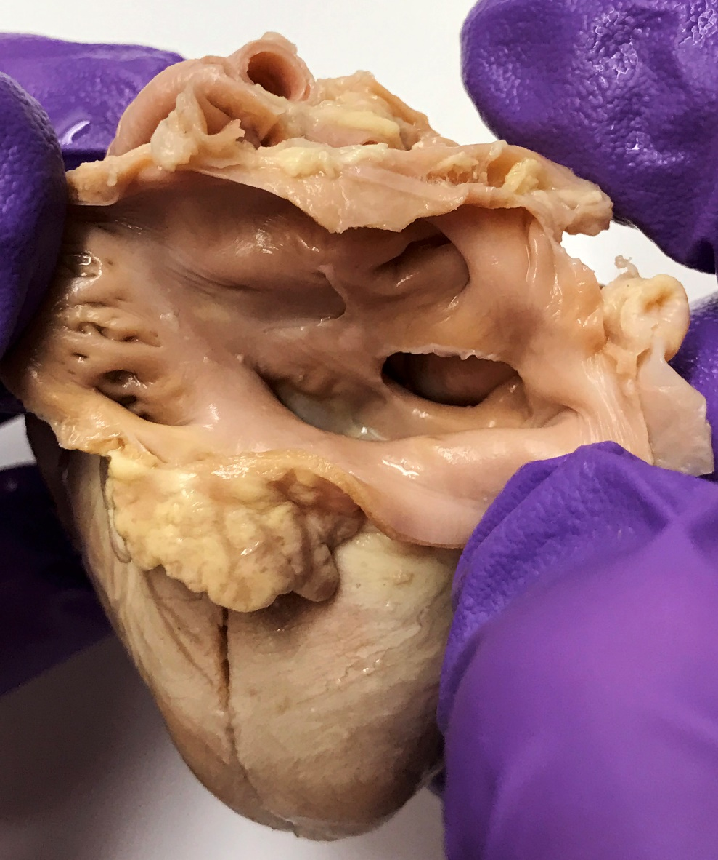

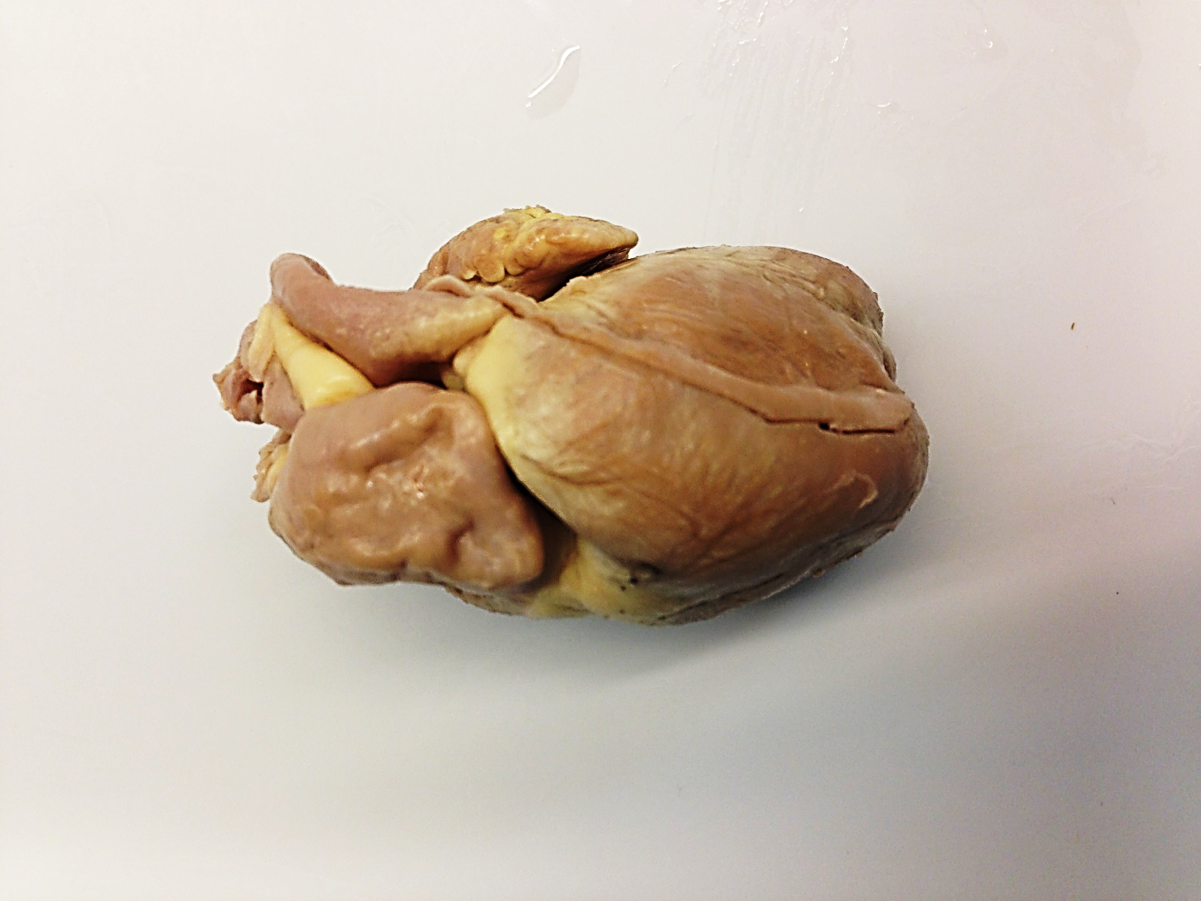

RAA

This is an example of a large atrial septal defect (ASD) in a kitten, as viewed from the left atrium.

You would not hear a heart murmur from the flow of blood through the ASD, but you might hear a systolic murmur associated with relative pulmonic stenosis (a larger than normal volume of blood going through a normal sized pulmonic valve).

Because of the volume overload caused by overcirculation of the left atrium, right atrium, and right ventricle, all of these structures (especially the RA and RV) are dilated (eccentric hypertrophy).

There would also be pulmonary overcirculation.