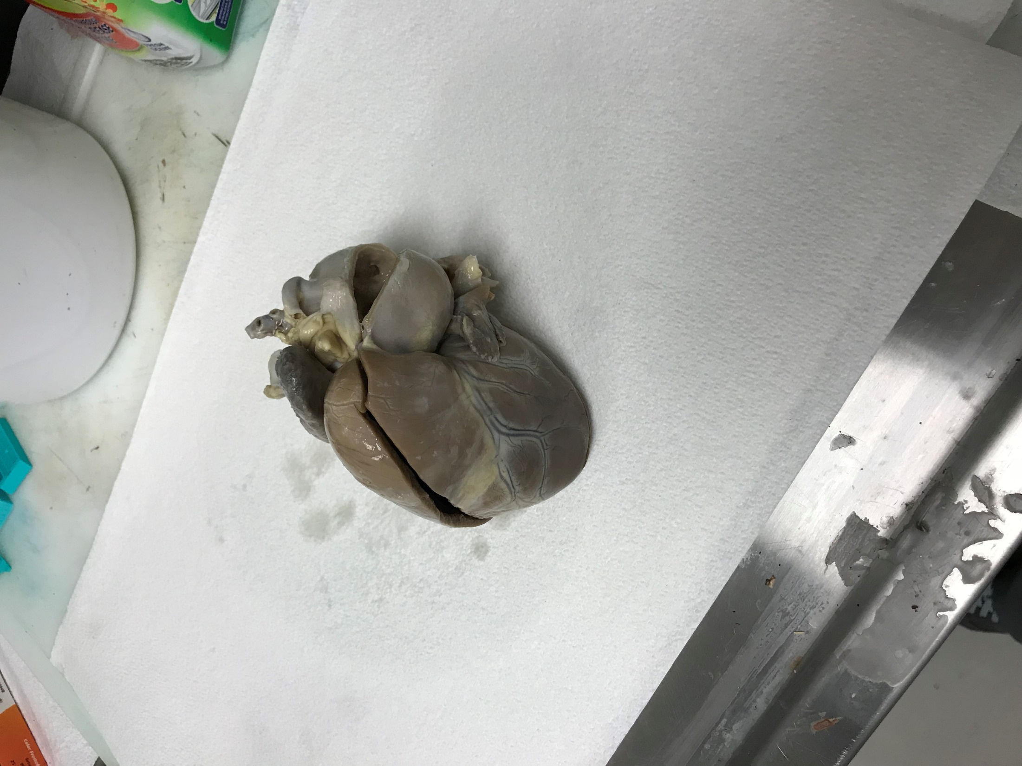

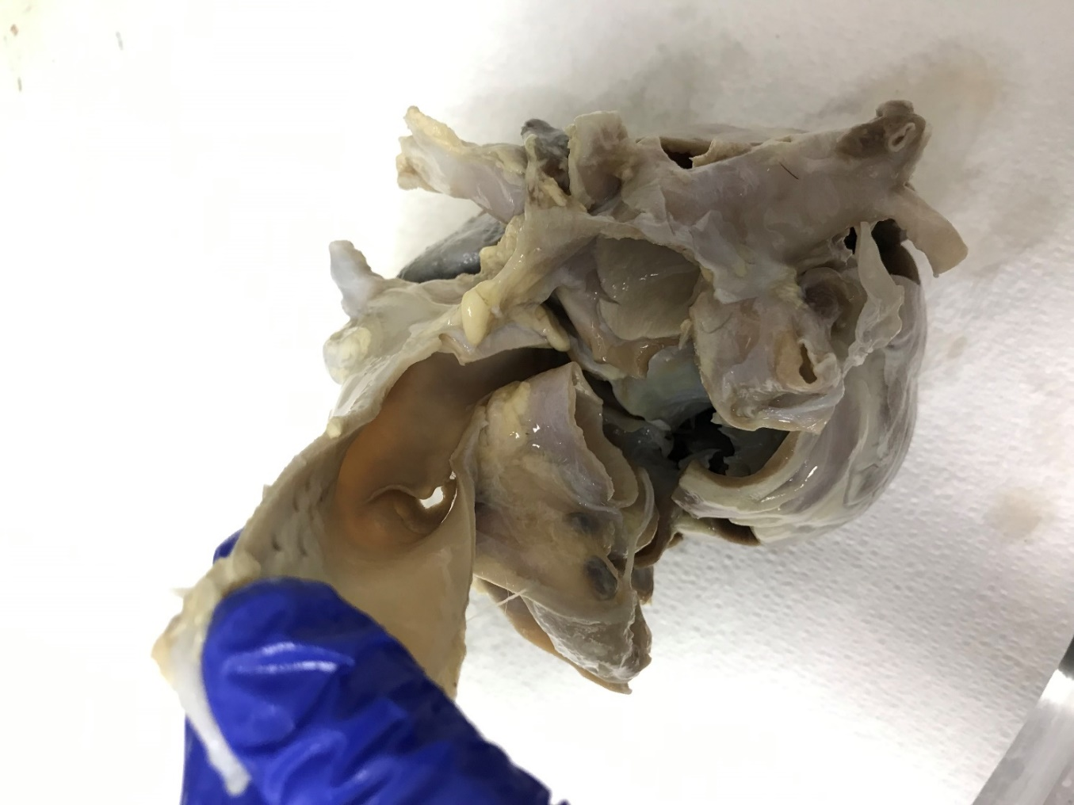

**PDA from aortic side**

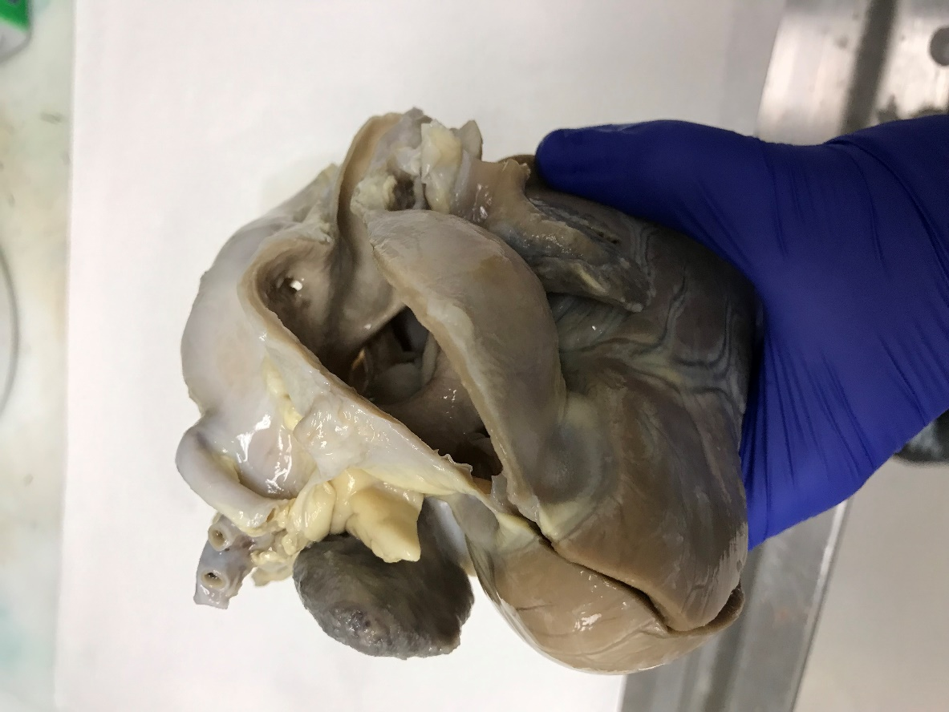

**PDA from PA side**

A 6-year-old spayed female shepherd mix presented for trouble breathing.

Echocardiography revealed a large PDA and severe pulmonary hypertension.

Flow across the PDA was still left-to-right.

Note the 4-chamber dilation, marked PA dilation, and large PDA visible from both the pulmonary artery and the aorta.

**LA**

**RA**

**RVOT**

**PA**

* Can you trace the path of a red blood cell from the left atrium through the PDA and back to the left atrium?
* Which structures are commonly dilated with an uncomplicated PDA?
* Why is the right heart dilated in this dog?

**RA**