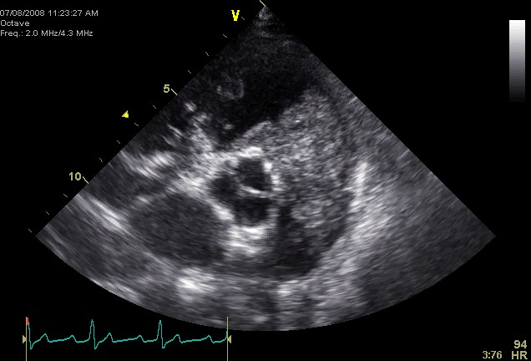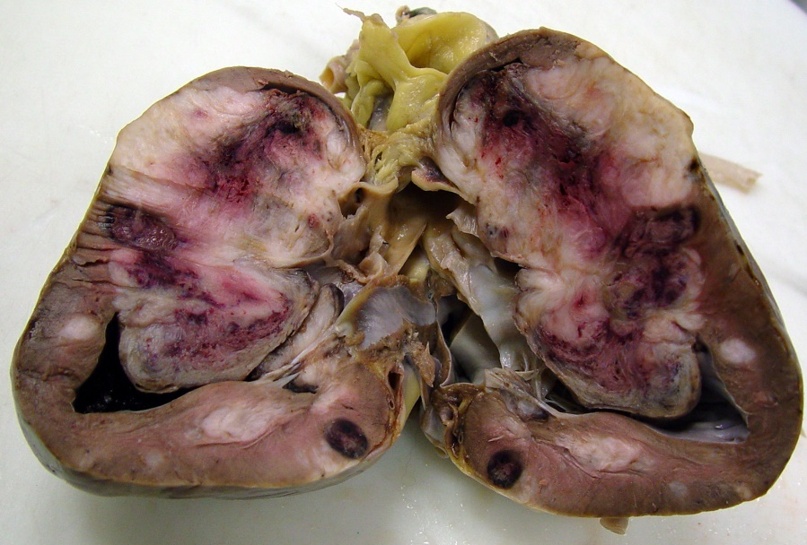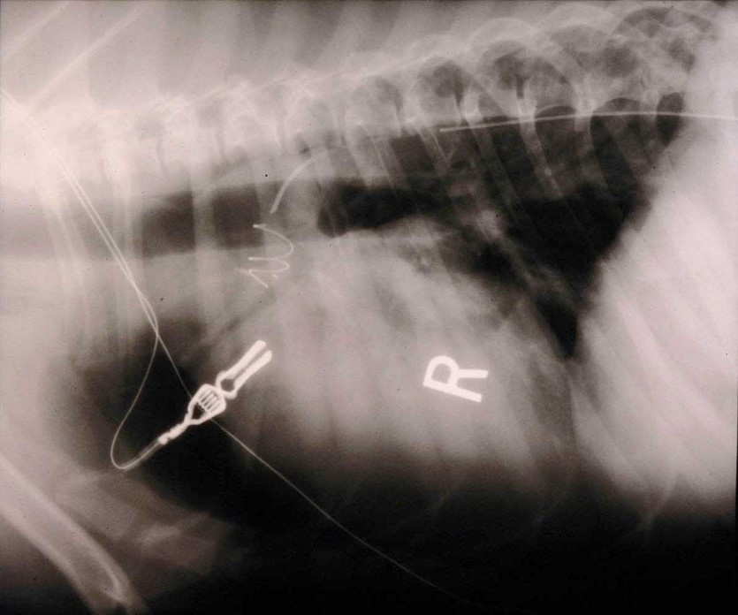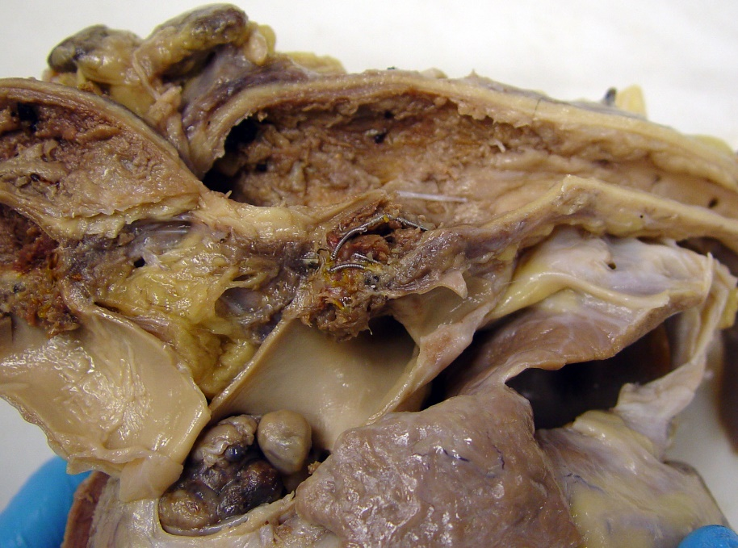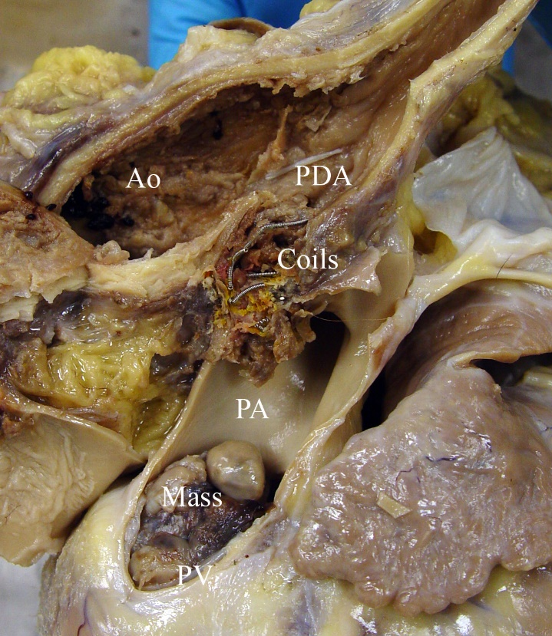

At 11 years old, patient developed shortness of breath and decreased exercise tolerance. Echocardiogram revealed a mass obstructing the right ventricular outflow tract and masses within the myocardium.

At 1.5 years old, coils were placed to occlude a PDA. Two thoracotomies had previously been unsuccessful. At 9 years old, patient developed DCM; the DCM was taurine responsive and resolved.

In this specimen there is no evidence of DCM (it resolved with taurine supplementation). Coils are visible with an associated thrombus occluding the PDA. Neoplasia (sarcoma) is visible obstructing the right ventricular outflow tract and infiltrating the myocardium.