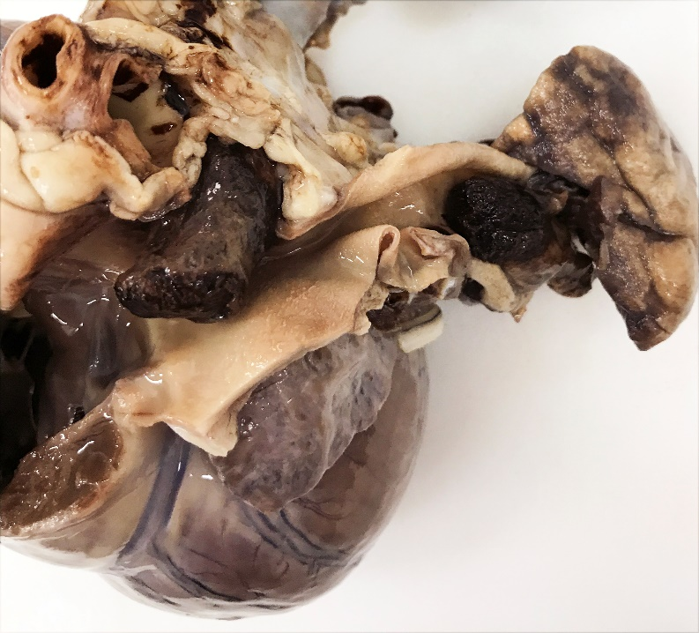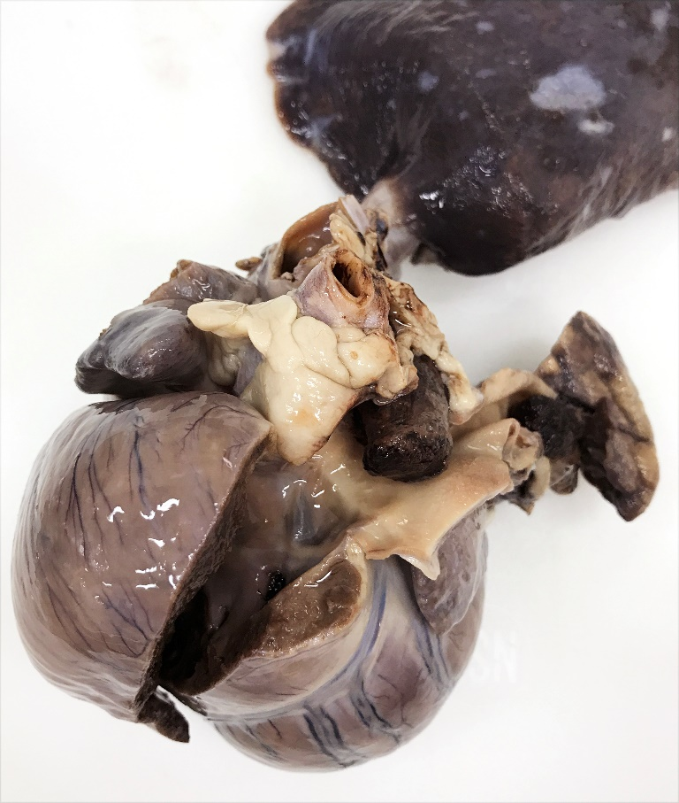

Clinical signs of PTE can include tachypnea, cough, dyspnea, cyanosis, syncope, and sudden death.

Pulmonary thromboembolism can result from heartworm disease or from other procoagulable diseases such as protein losing nephropathy (and other disease processes that result in loss of antithrombin), Cushing’s disease, neoplasia, and IMHA.

This was a dog that died suddenly, and had a history of heartworm disease.

The pulmonary artery branches are completely occluded by large, firm thrombi. The thrombus can be palpated within the PA branch as it enters the lung.

The RV and RA are dilated (eccentric hypertrophy), and the RV wall is thickened (concentric hypertrophy).

**PTE**

**PTE**

**RV**