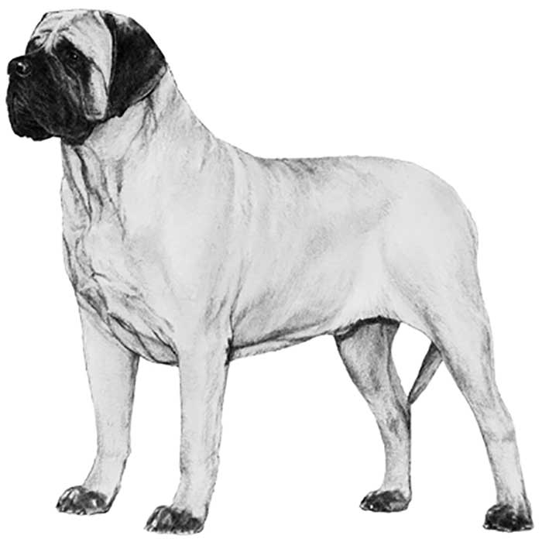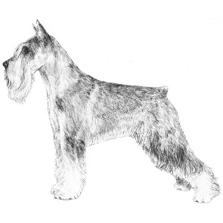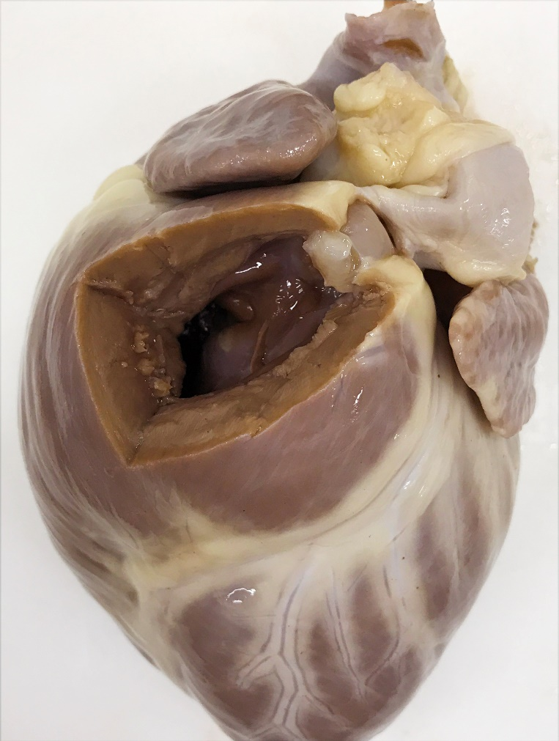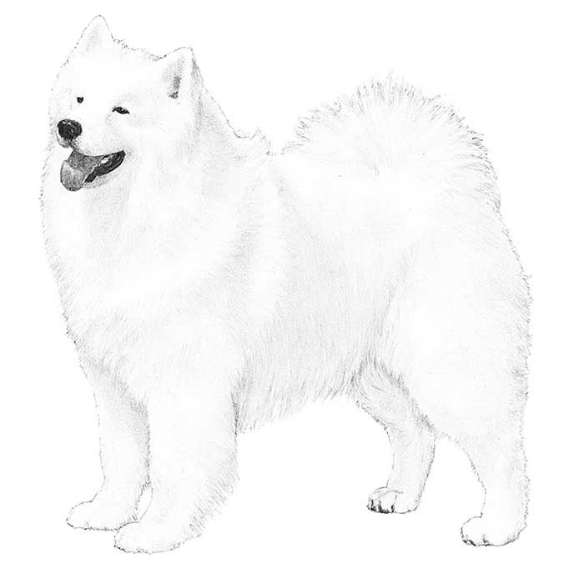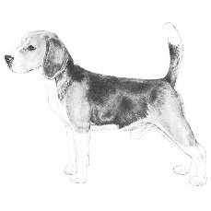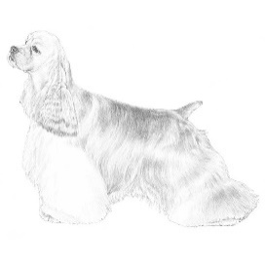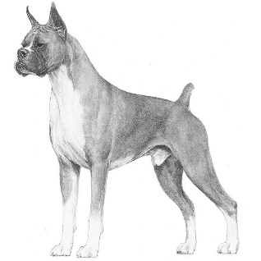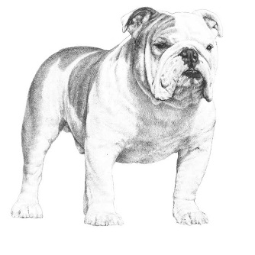

Predisposed breeds include English bulldogs, Chihuahuas, boxers, beagles, cocker spaniels, Samoyeds, schnauzers, mastiffs, and terriers.

Valvular pulmonic stenosis (PS) in a dog. The RV outflow tract free wall has been removed to display the thickened and irregular pulmonic valve and the severe concentric right ventricular hypertrophy that results from pressure overload.

There is post stenotic dilation of the PA, with a jet lesion that can be palpated as an irregular roughening of the endothelium.

**RV**

**PA**

**RA**

Open

Closed

Normal

Pulmonic Stenosis