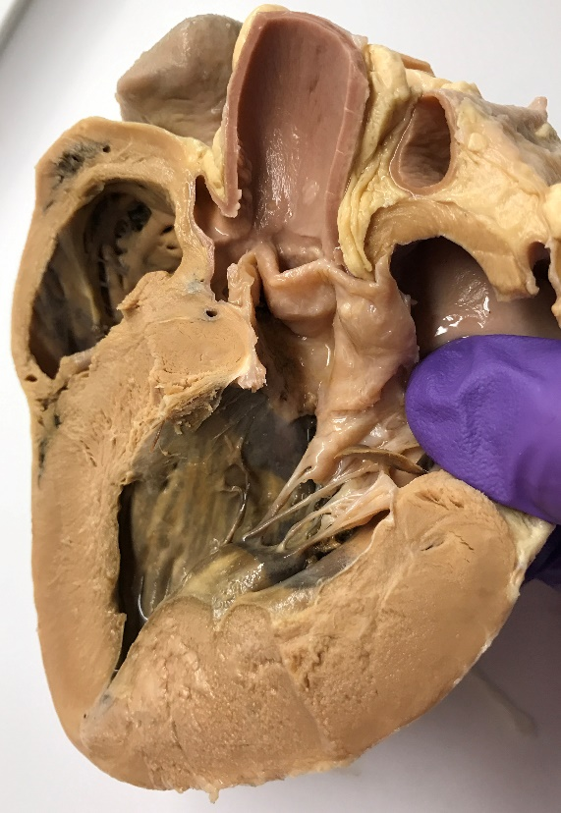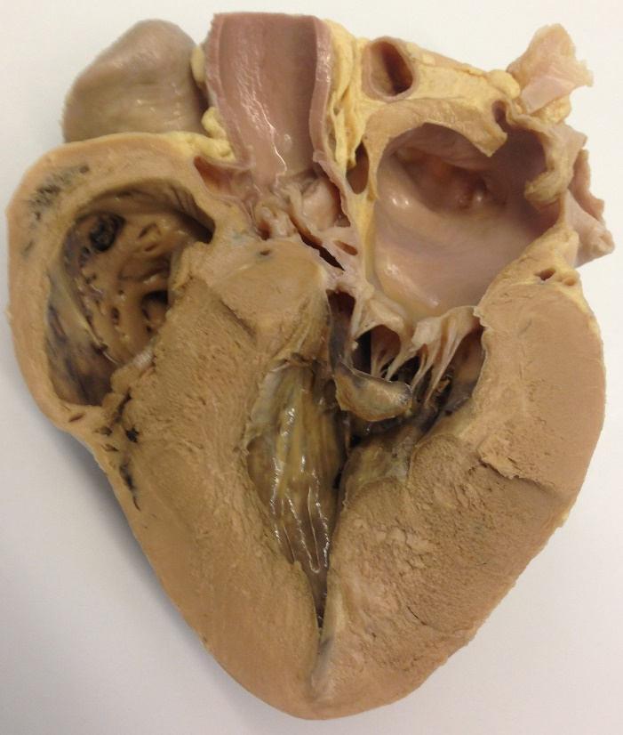

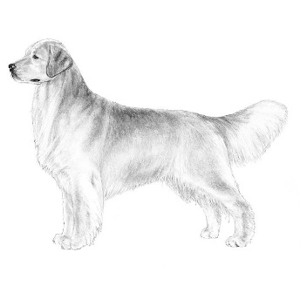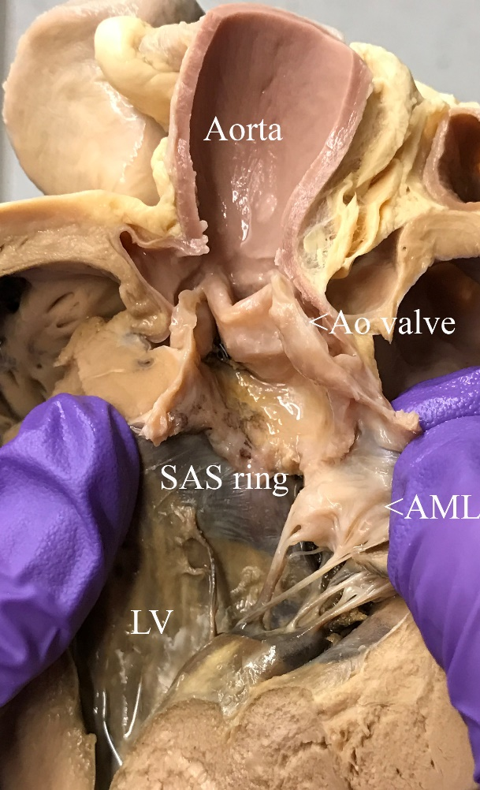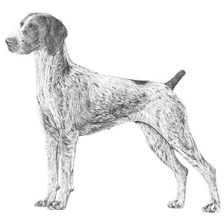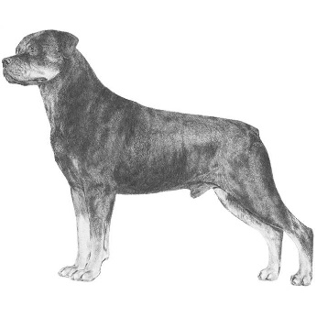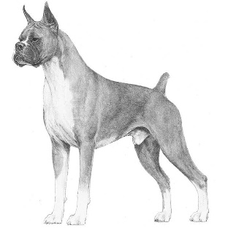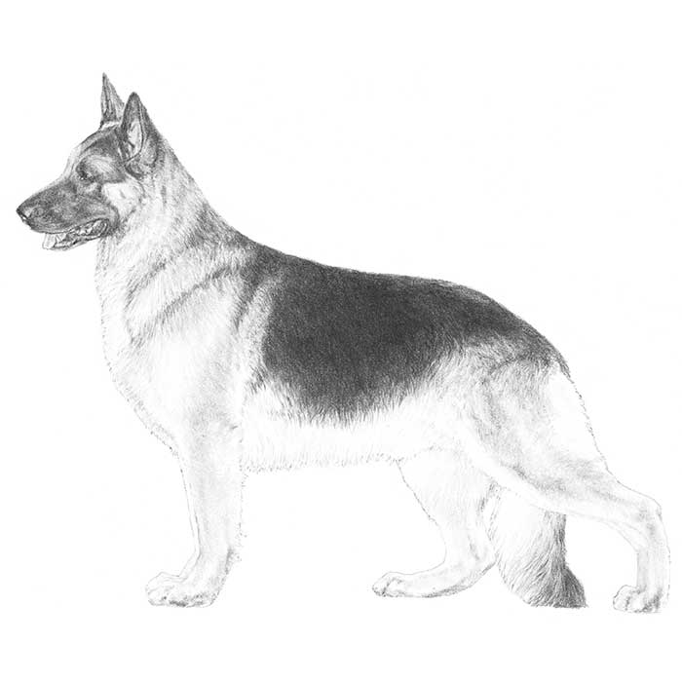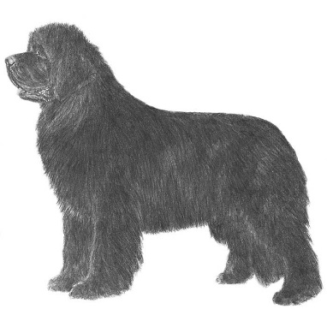

Predisposed breeds include Newfoundlands, German shepherd dogs, boxers, golden retrievers, Rottweilers, and German shorthair pointers.

Possible outcomes for dogs with subaortic stenosis include:

**Syncope/sudden death Aortic endocarditis Left-sided CHF (least common)**

Dogs with mild obstructions may remain asymptomatic.

Subaortic stenosis (SAS) in a dog. The subaortic ridge is visible below the aortic valve. The tough, fibrous nature of the ridge is palpable.

Note the severe concentric left ventricular hypertrophy that results from pressure overload.