Week 3: Cell Passaging & Subculturing

Feb 1st, 2024

General Notes

* Passaging (also known as subculturing or splitting) refers to the removal of the medium and transfer of the cells from a previous culture into a new culture in fresh growth medium.
* Cells should be passaged at ~80% confluence (the percentage of the culture vessel surface area that appears covered by a layer of cells).
* The passage number will increase whenever the cells touch new plastic. Thus, during cell passaging, the passage number will increase by one.

Materials

* Micropipettes and autoclaved tips
* KimWipes
* Ethanol (140 proof)
* Centrifuge with attachments for 15 and 50 mL tubes
* Counterbalancing tube(s) for centrifuge
* Chemical-resistant laboratory marker
* Pipette controller and serological pipettes
* Water/bead bath, set to 37°C
* Conical tubes and tube racks
* Biosafety cabinet
* Light and phase contrast microscope
* Hemocytometer
* Growth media (GM)
* Trypsin-EDTA (0.25%, 1X)
* Gibco DPBS, no calcium, no magnesium
* Trypan blue
* Tissue culture flasks and one 12-well plate

Method

**Passaging**

1. Warm growth media in the water bath.
2. View cells under light microscope and note observations.
3. Thaw 0.25% trypsin from the -20°C to 37°C in the water bath.
   1. The volume will depend on the surface area of plates/flasks from which you are passaging. Recommended volumes are shown the reference volumes table at the bottom of this protocol.
4. Once the media and trypsin are warm, carefully aspirate the spent media (i.e., media that remains after the cells have utilized the components) from the flask using an aspirating pipette connected to the vacuum inside the biosafety cabinet.
   1. NOTE: For greater precision, a 200 µL micropipette tip can be placed on the tip of the aspiration pipette.
5. Add the appropriate volume of sterile DPBS (see reference volumes table) using a serological pipette.
   1. This step washes off residual growth media, as FBS can inhibit trypsin.
6. Carefully aspirate DPBS using an aspirating pipetted connected to vacuum in the biosafety cabinet.
7. Add the appropriate volume of warmed trypsin (see reference volumes table) using a serological pipette. Tilt the culture vessel gently to ensure even distribution.
8. Place the culture vessel in the 37°C and set a timer for 5 minutes.
9. After 5 minutes, check cell attachment on the culture vessel using the microscope.
   1. The cells should appear circular and detached (Fig. 1). If cells are circular but not detached, firmly tap (~5 times) each side of flask to help cells detach. Wait (~30 sec) and repeat as necessary until no/very few cells are visibly attached under microscope.
   2. NOTE: Once detached, cells are in suspension and frequently will be moving quickly across field of view. To test if cells detached, gently agitate flask and observe if cells remain in place (i.e., do not move with flow of liquid movement).

Fig. 1: Example images of adherent cell culture before (left) and after (right) cell detachment with trypsin1

1. Immediately after observing no/very few visibly attached cells, bring flask back to biosafety cabinet and add an equal volume (in comparison to the volume of trypsin) of growth media using a pipette. Using the same pipette, rinse the flask surface by pipetting up and down (~5 times), dispensing directly onto entire bottom of flask to help cells detach. Transfer cell suspension to labeled (species/cell type, passage number, initials, date) tube.
   1. NOTE: Be quick about adding GM as soon as you observe no/very few visibly attached cells; the longer the trypsin is left with the cells, the more cells can be damaged by excessive exposure to protease. Adding media (which includes FBS) neutralizes trypsin and inactivates its proteolytic activity.
   2. NOTE: Since adding the growth media neutralizes the trypsin, it is also important to move the cells out of the culture vessel, as they could re-adhere to the tissue culture treated plastic (but will not adhere to the conical tube’s plastic).
2. Spin the sterile cell suspension in the centrifuge at 300 RCF for 5 minutes.
3. Bring the centrifuged cells into the biosafety cabinet.
4. Carefully aspirate off supernatant without disturbing cell pellet using aspirating pipette connected to vacuum in biosafety cabinet.
5. Resuspend the cell pellet in 5 mL of growth media. Mix well by pipetting up and down.
   1. Note: You should see the cell pellet at the bottom of the tube. When you add the media, be sure to pipette rather vigorously up and down to first dislodge the pellet and then suspend the cells evenly throughout the media. When you pipette, you want to be forceful but try to avoid introducing bubbles.
6. Transfer 10 µL of well-mixed cell suspension to a microcentrifuge tube for cell counting.
   1. NOTE: If your cell suspension has been sitting for a while, the cells may be more concentrated in the bottom of the tube. Thus, if that is the case, we recommend mixing the cells with a pipette before taking a sample.
7. To the microcentrifuge tube, add 10 µL of Trypan blue and mix well.
8. Count the cells on the hemocytometer.
   1. Mix the cell suspension and add 10 µL of stained cells into the hemocytometer chamber using a micropipette.
   2. Place the hemocytometer on the stage of the microscope and adjust the magnification to 10X. Focus on the cells.
   3. Using a hand tally counter, count the viable cells (those with unstained nuclei) in each of the four outside squares of the hemocytometer (Figure 2A), including cells that lie on the bottom and left-hand perimeters, but not those that lie on the top and right-hand perimeters (Figure 2B). Note the viable cell count.
   4. Repeat step 17c but for the dead cells (those with stained nuclei). Note the dead cell count.
   5. Calculate the viability percentage.
 $Viability \%= \frac{Viable Cell Count}{Viable Cell Count+Dead Cell Count}$

  6. Calculate the viable cell concentration (cells/mL)
      1. Each of the major squares of the hemocytometer represents a total volume of 0.1 mm3. Since 1 cm3 is equivalent to 1 mL, the cell concentration can be determined using the following equation:
      2. Viable cell density (viable cells / mL) = average viable cell count per square * dilution factor * 10,000
      3. For example, if the viable cell counts in the four outer square were 21, 15, 20, and 17, the average viable cell count per square is 18.25. Since the dilution factor is 2, the viable cell density = 18.25*2*10,000 = 365,000 viable cells/mL
   7. NOTE: If the cell density seems too high (i.e., there are too many cells in the hemocytometer to get an accurate approximation of cell number), dilute another sample of your cell suspension in DPBS and start at step 11A, being sure to factor in the additional dilution into your dilution factor.
   8. NOTE: If the cell density seems too low (i.e., there are hardly any cells to count), concentrate your sample by spinning down the cell suspension and resuspending in a smaller volume of GM. Start over at step 11A.

Fig. 2: Hemocytometer diagram indicating the (A) four sets in red and (B) the 16 squares within one of the sets that should be used for counting2

1. We will be passaging the cells into a 12-well plate to prepare for our adipogenicity/myogencicity test next class and into large surface area flasks to prepare for cryopreservation next week.
   1. NOTE: For the 12-well plate, a muscle and fat group will need to coordinate with each other to transfer cells between the groups.
   2. NOTE: The BSCs and SVCs cells grow at doubling times of 18 hour and 55 hour, respectively. Thus, we will seed the BSCs lower.
2. Generally, we recommend seeding 1,000-5,000 cells/cm2. The exact cell density will depend on your schedule and the cell growth rate. Also, when cells touch new plastic (i.e., when cells are seeded into a new plate or flask), the passage number then increases. Since the cells after an isolation are passage number 0 (“P0”), the cells after passaging will be passage number 1 (“P1”).
3. For the 12-well plate, seed the cells at BSCs at 2,000 cells/cm2 and SVCs at 4,000 cells/cm2. You will seed 4 wells with satellite cells and 6 wells with stromal vascular cells (see Fig. 3 for suggested plate arrangement).
   1. Based on the viable cell density and well surface area, you will need to calculate how many cells and how much media are needed for seeding. Please refer to the reference volumes table at the bottom of this protocol.

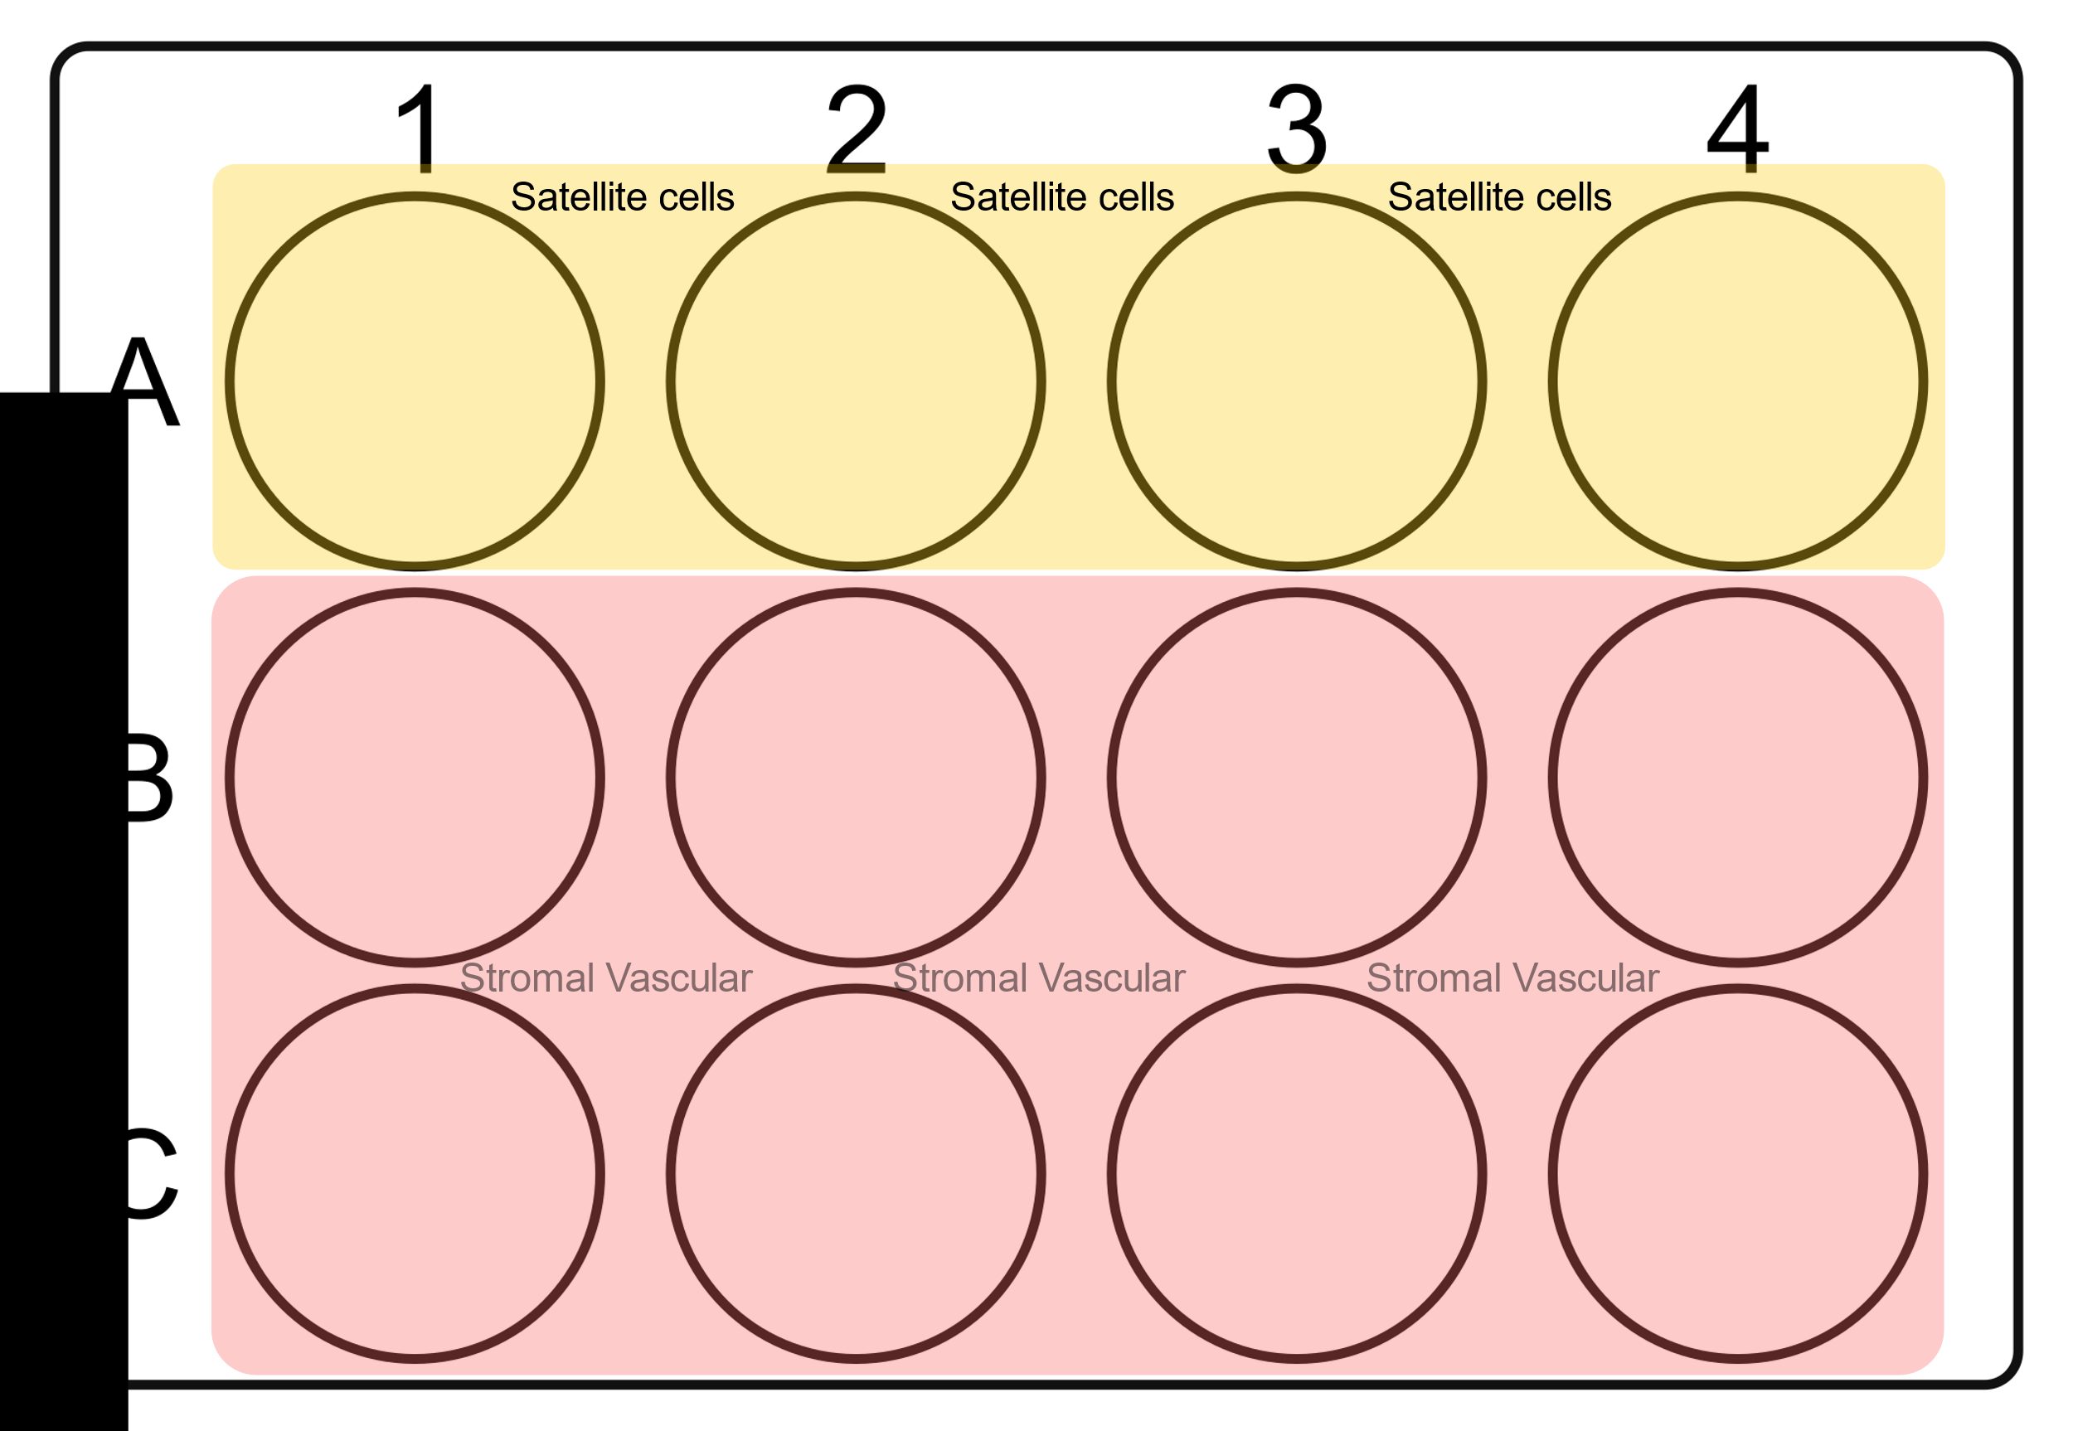

Fig. 3: Suggested 12-well plate arrangement

1. For cryopreservation, seed BSCs cells at 1,000 cells/cm2 and SVCs cells at 2,000 cells/cm2.
   1. Based on the viable cell density, calculate the surface area of culture vessel that you will passage the cells into. Then, for each flask, calculate the volume of cell suspension and volume of growth media needed (see reference volumes table at the bottom of this protocol).
2. Bring the flasks into the biosafety cabinet.
3. For each flask, mix the calculated cell suspension volume and growth media volume in a conical tube.
4. Add the diluted cell suspension into the labeled (with cell type, passage number, initials, and date) culture vessels. Gently tilt the flask to all four sides to distribute the cells.
5. Place the cells in the 37°C incubator.
6. During this week, please coordinate within your group or between groups to feed the cells (i.e., replenish media) on Sunday and Tuesday.
   1. To feed, you will aspirate out the spent media and then add fresh, warmed growth media to the flasks/plate.
   2. Feel free to use the Canvas discussion board to coordinate!

References

1. https://sciencellonline.com/blog/13-technical-tips-for-successful-primary-cell-culture/
2. https://www.stemcell.com/how-to-count-cells-with-a-hemocytometer.html

Reference volumes

|  |  |  |  |  |
| --- | --- | --- | --- | --- |
| **Vessel** | **Surface (cm2)** | **~PBS volume** | **~Trypsin volume** | **~Media volume** |
| 6-well plate | 9.6 | 1 mL | 500 uL | 2 mL |
| 12-well plate | 3.5 | 500 uL | 250 uL | 1 mL |
| 24-well plate | 1.9 | 500 uL | 250 uL | 1 mL |
| 48-well plate | 1.1 | 200 uL | 100 uL | 500 uL |
| 96-well plate | 0.32 | 100 uL | 50 uL | 200 uL |
| T-25 | 25 | 3 mL | 1 mL | 5 mL |
| T-75 | 75 | 5 mL | 2 mL | 12 mL |
| T-175 | 175 | 10 mL | 3 mL | 30 mL |