Week 4: Differentiation of Cow 🐄 Muscle and Porcine Fat Cells
Date: February 8, 2024

Objectives, Hypotheses, Background
Let’s confirm that the cells we’ve isolated are indeed muscle/fat!
For muscle 💪, this should be straightforward. We typically use two differentiation techniques, serum starvation (cessation of feeding at 90-100% confluence) and serum reduction (lower FBS concentration to 2% then feed regularly). We will compare these two differentiation regimes.
For adipose 🧈, things are more complicated. Bovine (and ruminant) adipogenesis and fat biology is less well understood. Typically, differentiation regimes (e.g., culture media formulations) used with human/pig/rodent cells do not work as well when applied to cow cells. Thus, in this class we will screen varying differentiation media and feeding regimes.
Fat cell differentiation usually involves two culture media. See this example from a paper the Kaplan Lab has published:
We will try varying both the culture media and the timing of the induction/accumulation media. Usually, the induction media is high in adipogenic factors to kickstart adipogenesis, after which only a pared down accumulation media is necessary.
Negative Control – No Lipid Accumulation expected
Just feed with BSC-GM. There will be no PPARG agonists, so we do not expect lipid accumulation.
Differentiation Strategy 1 – Conventional Differentiation Regime:
Sort of our positive control group, this will be roughly what’s usually given to fat cells.
Induction Media (2-3 Days): DMEM + 10% FBS + 10 ug/ml Insulin + 1 uM Dexamethasone + 0.5 mM isobutylmethylxantine (IBMX) + 2 uM Rosiglitazone. We will refer to this media as DM1-ind.
Accumulation Media (Rest of the time): DMEM + 10% FBS + Insulin. We will refer to this media as DM1-acc.
Differentiation Strategy 2 – Serum Free + Ascorbic Acid-Based Differentiation:
From Jurek et al, they discovered that 1) a lower concentration induction media worked fine; and 2) Lipid accumulation worked better sans FBS. They used bovine serum lipids though, still from the animal. The bovine serum lipids aren’t readily available, so we’re going to try with Intralipid, a soybean oil based medical lipid emulsion (usually administered intravenously).
Induction Media (2 Days): DMEM, 10% FBS, biotin (10 µM), pantothenate (5.67 uM), insulin (3 µg/mL), dexamethasone (0.3 µM), IBMX (0.1 mM), rosiglitazone (10 µM). We will refer to this media as DM2-ind.
Accumulation Media (Rest of the time): DMEM, 0% FBS, insulin (3 µg/mL), biotin (10 µM), 113 uM ascorbic acid, 500 ug/mL Intralipid. We will refer to this media as DM2-acc.

Materials Required
- Adipogenic Differentiation Media: DM1-ind, DM1-acc, DM2-ind, DM2-acc
- Myogenic Differentiation Media: 2% FBS
- 12 well plate with cells

Protocol/Procedure
- Have a look at the various cells in the 12 well plate under the microscope. Take pictures and note any observations.
Muscle Differentiation
- Divide your 4 satellite cell wells into 2 groups (two wells each) -- serum starvation and serum reduction (Fig. 1).
- Feed cells on appropriate regimes
  - To the serum starvation group, feed one last time with growth media when the cells are ~90-100% confluent. Do not feed again until next class.
  - For serum reduction cells, feed with 2% FBS muscle differentiation medium on a Thurs, Sun, Tues schedule.
  - Reminders for cell feeding
    - Gently pipette out the media without disturbing the cells at the bottom of the well, discard the old media
    - Gently pipette new media (1 ml) into the well.
      - Tilt the plate towards you and pipette the new media along the wall of the well. DO NOT pipette directly onto the cells on the bottom surface of the well plate
Adipose Differentiation
- Obtain aliquots of each differentiation media (DM1-ind, DM1-acc, DM2-ind, DM2-acc)
  - Clearly label with your group/class/date
- Divide your 6 adipose wells in the 12 well plate into 3 groups of two wells (Fig. 1). Clearly mark your plate with areas for GM Ctrl, DM1, and DM2.
- Change the media of the 6 wells using BSC-GM, DM1-ind, and DM2-ind.
  - Add 1 mL of the appropriate medium
    - Today we will start with induction media. For Sunday feeding, you will use the accumulation media.
  - Carefully replace the media using the same techniques as done during the muscle cell media change.
- Store 12 well plate in the 37°C 5% CO2 incubator.
- Change the media on Sunday. Be gentle.
  - GM Ctrl = Change with same BSC-GM
  - DM1 = Change to DM1-acc
  - DM2 = Change to DM2-acc
An example plate layout is shown below.
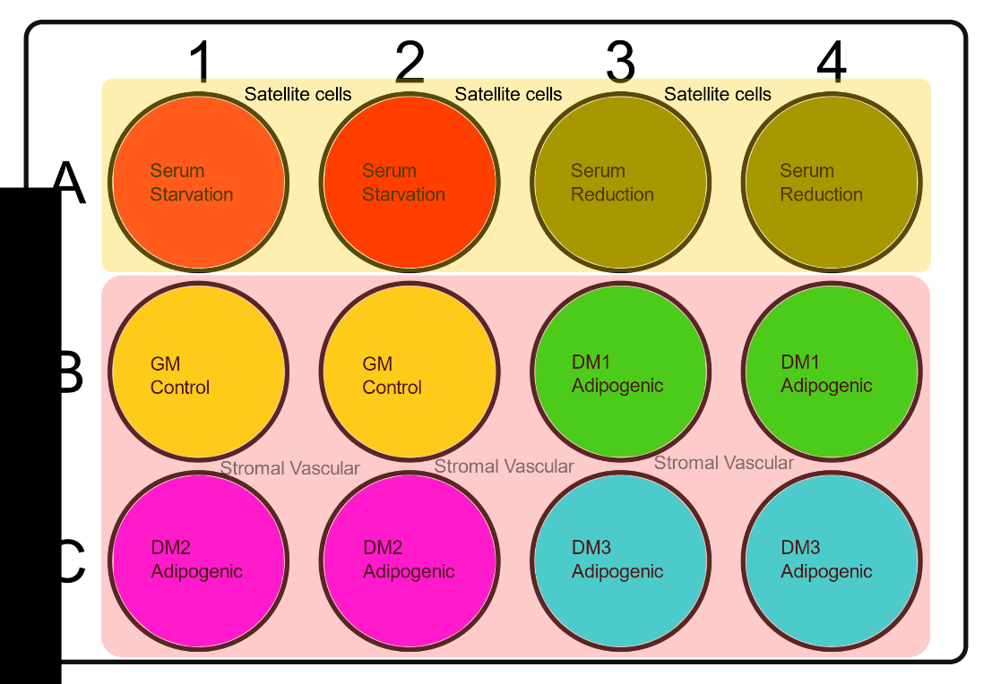
Figure 1: Proposed 12-well plate design for differentiation experiment

Data/Observations/Conclusions

Reference volumes:

Vessel | Surface (cm2) | ~PBS volume | ~Trypsin volume | ~Media volume
6-well plate | 9.6 | 1 mL | 500 uL | 2 mL
12-well plate | 3.5 | 500 uL | 250 uL | 1 mL
24-well plate | 1.9 | 500 uL | 250 uL | 1 mL
48-well plate | 1.1 | 200 uL | 100 uL | 500 uL
96-well plate | 0.32 | 100 uL | 50 uL | 200 uL
T-25 | 25 | 3 mL | 1 mL | 5 mL
T-75 | 75 | 5 mL | 2 mL | 12 mL
T-175 | 175 | 10 mL | 3 mL | 30 mL

References
Dohmen RGJ, Hubalek S, Melke J, Messmer T, Cantoni F, Mei A, et al. Muscle-derived fibro-adipogenic progenitor cells for production of cultured bovine adipose tissue. Npj Sci Food 2022;6:6. https://doi.org/10.1038/s41538-021-00122-2
Jurek S, Sandhu MA, Trappe S, Bermúdez-Peña MC, Kolisek M, Sponder G, et al. Optimizing adipogenic transdifferentiation of bovine mesenchymal stem cells: a prominent role of ascorbic acid in FABP4 induction. Adipocyte 2020;9:35–50. https://doi.org/10.1080/21623945.2020.1720480
Mitic, R., Cantoni, F., Borlin, C. S., Post, M. J., & Jackisch, L. (2023). A simplified and defined serum-free medium for cultivating fat across species. iScience. https://doi.org/10.1016/j.isci.2022.105822
Pu Y, Veiga-Lopez A. PPARγ agonist through the terminal differentiation phase is essential for adipogenic differentiation of fetal ovine preadipocytes. Cellular & Molecular Biology Letters 2017;22:6. https://doi.org/10.1186/s11658-017-0037-1

