## Module 2: Week 6 Pig 🐄 Fat Cell Thawing and DOE Media Prep

**Date: February 29, 2024**

## Objectives, Hypotheses, Background

For module 2, there are two objectives:

(1) to optimize the lipid accumulation media with design of experiments

(2) to grow a larger amount of stromal vascular cells cells (SVCs) then aggregate them into tangibly large cultured fat tissues/constructs.

Previously, we screened several differentiation media formulations to see if any were good for inducing adipogenesis and lipid accumulation in the SVCs. You will take what you think is the best media and try to refine it by varying some of the components.

Today, we will thaw some more SVCs: into a 48-well plate for adipogenic-media optimization and into a T175 flask for the fat construct. For now, we will culture them in normal growth media so that they recover and grow to confluency/close to confluency. Afterwards, we will switch to adipogenic media.

Using your data from Week 4, we will optimize the best performing medium – DM2 (Serum-Free + Ascorbic Acid-Based Differentiation Medium). For optimization, we will vary 4-variables in a central composite design DOE. The design requires preparation of 25 different media. To simplify this, we will be working as a big research team. Each group will prepare 7 media, 6 unique media and one common medium that is the center point.

As a refresher – here is the DM2 formulation.

Differentiation Strategy 2 – Serum Free + Ascorbic Acid-Based Differentiation:

From Jurek et al, they discovered that 1) a lower concentration induction media worked fine; and 2) Lipid accumulation worked better sans FBS. They used bovine serum lipids though, still from the animal. The bovine serum lipids aren’t readily available, so we’re going to try with Intralipid, a soybean oil based medical lipid emulsion (usually given via IV).

**Induction Media (2 Days):** DMEM, 10% FBS, biotin (10 µM), pantothenate (5.67 uM), insulin (3 µg/mL), dexamethasone (0.3 µM), IBMX (0.1 mM), rosiglitazone (10 µM)

**Accumulation Media (Rest of the time):** DMEM, 0% FBS, insulin (3 µg/mL), biotin (10 µM), 113 uM ascorbic acid, 500 ug/mL Intralipid

We will optimize the accumulation medium. We will introduce IBMX and pantothenate as potential media additives, while also varying insulin and ascorbic acid.

## Materials Required

* 48-well plate
* T175 flask
* SVCs (1 million cells in 1 mL freezing media)
* Growth Media
* Conical tubes
* DM2 induction medium -- DMEM, 10% FBS, biotin (10 µM), pantothenate (5.67 uM), insulin (3 µg/mL), dexamethasone (0.3 µM), IBMX (0.1 mM), rosiglitazone (10 µM)
* DM2 base accumulation medium – DMEM with biotin (10 µM) and 500 µg/mL Intralipid (and without FBS)
* DM2 accumulation medium additives
  + Insulin (10 mg/mL)
  + Pantothenate (8.5 mM)
  + Ascorbic Acid (69 mM)
  + IBMX (250 mM)

## Protocol/Procedure

Cell Thawing

1. Warm 9 ml of growth media in a 15 ml conical tube.
2. Get vial of cells and place in 37C water bath for 2 minutes.
   1. Vial is ready for the next step when the ice block starts to become liquid, or when there's liquid and a large piece of ice floating in it
   2. Once the ice starts melting/thawing, the whole solution will very quickly follow so don't wait in the water bath until it's almost completely thawed
3. Spray down the vial thoroughly with ethanol before placing in the biohood, as the water bath represents an elevated risk of contamination.
4. Slowly dispense 1 ml of warmed media from the 15 mL conical tube into the bottom of the cryovial, then pipette up liquid from the bottom of the vial and dispense it near the top of the liquid.
   1. This is so that the cells don't immediately go from high solute DMSO media into physiological solute media
   2. i.e to slowly reduce the osmolarity of the freezing media and improve cell viability during thawing
   3. BE CAREFUL DON’T LET VIAL OVERFLOW WHEN ADDING LIQUID/PIPETTING
5. Transfer all of the cell suspension to the rest of the growth media in the 15 ml conical, mix well to make a homogenous solution.
   1. You can also rinse the empty vial with more of the growth media to ensure that all cells are acquired
6. Spin down your 15 mL conical tube with cells at 300g for 5 minutes.
7. While centrifuging, add 40 mL BSC-GM to a clean 50 mL conical tube.
8. Aspirate out the supernatant, being careful not to disturb the cell pellet.
9. Resuspend cell pellet to 25,000 cells/mL
   1. Transfer 10 mL of BSC-GM from the 50 mL conical tube with media into the 15 mL conical tube with the cell pellet.
   2. Pipette up and down to resuspend the pellet then move all 10 mL of the cell suspension back to the 50 mL conical tube.
   3. Cell concentration: 1,000,000 cells / 40 mL = 25,000 cells/mL
10. POOL EVERY GROUP’S CELLS TOGETHER.
    1. The reason for this step is to ensure a similar cell population for each group’s DOE contributions. Since every group has different cells from freezing, there could be group to group differences if each group was to use its own cells.
    2. After pooling, the instructors will mix the cells together and give each group 40 mL of cell suspension.
11. Seed cells into a 48-well plate for media testing and into a T175 flasks for fat construct
    1. Into 21 wells of 48-well plate (in wells highlighted in Fig. 1)
       1. We will seed rather high, at ~7,500 cells/cm2
       2. To each well, add 300 µL of cell suspension

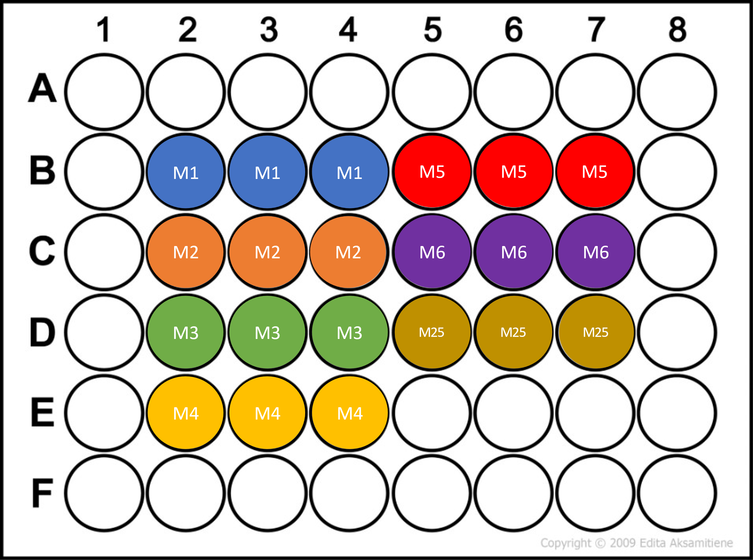

**Figure 1:** 48-well plate layout for DOE

* 1. Into a T175, add the rest of your cells with media.
  2. Label flasks with class, group, cell identity and passage #, date

**Making Differentiation Media**

Fat construct (T175)

For your fat construct, we expect about 5 media changes (25 mL each time). We have prepared 25 mL of DM2-ind and 100 mL of DM2-acc. You should store the media at 4C.

DOE Media Optimization

For the DOE, we have designed a 4-factor, RSM central composite design for you (Table 1). In Fig. 2, you seen an example for a similar design for three factors. We will be using the same design but in 4 dimensions. In total, you will need to prepare 7 media – 6 unique media and a common center point medium.

|  |  |
| --- | --- |
| **Figure 2:** Example of RSM central composite design for three factors | **Table 1:** DOE Design from JMP |

1. You will need to prepare 7 media, with ~4 mL total of each medium.
2. Label 7 x 15 mL tubes with your media numbers from the pattern column. Each group is assigned the media below.
   1. Group 1 will make media 1-6 and 25.
   2. Group 2 will make media 7-12 and 26.
   3. Group 3 will make media 13-18 and 27.
   4. Group 4 will make media 19-24 and 28.
3. To each tube, add 4 mL of your base adipogenic medium.
4. Using Table 1 and some math, you will need to calculate how much of your component to add to each medium.
   1. Stock concentrations
      1. Insulin: 10 mg/mL
      2. Ascorbic acid: 69 mM
      3. Pantothenate: 8.5 mM
      4. IBMX: 0.25M
   2. In Table 1
      1. -1 (-/a) is the low concentration of your factor
      2. 1 (+/A) is the high concentration of your factor
      3. 0 is the middle concentration of your factor (the average concentration between your low and high concentrations)
   3. As an example, the calculations below demonstrate how you would prepare 10 media for an insulin and glucose DOE, seen in Table 2
      1. Stock concentrations
         1. Insulin stock concentration: 10 mg/mL = 10,000 µg/mL
         2. Glucose stock concentration: 200 g/L = 1.11 M = 1,110 mM
      2. Calculate volume to add to 4 mL for low, middle, and high concentrations
         1. C1V1 = C2V2 where C is concentration and V is volume
         2. Insulin
            1. Low: 5 µg/mL * 4 mL = 10,000 µg/mL * x à x = 0.002 mL = 2 µL
            2. Mid: 10 µg/mL * 4 mL = 10,000 µg/mL * x à x = 0.004 mL = 4 µL
            3. High: 15 µg/mL * 4 mL = 10,000 µg/mL* x à x = 0.006 mL = 6 µL
         3. Glucose
            1. Low: 10 mM * 4 mL = 1,110 mM * x à x = 0.036 mL = 36 µL
            2. Mid: 20 mM * 4 mL = 1,110 mM * x à x = 0.072 mL = 72 µL
            3. High: 30 mM * 4 mL = 1,110 mM * x à x = 0.108 mL = 108 µL
         4. To each tube, you would add add the appropriate volume of stock solution, as indicated in Table 2

**Table 2:** Example Media Prep for insulin and glucose



Once you have prepared your media, your work for today’s class is done. However, you will need to come in Sun, Tues, Thur to feed your cells

1. On this Sunday, check your cell confluency under the microscope. **ONLY IF** the cells are >90% confluent, feed with adipogenic induction medium. If not, feed with growth medium.
2. Once your cells are confluent, be sure you are only feeding with adipogenic medium. Your first adipogenic feeding will be with induction medium. All subsequent feedings will be with accumulation medium.
3. As a reminder,
   1. For the 48-well plate, you will feed the triplicate wells with 250 µL of medium, as shown in Fig. 1.
      1. For speed, you may use the same tip to aspirate out from different wells.
      2. Since we do not want the cells sitting dry for long, it may be best to aspirate ½ of the wells and feed with media. Then you will get a new aspirating tip, aspirate the remaining wells, and feed with media.
      3. Be gentle when aspirating and feeding.
         1. Never touch the cells directly.
            1. For aspiration, tilt the plate to get the media concentrated in one are.
            2. For feeding, dispense media onto the walls of the well.
   2. For the T175, feed with 25 mL of adipogenic medium.
      * 1. Never touch the cells directly.
           1. For aspiration, tilt the plate to get the media concentrated in one are.
           2. For feeding, dispense media onto the back wall of the flask.

## Data/Observations/Conclusions

Reference volumes:

|  |  |  |  |  |
| --- | --- | --- | --- | --- |
| **Vessel** | **Surface (cm2)** | **~PBS volume** | **~Trypsin volume** | **~Media volume** |
| 6-well plate | 9.6 | 1 mL | 500 uL | 2 mL |
| 12-well plate | 3.5 | 500 uL | 250 uL | 1 mL |
| 24-well plate | 1.9 | 500 uL | 250 uL | 1 mL |
| 48-well plate | 1.1 | 200 uL | 100 uL | 500 uL |
| 96-well plate | 0.32 | 100 uL | 50 uL | 200 uL |
| T-25 | 25 | 3 mL | 1 mL | 5 mL |
| T-75 | 75 | 5 mL | 2 mL | 12 mL |
| T-175 | 175 | 10 mL | 3 mL | 30 mL |

## References

Dohmen RGJ, Hubalek S, Melke J, Messmer T, Cantoni F, Mei A, et al. Muscle-derived fibro-adipogenic progenitor cells for production of cultured bovine adipose tissue. Npj Sci Food 2022;6:6. https://doi.org/10.1038/s41538-021-00122-2

Jurek S, Sandhu MA, Trappe S, Bermúdez-Peña MC, Kolisek M, Sponder G, et al. Optimizing adipogenic transdifferentiation of bovine mesenchymal stem cells: a prominent role of ascorbic acid in FABP4 induction. Adipocyte 2020;9:35–50. <https://doi.org/10.1080/21623945.2020.1720480>

Pu Y, Veiga-Lopez A. PPARγ agonist through the terminal differentiation phase is essential for adipogenic differentiation of fetal ovine preadipocytes. Cellular & Molecular Biology Letters 2017;22:6. <https://doi.org/10.1186/s11658-017-0037-1>