**Assignment #4: Make plant-based leather from a symbiotic culture of bacteria and yeast (kombucha SCOBY)**

**SCOBYs given out:** September 11, 2024

**Assignment due:** October 23rd, 2024

SCOBYs are given out in Tupperware containing a starter culture of fresh sweet tea + old starter culture from a previous batch + a small SCOBY pellicle fragment. ***Within 24 hours*** of receiving the SCOBY, replace the lid of your tupperware with something permeable to oxygen (e.g. paper towel). ***Within 2-5 days,*** transplant your SCOBY into a larger volume of sweet tea in the culturing container you plan to culture your SCOBY in, following protocol below.

*If something happens to your SCOBY and you need a new one, don't hesitate to ask Blake or Sanjana for a new SCOBY starter! This is why we are giving them out so far ahead of time.

**Assignment Instructions:**

Kombucha is a popular drink, and a fun beverage to make at home. It is made using a symbiotic culture of bacteria and yeast (SCOBY). Bacteria secrete cellulose that make up the SCOBY’s structural integrity, and the bacteria also release acids into the media that contribute to the acidic flavor of the Kombucha. The yeast release small amounts of alcohol, and use acidic inputs from the bacteria. During week 2, you will receive a small SCOBY and starter culture to care for at home. Over the next few weeks, follow the instructions below to grow your SCOBY in a large jar, while keeping it alive and uncontaminated. SCOBYs grow in the shape of their container, so you can play around with cool container shapes and the SCOBY will take the shape of wherever oxygen is present. Once your SCOBY is large enough to your standards, remove the SCOBY (or just part of It, so the culture can continue to grow) and let it dry. You may also consider experimenting with different food colorings, or natural colorants (e.g. turmeric, beet powder, spirulina, etc) to dye the SCOBY leather. ***Once you have your final product, prepare one PowerPoint slide about your design scheme, challenges, and wins.***

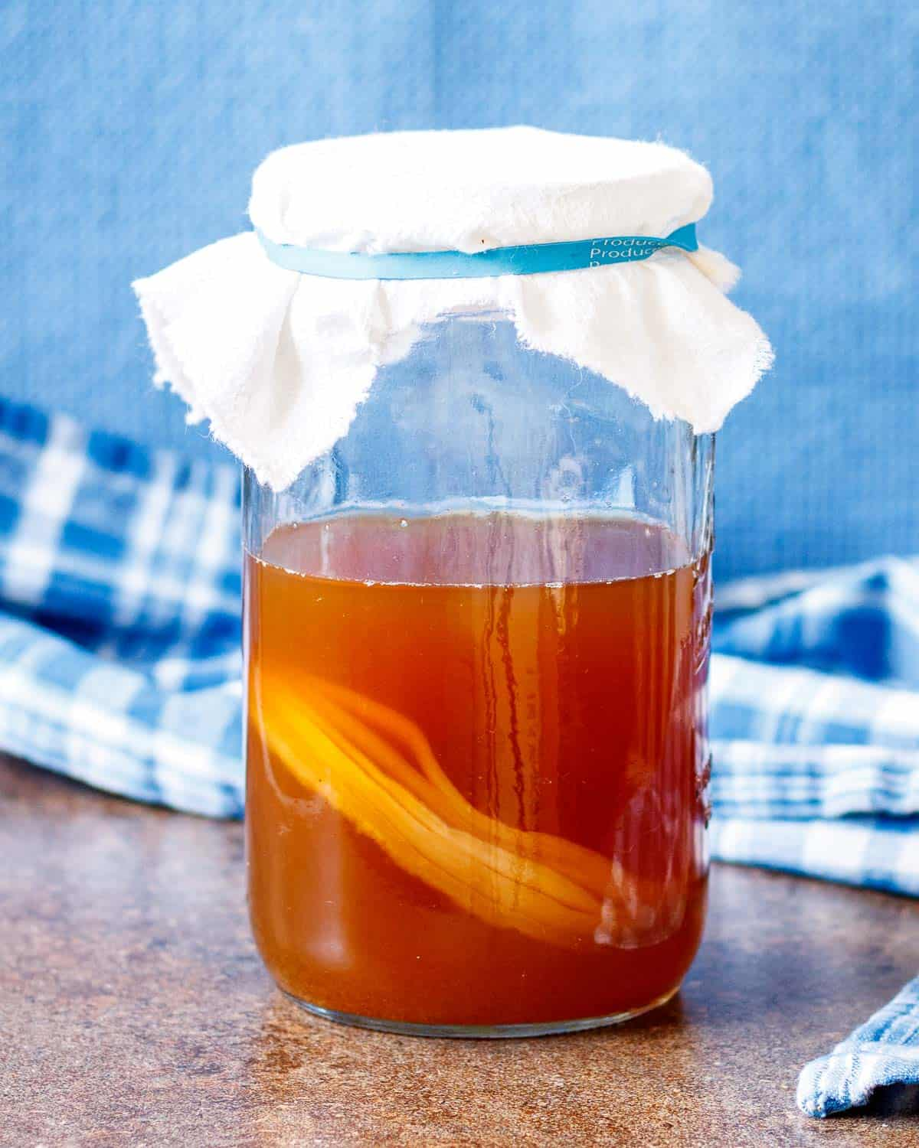 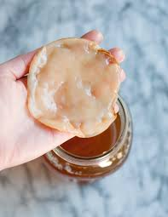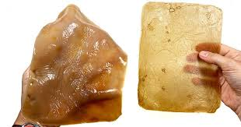

Dried SCOBY

**Kombucha leather protocol**

**Ingredients**:

1. Freshly prepared sweet tea using the following ratio: 3 cups water, 0.5 cup sugar, 3 teabags (scale to match volume of container you are growing your SCOBY in)
2. Starter culture that SCOBY was growing in previously (contains seed culture necessary for SCOBY survival in new environment)
3. SCOBY pellicle fragment

**Directions:**

1. Wear gloves and/or wash hands thoroughly before handling SCOBY.
2. Carefully wash your culturing container that the kombucha culture will be grown in with hot water and soap. This could be a small container such as a mason jar, which will produce a small round SCOBY, or something large like a traditional casserole dish, which would make a large rectangular SCOBY.
3. Prepare freshly made sweet tea by heating sugar water and tea bags until the tea is boiling >1 minute (can use microwave or stove for this). Boiling the tea makes sure that that tea has no microbes in it to start.
4. Let the freshly made sweet tea cool down. Make sure it is ***completely cooled*** before adding it to the live scoby in your culturing container! If the freshly made sweet tea is safe to touch or drink, it is ready. If the tea is too hot, the yeast and bacteria in the SCOBY will die.
5. Add SCOBY pellicle fragment and premade kombucha culture into your culturing container. Then add the cooled freshly made sweet tea. A good ratio of freshly made sweet tea to starter culture is 3:1. Less starter culture can be added, but the growth will be slowed.
6. Loosely seal your culturing container so that gas exchange can still occur while dust is kept out. ***Suggestion:*** *a paper towel with a rubber band around it works well for air exchange.*
7. Place culturing container in a clean, moderately warm spot, away from direct sunlight. ***Suggestion:*** *Formation of the new SCOBY pellicle can be sped up by placing your container in a warmer environment. If you want to halt the growth, you can set it in the fridge.*
8. You can expand your culture to larger volumes or multiple containers by splitting the SCOBY into fragments, and providing the new containers with starter culture + fresh tea.
9. When SCOBY has reached desired thickness (1-3 weeks), harvest by removing SCOBY from the container (after washing hands/utensils thoroughly), rinsing, patting dry and laying on a flat surface.
10. Drying times vary with temp and humidity, but should be less than 1 week.
11. Cut your SCOBY to desired shape for final product. Can experiment with natural dyes to add colors. Get creative here!

Inspiration for Kombucha leather products you could make:

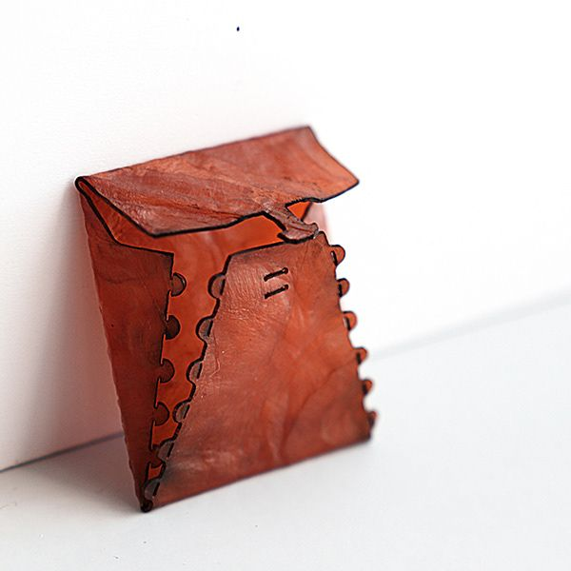 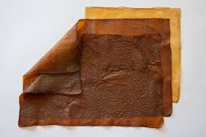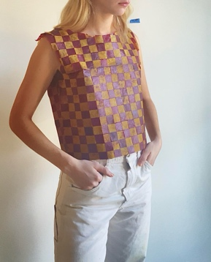

**Grading (5 points)**

1 point: Creativity

1 point: Slide includes design scheme

1 point: Slide includes challenges

1 point: Slide includes wins

1 point: Bring your final physical product to class