Wet-spinning of soy protein isolate into fibers
Lab Demonstration Fa24-BME-0193-02 Special Topics Sustainable Materials

Summary: Wet-spinning is a process used to regenerate biopolymer solutions, like proteins or cellulose, into continuous filamentous fibers by extruding the solution into a coagulation bath that solidifies the material. This technique is particularly valuable in creating biodegradable textile fibers, as it can transform natural polymers into durable, yet eco-friendly threads suitable for various applications. By adding plasticizers, such as glycerol, flexibility and elasticity can be enhanced, which is crucial for comfort and performance in textiles. Cross-linkers, like aldehydes, can also be incorporated to improve tensile strength, ensuring the fibers maintain durability during use. Wet-spun fibers offer a sustainable alternative to traditional synthetic fibers, reducing environmental impact while retaining essential qualities for textile applications.
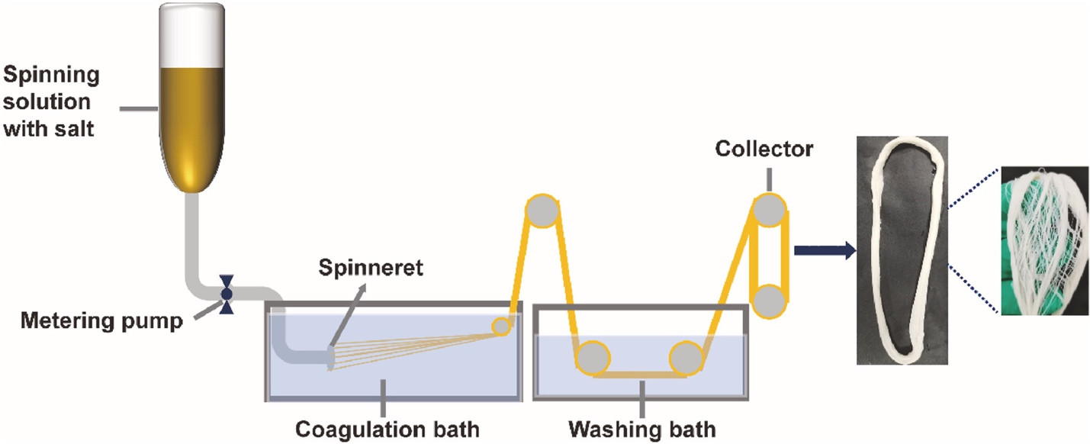
Figure from Cui et al. Effect of salt on solution behavior of spinning medium and properties of meat analogue fibers. Food Hydrocolloids. 2023

Materials:
Doping solution (amounts are intentionally vague, as these formulas are unpublished)
- Soy protein isolate (the kind you can buy from the grocery store)
- Reducing agent (to reduce disulfide bonds from cysteine amino acids in protein)
- High concentration of denaturant such as urea, strong acid, or strong base (to help the soy protein dissolve)
Coagulation baths
- Citric acid
- Methanol
- Water?
Methods:
- Place doping solution in a syringe, centrifuge syringe to spin down solution, and remove air bubble using a long needle.
- Place syringe with doping solution on syringe pump and slowly dispense the soy protein isolate doping solution into the coagulation bath.
- Remove fibers with tweezers or roll them up on a spool and let dry.

