Adobe Licenses 2019:

Student & Faculty/Staff Log In Instructions

Adobe has changed the process for obtaining a license for their products. There are now extra steps students and faculty will need to follow when using these products.

Adobe Faculty/Staff Log In Instructions
- When a faculty or staff member open any adobe product, they will get this sign on page:
- Faculty and staff will need to press “Sign in with an Enterprise ID”:
- Faculty will type in their Tufts email address. When they go to type in their password, the screen will switch to a page which has them choose an account type. Press “Enterprise ID”.
- This will redirect to the Tufts secure log in page. Faculty will use their UTLN and password. (ex: jsmith01). They will also be prompted to go through Duo Security.
- Once faculty log in, they should now be able to use any adobe product.

Adobe Student Log in Instructions
- When a student launches any Adobe app, they will be prompted with this sign in screen. Click the link labelled “Get an Adobe ID”.
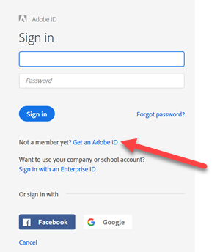
- Once the student clicks the link, they will be prompted with this sign up page. Students will need to sign up for an account and need to use this information any time they wish to access adobe products on tufts computers.
- After the student completes the sign-up form, they will see this page. Adobe will send them a Verification email to verify their account.
- Once they verify their email, they should click “Check again and continue” to start using the product. Students should now be able to use adobe products.

