Using ArcMap on the TTS Virtual Lab: Windows Version
August 26, 2020

Log in to the TTS Virtual Lab 1
Section I: Using the TTS Virtual Lab through VMware Horizon HTML Access 2
Section II: Connecting to the TTS Virtual Lab by installing the VMware Client 3
Section III: Accessing ArcMap and ArcGIS Pro within TTS Virtual Lab 7

Log in to the TTS Virtual Lab
- Go to https://access.tufts.edu/tts-virtual-lab-vdi to open the VDI.
- Press Open.
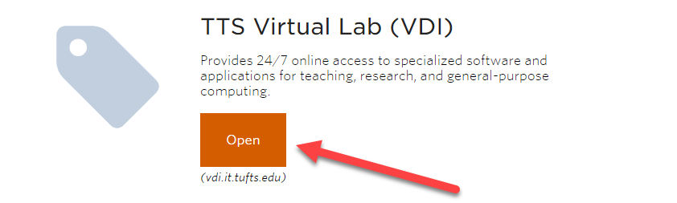
- You have 2 options here.
  - Install the VMware Horizon Client – this has better performance if you will be REGULARLY using the VDI, although it does involve more initial steps to download and install the software.
  - Use the VMware Horizon HTML Interface – this will allow you to use the VDI directly through a browser window. This is fine if you are only occasionally using the VDI.
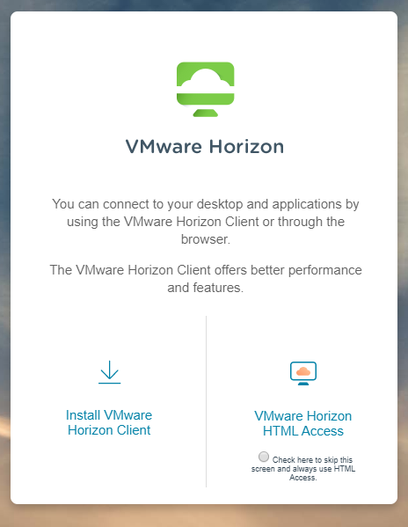

Section I: Using the TTS Virtual Lab through VMware Horizon HTML Access
- Click on the right option, VMware Horizon HTML Access.
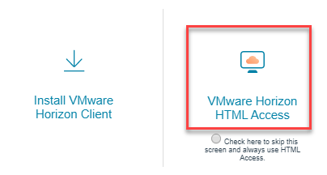
- Sign in with your Tufts Username (UTLN) and password.
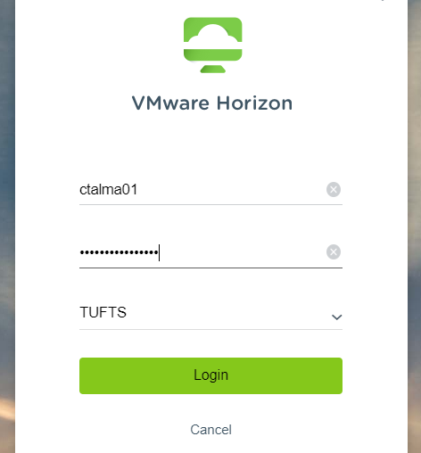
- Click on the TTS Virtual Lab
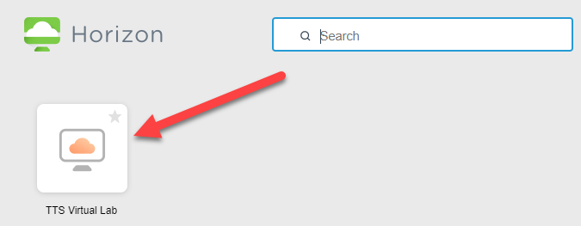
- Now a Data Lab computer has opened within one of your browser tabs. Congrats, you have successfully accessed the VDI within the HTML Interface.
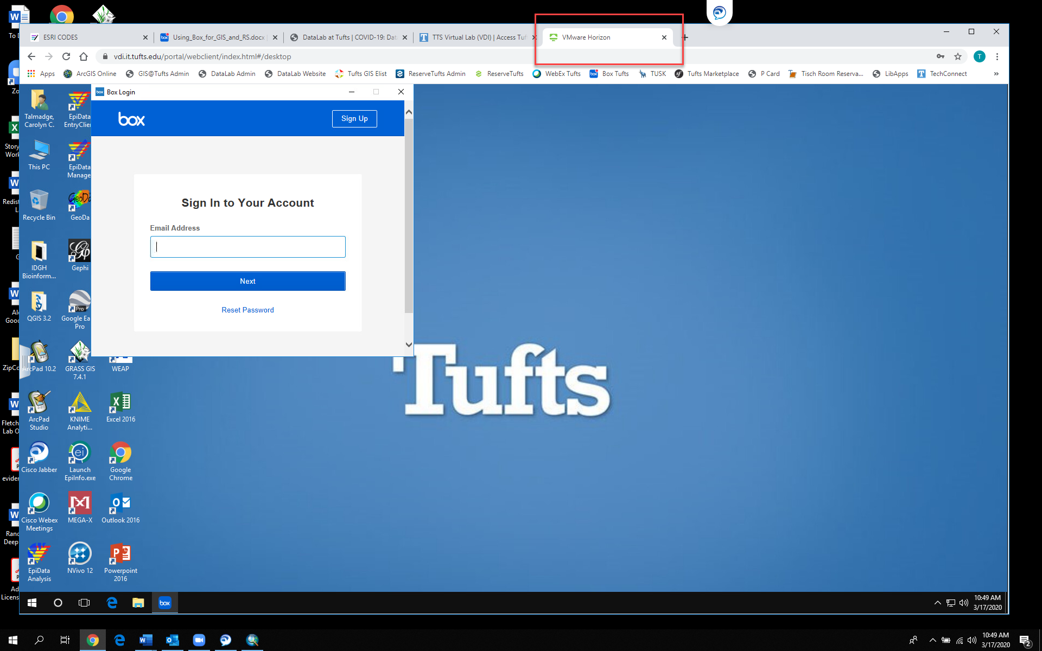’

Section II: Connecting to the TTS Virtual Lab by installing the VMware Client
- Go to https://access.tufts.edu/tts-virtual-lab-vdi and press Open.
- Select the option for Install VMware Horizon Client
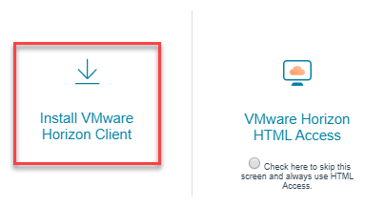
- Select the product that is right for you. In this case, I am working on a Windows computer so used the first option. Press Go to Downloads. 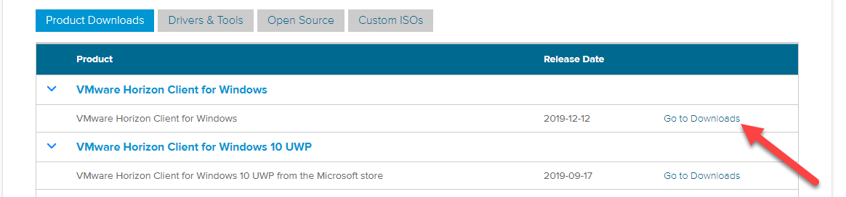
- Again, press Download Now.
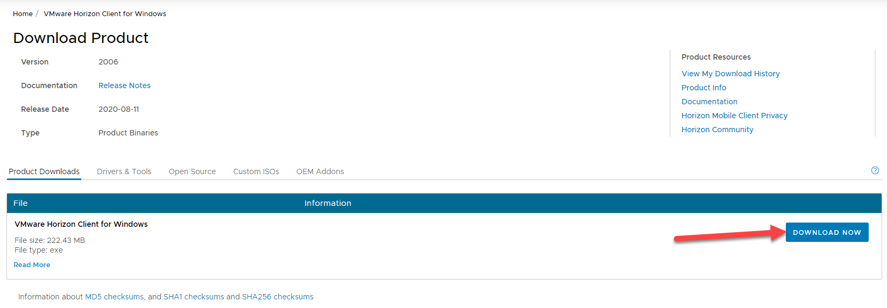

- The client will download. Depending on what browser you are using, it might go right to your downloads folder, have a pop up or download to the browser bar at the bottom. In Chrome, press Show in Folder, which opens your downloads folder. Double click on the VMware-Horizon-Client.exe
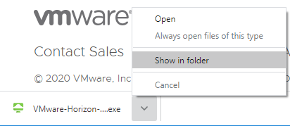 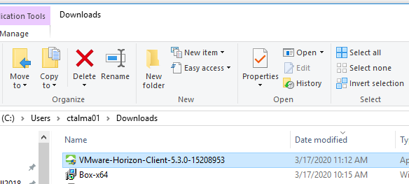\
- Press Yes when asked if you want to allow this application to make changes to your device.
- Press Agree & Install when prompted with the privacy agreement and license info.
- Press Finish when it is successful. You must restart your computer to use the software. Save/close other applications and press Restart Now.
- When your computer restarts, search for VMware Horizon Client. Click on the application. 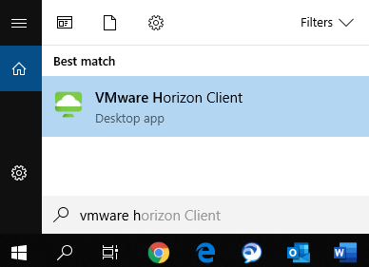
- When the client opens, double click on the plus sign to Add Server. 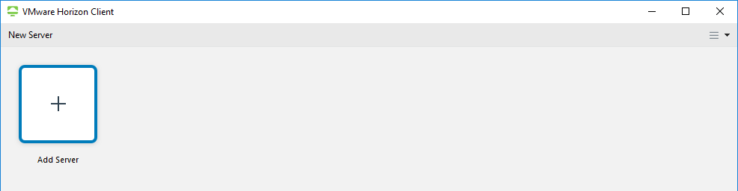
- Input vdi.it.tufts.edu as the server to connect to.
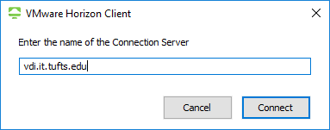
- Input your Tufts Username and Tufts Password to sign in. Make sure the Domain says TUFTS. Press Login.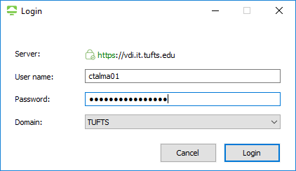
- Double click on the TTS Virtual Lab. 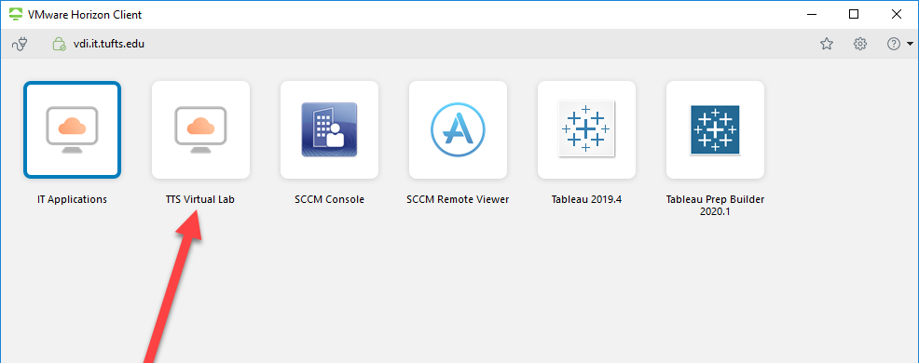
- The Desktop will load and likely be full screen. There are controls at the top that let you minimize the VDI, or make it not full screen. Choose your preference. 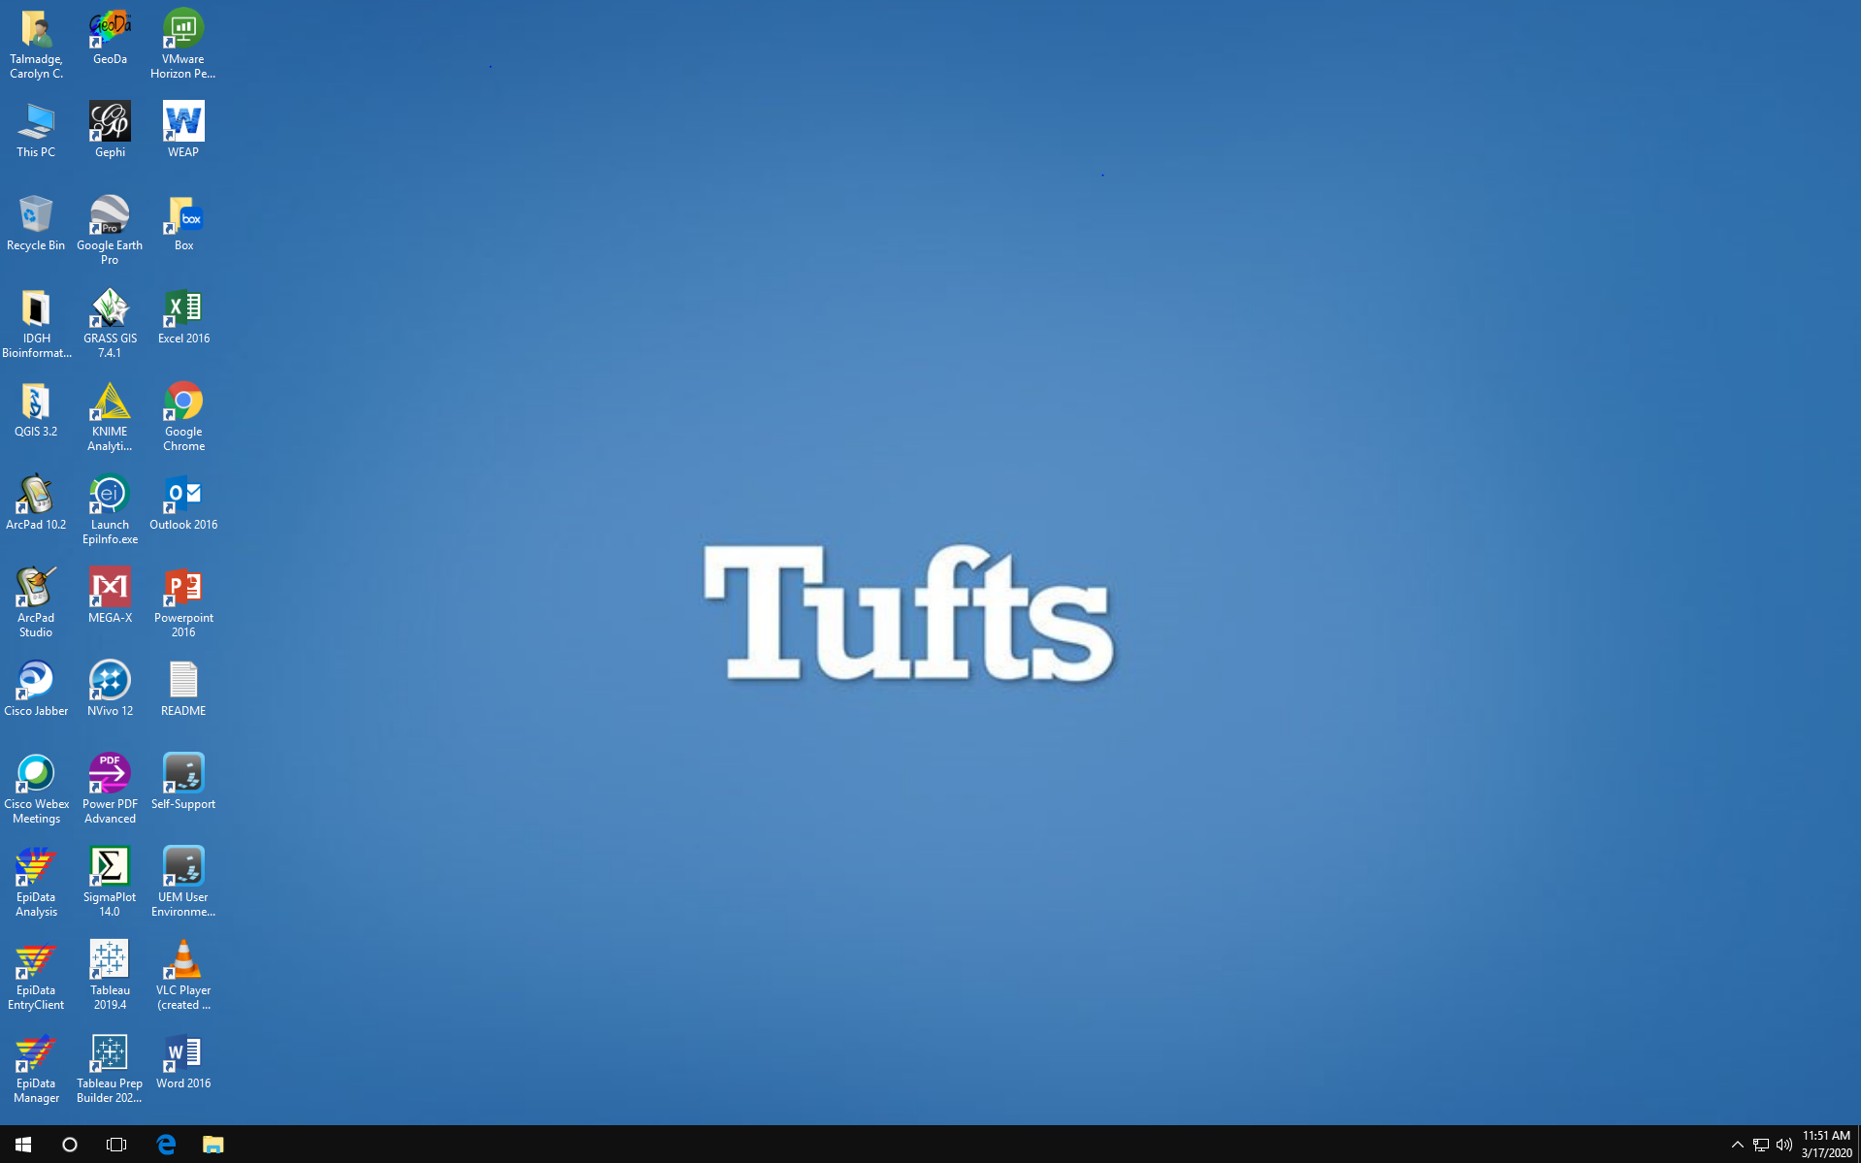

- To close the VDI, you can press the X or go to options and select Disconnect. This will act the same as if you were logging off a Desktop computer in the Data Lab, so make sure to save all your work.
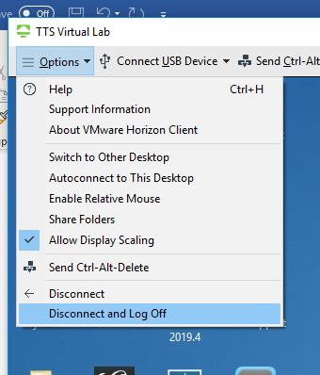

Section III: Accessing ArcMap and ArcGIS Pro within TTS Virtual Lab
Accessing the software works the same on the remote lab as it would if you were in the Data Lab.
- To open ArcMap or ArcGIS Pro, you can simply search for the program by clicking on the magnifying glass icon.
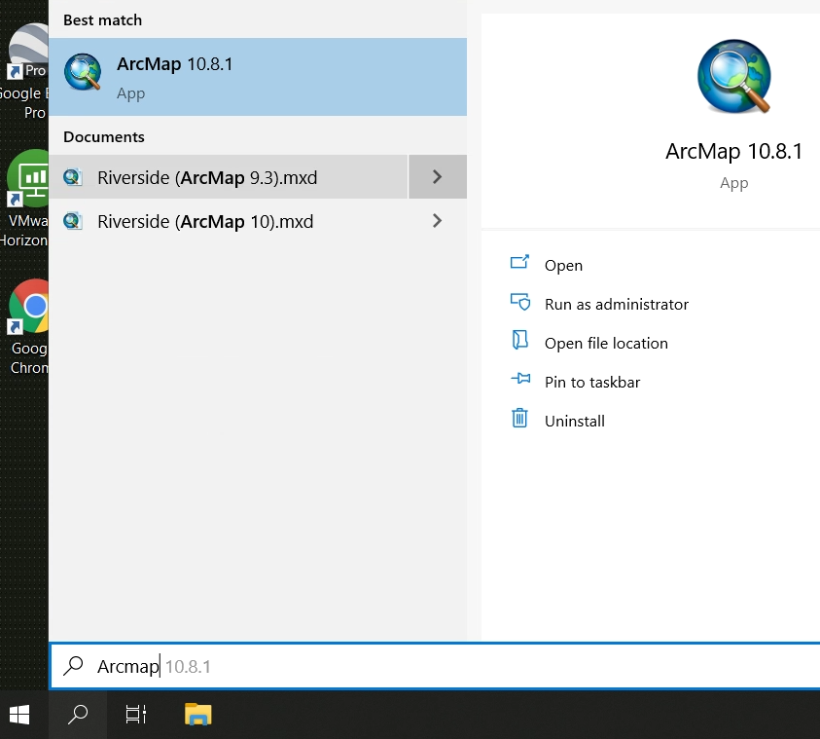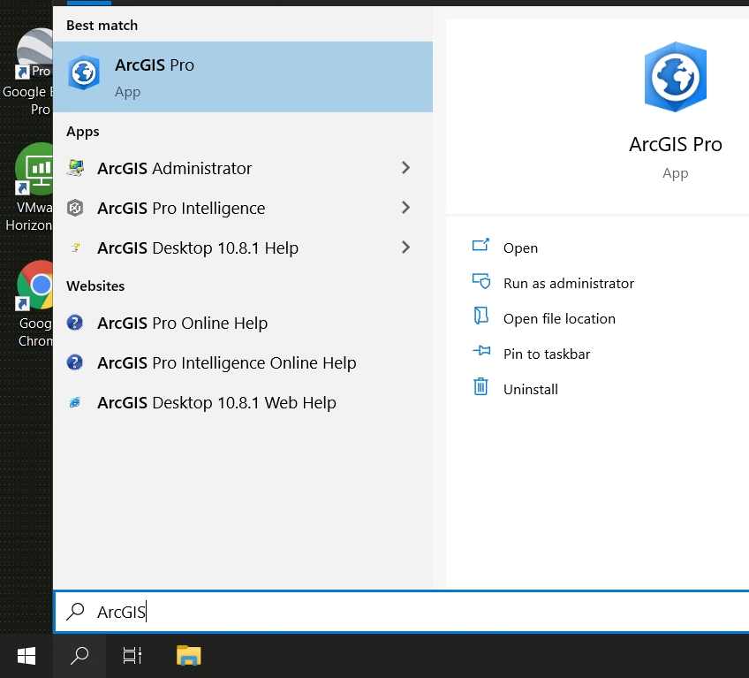
- Alternatively, you can click on the windows icon to find it in the list of available software under ArcGIS.
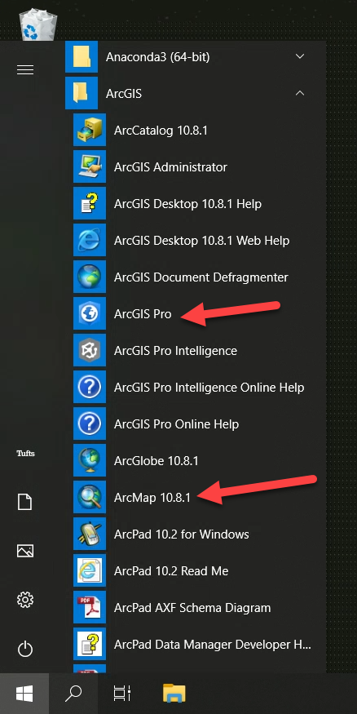
- You’ll likely also want to sign into Box Drive when prompted, as you will likely be storing most of your GIS data in box. For more information on how to connect to Box and use it in ArcMap, see the following Document: https://tufts.box.com/v/BoxGISinstructions

