ArcGIS Pro Student Digital Download Edition:

Instructions for Installing ArcGIS Pro 2.6 on a Window’s PC
Revised August 26, 2020
Before Installing ArcGIS Pro 2.6: 1
Activate your Student Digital Download Code 2
Download and Install the Software 4
Signing into ArcGIS Pro using your ArcGIS Organization’s URL 6
Additional Resources for ArcMap 7
You will need to have received an ESRI student digital download code. If you are in a GIS class, you professor has a code for you. If you are not in a class but would like to install the software, please email us at DataLab-support@elist.tufts.edu to request a code. Support for the ArcGIS Desktop Education Edition is available at http://esri.com/evalhelp.

Before Installing ArcGIS Pro 2.6:
- Check the system requirements to make sure your computer has the hardware and software required.
  - ArcGIS Pro requires Microsoft .NET Framework 4.5.1 and Microsoft Internet Explorer version 10 or newer. Before running the installation program for ArcGIS Pro, ensure that your machine meets these prerequisites. The Install Guide for ArcGIS Pro provides an overview of installing and setting up ArcGIS Pro and links to detailed resources, including system requirements.
- You will need to log in to our Tufts Organization’s account one time so an account is created in your name Go to www.esri.com
- Click on the Sign In link at the top right of the page.
- Click on Sign in with Your ArcGIS organization’s URL. Do NOT click sign in with ArcGIS Login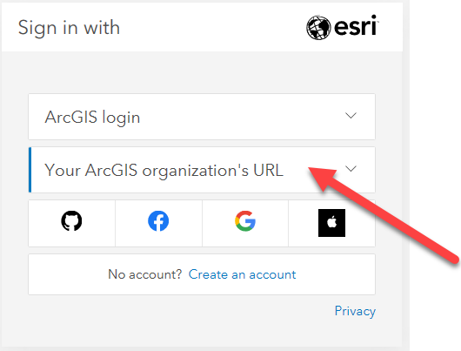
- Enter tuftsgis as the organizations URL so it looks like the following image. If this is your personal computer, you can check remember this URL and it will be faster next time.
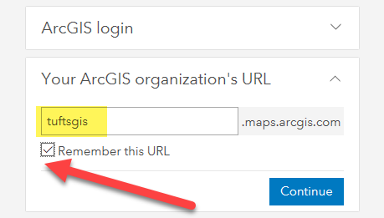
- You will then be prompted to log in with TUFTS UNIVERSITY. Press the blue Tufts button.
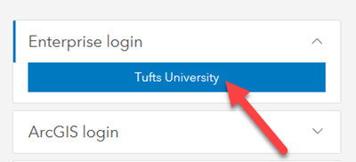
- Now you will log in with your Tufts Username (UTLN) and password. You will need to also go through duo authentication. Press Login.
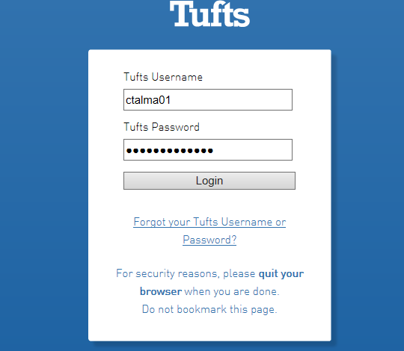
An AGOL account has now been created within our Tufts University organization account that is associated with your Tufts Username.

Activate your Student Digital Download Code
- Visit http://www.esri.com/EducationEdition
- Click on I have an ESRI Account. You will log in the same way you just did in the step above.
- Click on Sign in with Your ArcGIS organization’s URL. Do NOT click sign in with ArcGIS Login
- Enter tuftsgis as the organizations URL so it looks like the following image. If this is your personal computer, you can check remember this URL and it will be faster next time.
- You will then be prompted to log in with TUFTS UNIVERSITY. Press the blue Tufts button.
- Now you will log in with your Tufts Username (UTLN) and password. You will need to also go through duo authentication. Press Login.
- Enter the authorization code you have been given by your GIS Professor or the Data Lab Staff. The format of the code is similar to EVA123456789.
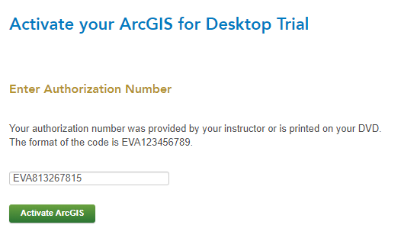
- Click Activate ArcGIS.

Download and Install the Software
- The newest version of ArcGIS Pro 2.6 is not yet available through this ESRI site. Therefore, we have downloaded the software and made it available for you at this link. Go to the following link: https://tufts.box.com/s/hkvpd4e4qozdu15f16epoge0zwadbsqf
- Click on the file ArcGISPro_26_175036.exe and press Download to access the software installer.
- Once it downloads, Run the installation wizard by opening the ArcGISPro executable (.exe).
- Select a destination folder to extract the install files to and press Next.
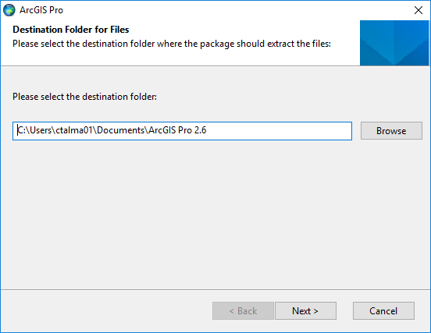
- Leave the option “Launch the setup program” checked and press close.
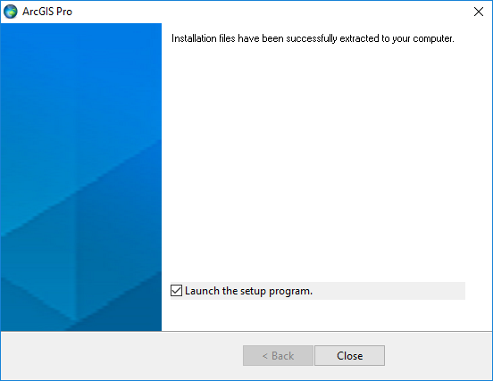
- Click next through the various prompts in the ArcGIS Pro setup wizard.
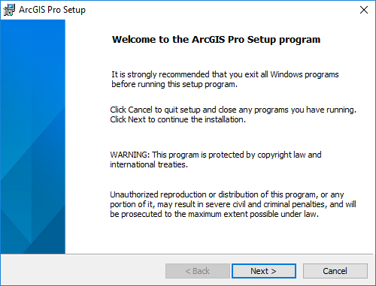
- Accept the master agreement.
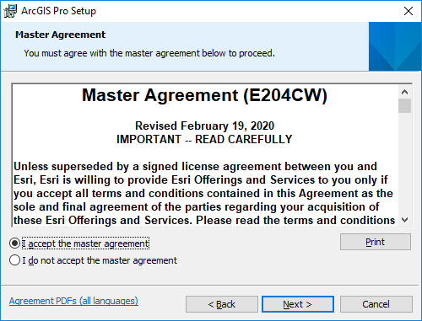
- Press Next at the install features window.
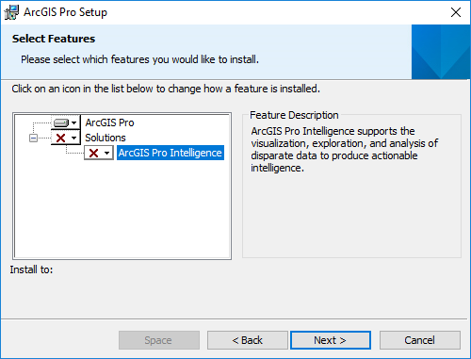
- Press Install when prompted.
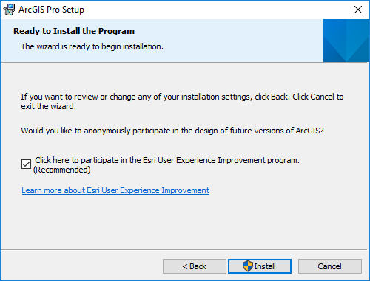
- Press YES when asked if you want to let the program make changes to your computer.
- Proceed through the setup installer options by clicking Next until you receive this completion. Press Finish and the program will launch.
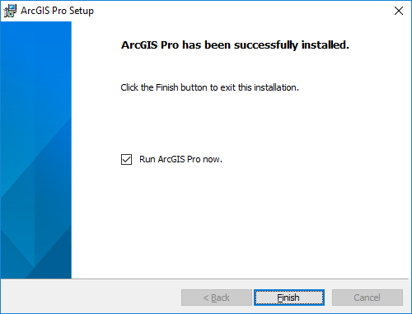
- The software will open after you have finished installing.

Signing into ArcGIS Pro using your ArcGIS Organization’s URL
The software is licensed upon launching the ArcGIS Pro 2.6. Follow these directions to log into our Tufts Organization account upon launching Pro:
- When the sign in box comes up, click on the link for Sign in with Your ArcGIS organizations’s URL. Very important to not just press “ArcGIS Login”
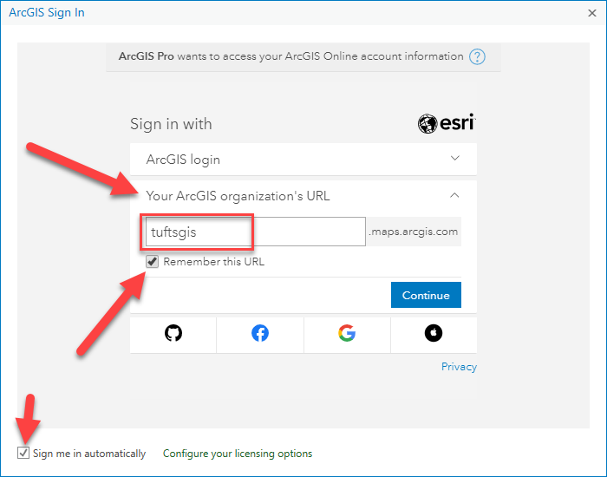
- Enter tuftsgis in the text box so the full domain reads tuftsgis.maps.arcgis.com
- Check the box that says Remember this URL and Sign me in Automatically.
- Press Continue. Then press Tufts University.
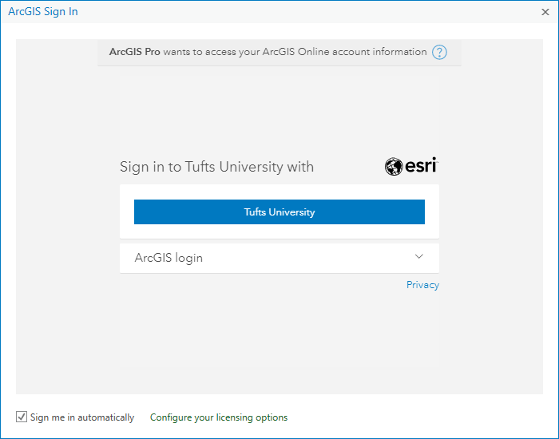
- Use your Tufts username (UTLN) and password to login. Then ArcGIS Pro should open. If it doesn’t, contact DataLab-support@elist.tufts.edu for assistance.

Additional Resources for ArcMap
- For information on how to connect to Box in ArcGIS Pro, see these instructions: https://tufts.app.box.com/file/631995847090

- For Information on how to Install the VPN, Map the Network Drives and Connect to Folders in ArcMap, see these instructions: https://tufts.box.com/s/7wl2b3jxp309a962q6b8g1270kgm68ky

