ArcGIS Pro Student Digital Download Edition:

Instructions for installing VMWare, Windows then ArcGIS Pro 2.6 on your Mac Computer
Revised August 26, 2020
Introduction 1
Choosing the Best Option for You 2
Checking System Requirements 3
Downloading and Installing VMWare Fusion 5
Downloading Windows 10 5
Using VMWare Fusion to Install Windows on MacOS 6
Before Installing ArcGIS Pro 2.6: 6
Activate your Student Digital Download Code 9
Download and Install the Software 10
Signing into ArcGIS Pro using your ArcGIS Organization’s URL 13
Additional Resources for ArcMap 14
You will need to have received an ESRI student digital download code. If you are in a GIS class, you professor has a code for you. If you are not in a class but would like to install the software, please email us at DataLab-support@elist.tufts.edu to request a code. Support for the ArcGIS Desktop Education Edition is available at http://esri.com/evalhelp.

Introduction
Some software (like ArcGIS) is only available for Windows and cannot be installed directly onto a Mac Operating System (MacOS). However, it is possible to install Windows as a separate operating system (OS) on a Mac computer, allowing for the use of such software. There are two primary methods of doing this:
- Virtual Machine (recommended) – using third-party software, it is possible to run Windows on top of and simultaneously alongside MacOS in a virtual environment. While this might hinder performance, it is easy to set up and use, making it the preferred option. This can be accomplished using the virtualization software VMWare Fusion, which is available to Tufts affiliates at no cost.

- Boot Camp (advanced) – the multi-boot utility developed by Apple and pre-installed on all Mac computers. This can be used to create a non-virtualized environment on a Mac computer to install Windows onto. However, it requires careful setup and only allows for one operating system (Windows or MacOS) to be used at a time.
NOTE: To install VMWare on a Mac, you will need at least 60 GB of free space on the Mac. To check free space, click the Apple Icon () and then About this Mac > Storage. This will take up to three hours to complete, please budget your time accordingly.
For more information on working remotely, please see here: https://it.tufts.edu/working-remotely

Choosing the Best Option for You
The best option for installing Windows on MacOS depends on two primary factors:
- The type and amount of analysis to be performed using Windows.
- Extent of desired interaction with MacOS while using Windows.
VMWare Fusion runs Windows alongside MacOS as a virtual machine. This means there will be less memory and processing power available as it will have to be shared between the two operating systems. Hence, this option is better for light analysis and simple data visualization. However, it does have the benefit of easily switching between the two operating systems (Windows and MacOS) within a single session.
PROS:
- Allows for concurrent use of both Windows and MacOS.
- Allows for easy file transfer between Windows and MacOS.
- Allows for copy and paste between Windows and MacOS.
- Utilizes all free disk space.
- Does not require a permanent disk partition.
CONS:
- Memory (RAM) and processing (CPU) resources are shared between the two operating systems (Windows and MacOS), resulting in slower processing speeds.
- Not ideal for intensive analytical processes.
Boot Camp is a better choice for users who require the full processing power of their computer because it only allows for the use of one operating system at a time. However, this means that it is impossible to use both operating systems (Windows and MacOS) at the same time nor flip between them within a single session.
PROS:
- Pre-installed on all Mac computers since 2007.
- Windows and all of its applications (like ArcGIS) will be able to harness the full processing power of your computer.
- Allows for access of files on your MacOS system while using Windows and vice versa.
CONS:
- Requires a dedicated, semi-permanent disk partition.
- Disk space for Windows and all of its applications must be allocated in advance and cannot be changed later.
- User must sign out of one operating system and restart the computer to use the other OS.
- Cannot directly copy and paste or share files between the two systems.

Checking System Requirements
Regardless of which method you choose, you must first determine whether your computer meets the minimum requirements for installing Windows and any Windows applications you might want to use (like ArcGIS). Then you must also determine whether your computer meets the requirements of using wither VMWare, Parallels, or Boot Strap.
To check the system information of your Mac computer, click on the Apple icon in the upper-left corner of your screen and select About This Mac. To determine free disk space, click on the Storage tab.
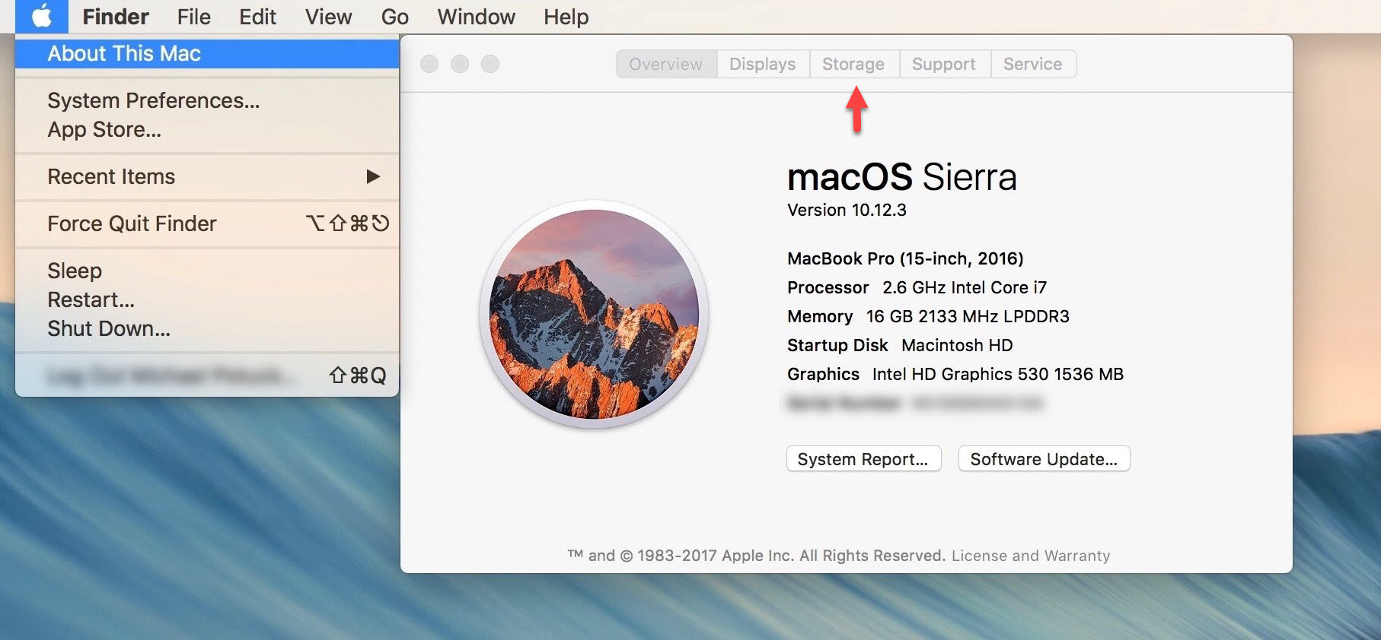

Minimum System Requirements for Windows 10:
- Processor (CPU): 1 GHz or faster processor or System on a Chip (SoC)
- Memory (RAM): 1 GB for 32-bit or 2 GB for 64-bit
- Disk space: 32 GB
- Display: 800x600

Minimum System Requirements for ArcGIS Desktop 10.8:
- Processor (CPU): 2.2 GHz minimum; hyper-threading (HHT) or multi-core recommended
- Memory (RAM): 4 GB minimum; at least 8 GB recommended
- Disk space: 4 GB minimum; at least 6 GB recommended
- Graphics memory: 64 MB minimum; at least 256 MB recommended
- Display: 1024x768; 24-bit color depth

- Check system requirements for latest version:
https://desktop.arcgis.com/en/system-requirements/latest/arcgis-desktop-system-requirements.htm
Minimum System Requirements for VMWare Fusion 11:
- Hardware:
  - All Mac computers launched in 2011 or later are supported except:
    - 2012 Mac Pro “Quad Core” using the Intel Xeon W3565 Processor
  - In addition the following are also supported:
    - 2010 Mac Pro “Six Core”, “Eight Core” and “Twelve Core”
- Memory (RAM): 4 GB minimum; at least 8 GB recommended
- Disk space: 750 MB for VMWare Fusion plus space needed for Virtual Machine(s)
- Operating system: macOS 10.13 or later

- Check system requirements for latest version: https://kb.vmware.com/s/article/2005196
Minimum System Requirements for installing Windows 10 using Boot Camp:
- Hardware:
  - MacBook introduced in 2015 or later
  - MacBook Air introduced in 2012 or later
  - MacBook Pro introduced in 2012 or later
  - Mac mini introduced in 2012 or later
  - Mac Pro introduced in 2013 or later
  - iMac introduced in 2012 or later
  - iMac Pro (all models)
- Disk space: at least 64 GB of free space; 128 GB or more recommended

- More information: https://support.apple.com/en-us/HT201468

Downloading and Installing VMWare Fusion
Tufts affiliates can get VMware Fusion though the VMWare Academic Program for free as follows:
- Go to the Tufts University VMWare Academic Program site at https://vmap-tufts.onthehub.com/
- Click Sign In at the upper-right corner of the website
- Use your Tufts username (UTLN) and password to sign in
- If you are a student, provide your expected graduation date to receive special pricing upon graduation
- Click on the tab corresponding to your primary affiliation: Student or Faculty/Staff
- Under VMWare, click again on the tab corresponding to your primary affiliation
- Under Software, select VMWare Fusion 11
- Click Add to Cart and then Check Out
- The next page includes details of your order, including your serial number (in red)
- Take note of your serial number for future reference!
  - You will receive an email with your order information, but that will not include the serial number
  - You must save this serial number safely. Otherwise it costs $30 to get the serial back.
- Click Download
- Once the download is complete, install the software
- You will be prompted to enter your serial number during the installation process
You will receive a 12-month license which is effectively a prolonged 12-month evaluation period. You might see a message stating that your evaluation period is ending in ### days. Feel free to ignore said message. At the end of the 12-month “evaluation period” you will be able to download a new version and get a new 12-month license as long as you still remain a Tufts affiliate.

Downloading Windows 10
To install Windows 10 on your Mac computer you need both a Windows 10 product key and a disk image (ISO).
Tufts affiliates can get a free (students) or discounted (faculty/staff) Windows 10 product key as follows:
- Go to Tufts On The Hub at https://tufts.onthehub.com/
- Sign in with your Tufts username (UTLN) and password
- Click on the tab corresponding to your primary affiliation: Student or Faculty/Staff
- Select Microsoft, then Windows 10
- Click Add to Cart and then Check Out
- Once you finalize the checkout process, you will get a product key for Windows 10 Education
- Take note of your product key for future reference!
  - You must save this product key safely. Otherwise you cannot get another key for one year.
- Once you have your product key, you can download a Windows 10 disk image (ISO-file).
If you are at home, do the following:
- Go to https://www.microsoft.com/en-us/software-download/vlacademicwindows10
- Scroll to the bottom of the pace and select your language (English)
- Click on 64-bit Download
- Save the ISO-file to a convenient location on your Mac computer

Using VMWare Fusion to Install Windows on MacOS

- Before proceeding, check system requirements and make sure you have the following:
  - VMWare Fusion installed on your Mac computer
  - Windows 10 disk image (ISO-file) downloaded onto your Mac computer
  - Windows 10 product key on hand
- Launch VMWare Fusion
  - If the New Virtual Machine Assistant does not automatically start, go to File > New to launch it
- Select Install From Disc or Image and click Continue
- Click Use Another Disc or Disc Image
- Select the Windows ISO-file you downloaded, then click Open
- Ensure the Use Easy Install option is selected
- Pick an account name and password
- Provide your Windows product key and click Continue
- Choose the integration level most suitable for you and click Continue
  - You may not know which level is suitable – if so, we suggest more isolated. This means you can drag and drop files into the Windows machine, but it is otherwise isolated.
- You will see an overview of the settings and technical specifications of your new virtual machine (VM). You might want to click Customize Settings and allocate more disk space or memory (RAM) to your new VM to match the system requirements of various Windows applications you might want to run on it
  - You might want to refer to the previously outlined system requirements
  - If you are unsure, feel free to accept the defaults – you can always change this later
- Once done, click Finish
- Select where to store your new VM and click Save
- Your new VM will power on and install Windows (this might take a long time)
- Once the installation completes, you will be able to sign in to your new Windows account
  - If you see an error that states “Could not open dev/vmmon: Broken pipe”, please do the following:
    - Exit out of the VMWare image by clicking the “x” to close the window.
    - Restart VMWare Fusion. Right click on the VMWare Fusion icon to open the program.
    - Now go to System Preferences > Security & Privacy and verify if VMWare is allowed to run and there is no mention of a blocked application. If VMWare has been blocked, click allow.
    - Try to run VMWare again.
    - If this doesn’t work, restart your Mac and check Security & Privacy again.
    - Try to run VMWare again.

- More information, including an installation video: https://kb.vmware.com/s/article/1011677
- Changing the disk size of your VM after creation: https://kb.vmware.com/s/article/1020778
- Changing the amount of RAM assigned to a VM: https://kb.vmware.com/s/article/1004059

Before Installing ArcGIS Pro 2.6:
- Check the system requirements to make sure your computer has the hardware and software required.
  - ArcGIS Pro requires Microsoft .NET Framework 4.5.1 and Microsoft Internet Explorer version 10 or newer. Before running the installation program for ArcGIS Pro, ensure that your machine meets these prerequisites. The Install Guide for ArcGIS Pro provides an overview of installing and setting up ArcGIS Pro and links to detailed resources, including system requirements.
- You will need to log in to our Tufts Organization’s account one time so an account is created in your name Go to www.esri.com
- Click on the Sign In link at the top right of the page.
- Click on Sign in with Your ArcGIS organization’s URL. Do NOT click sign in with ArcGIS Login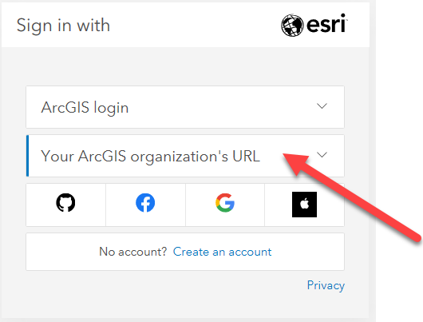
- Enter tuftsgis as the organizations URL so it looks like the following image. If this is your personal computer, you can check remember this URL and it will be faster next time.
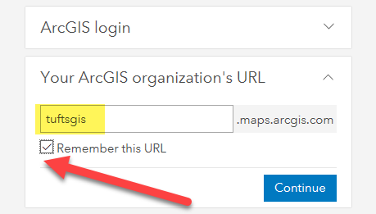
- You will then be prompted to log in with TUFTS UNIVERSITY. Press the blue Tufts button.
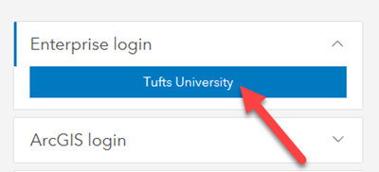
- Now you will log in with your Tufts Username (UTLN) and password. You will need to also go through duo authentication. Press Login.
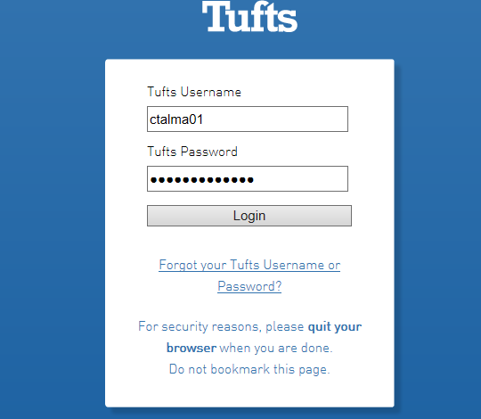
An AGOL account has now been created within our Tufts University organization account that is associated with your Tufts Username.

Activate your Student Digital Download Code
- Visit http://www.esri.com/EducationEdition
- Click on I have an ESRI Account. You will log in the same way you just did in the step above.
- Click on Sign in with Your ArcGIS organization’s URL. Do NOT click sign in with ArcGIS Login
- Enter tuftsgis as the organizations URL so it looks like the following image. If this is your personal computer, you can check remember this URL and it will be faster next time.
- You will then be prompted to log in with TUFTS UNIVERSITY. Press the blue Tufts button.
- Now you will log in with your Tufts Username (UTLN) and password. You will need to also go through duo authentication. Press Login.
- Enter the authorization code you have been given by your GIS Professor or the Data Lab Staff. The format of the code is similar to EVA123456789.
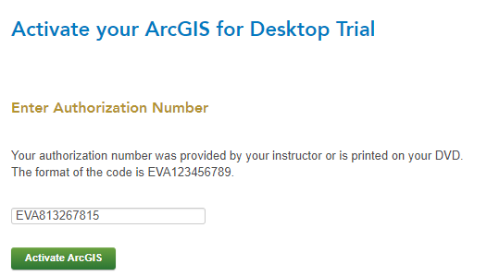
- Click Activate ArcGIS.

Download and Install the Software
- The newest version of ArcGIS Pro 2.6 is not yet available through this ESRI site. Therefore, we have downloaded the software and made it available for you at this link. Go to the following link: https://tufts.box.com/s/hkvpd4e4qozdu15f16epoge0zwadbsqf
- Click on the file ArcGISPro_26_175036.exe and press Download to access the software installer.
- Once it downloads, Run the installation wizard by opening the ArcGISPro executable (.exe).
- Select a destination folder to extract the install files to and press Next.
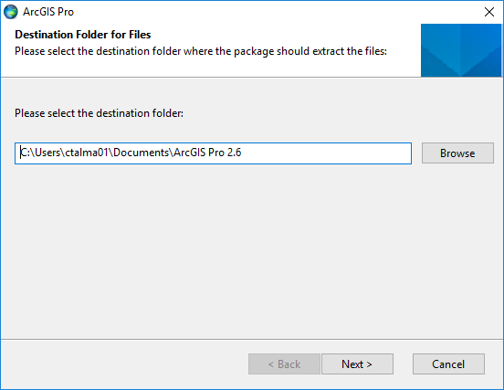
- Leave the option “Launch the setup program” checked and press close.
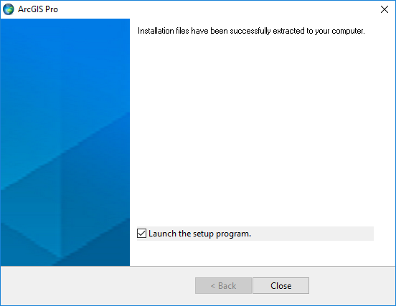
- Click next through the various prompts in the ArcGIS Pro setup wizard.
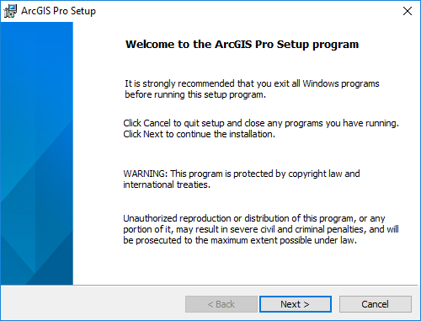
- Accept the master agreement.
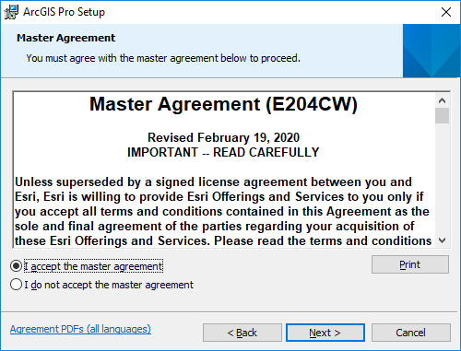
- Press Next at the install features window.
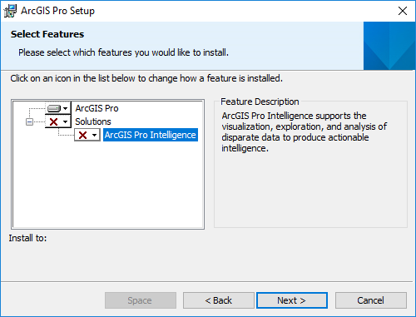
- Press Install when prompted.
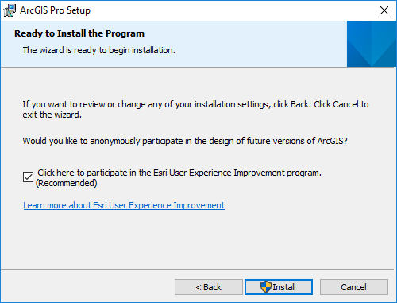
- Press YES when asked if you want to let the program make changes to your computer.
- Proceed through the setup installer options by clicking Next until you receive this completion. Press Finish and the program will launch.
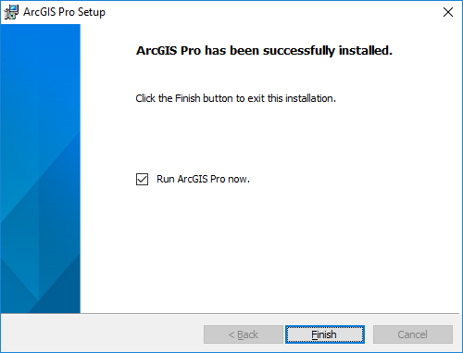
- The software will open after you have finished installing.

Signing into ArcGIS Pro using your ArcGIS Organization’s URL
The software is licensed upon launching the ArcGIS Pro 2.6. Follow these directions to log into our Tufts Organization account upon launching Pro:
- When the sign in box comes up, click on the link for Sign in with Your ArcGIS organizations’s URL. Very important to not just press “ArcGIS Login”
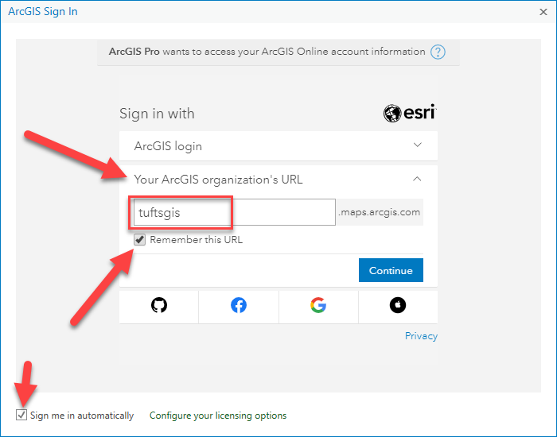
- Enter tuftsgis in the text box so the full domain reads tuftsgis.maps.arcgis.com
- Check the box that says Remember this URL and Sign me in Automatically.
- Press Continue. Then press Tufts University.
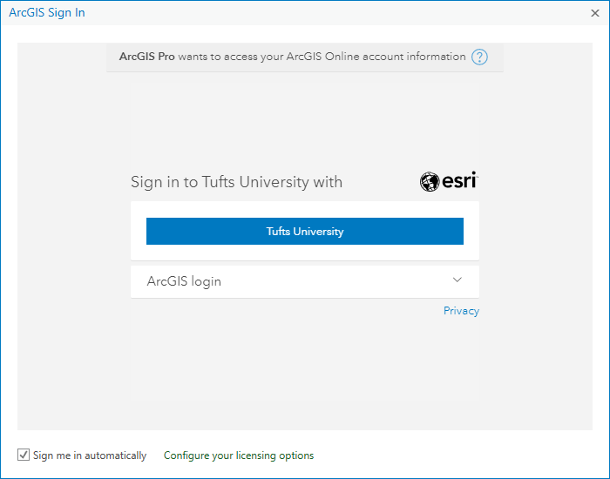
- Use your Tufts username (UTLN) and password to login. Then ArcGIS Pro should open. If it doesn’t, contact DataLab-support@elist.tufts.edu for assistance.

Additional Resources for ArcMap
- For information on how to connect to Box in ArcGIS Pro, see these instructions: https://tufts.app.box.com/file/631995847090

- For Information on how to Install the VPN, Map the Network Drives and Connect to Folders in ArcMap, see these instructions: https://tufts.box.com/s/7wl2b3jxp309a962q6b8g1270kgm68ky

